Setting Up & Using TouchChat HD

Getting Started

Selecting a Vocabulary File
- Tap Vocab in upper left-hand corner of the screen
- Press Choose new vocab.
- Scroll to find your vocabulary file

Storing a Custom Vocabulary file.
Each file is presented as a locked file that must be copied and renamed before editing is permitted.
- In the list of vocabulary files page, tap Menu
- To copy an existing file, tap Copy a vocab
- Select the vocabulary file you wish to copy
- Write the title and description of the vocab, then select Save

Settings

How to open the settings
- First tap Menu in the upper right hand corner
- Then tap Settings
Here you may edit the speech display bar, where your message will appear, the button touch settings, and more by scrolling down and pressing the toggle switch on the right. Green means it’s turned on, and white means it’s turned off.
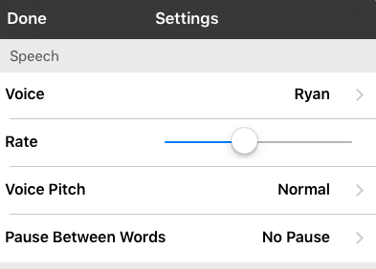

Sounds Setting Changing Voice
  - Tap Menu in the upper right hand corner
  - Tap Settings to open the settings
  - Scroll down to speech, and tap Voice
  - There are a variety of voices with different accents to choose from that can be downloaded to the app.
  - Tap the mini speaker icon to hear the voice, and tap the name of the voice to choose it.

Button Touch Settings
By default, the buttons will activate immediately when touched. To accommodate for accidental selections, try Activate on Release (when your finger exits the screen). This allows the user to put their hand on the screen and drag it to the desired button, and that button will activate when they remove their hand.
Dwell time defines how long you must remain on the button before it activates. NOTE: You may want to explore the IOS general accessibility touch settings as well as the settings within Touch Chat.
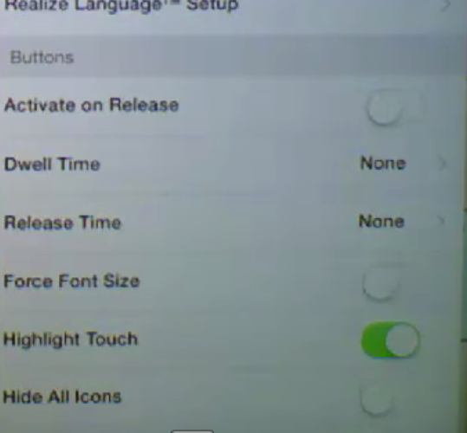

Editing
To edit a vocabulary, first have the vocabulary file open. In order to customize the pages, you must first open the page you want to edit. Then select menu and edit page. Notice the bar at the top is now red. Instead of speaking when you select buttons, you will bring up editing options when buttons are selected.
WARNING: If you are not careful you will move buttons on the page! If you want to rearrange the page, simply slide the button where you want it to go, and SWAP!

Editing a button
- Tap Menu then tap Edit Page
- Tap the button you wish to edit
- Tap Edit this button to edit it
- Tap Label and/or, Message (Note) By default the message is the same as the message. However, you may want a longer message spoken with a shorter label.
- Images can be selected from the Symbol Styx image library by tapping select image - or imported from the iPad's photo library or use the camera by tapping import image.
- By scrolling down, you may customize the appearance of the button, including font, size, and color
- Tap save, then Done

Button Actions
Shows you what the button will do when it is selected. Speech message, navigate, play video, play audio and many more actions are available here.

Create a Button that Navigates to a New Page
Open to the page where you wish to create the button that will Navigate to a new page. Be sure you know the name of the page you want to link.
- Select Menu.
- Select Edit Page.
- Tap the button you wish to edit, then tap Edit this button
- Label the button and apply an icon and any preferred style changes
- Scroll down to the Button actions area and select Add.
- Select Navigate to go to SPECIFIC PAGE, select Navigate to Home to go to the home page, or select Navigate Back to go back to the previous page,
- To navigate to a new page, tap Navigate then tap the plus sign in the right hand corner.
- Choose a page name, number of rows and columns, the color, and image then select Save.

How to copy and paste the button
- Tap the Menu button
- Choose Edit Page
- Touch the button you would like to copy
- Select Copy Button
- Tap Done in the top left corner
- Go to the page where you wish to “paste” the copied button
- Once there, tap the Menu button in the top right of the screen and choose Edit page
- Tap on the location you wish to paste to
- Select Paste Button from the menu.

Sending Your Message Email & Social Media
- Select Menu
- Select Settings, scroll down and turn Allow Social Networking on.
- Exit the Menu by selecting Done.
- Once you’ve typed your message, touch and hold the speech display bar.
- 5. Select SHARE
- 6. Choose the service you wish to use. Once that service opens, your text will automatically be placed within that application. It will copy all spoken text since the CLEAR button was last hit whether or not it is all visible in the speech display bar.

Bilingual Options
There are two ways of using TouchChat with two languages.
- The first option is to make the voice speak a different language than the buttons by opening settings and changing the voice.
- The second option is to open the list of vocabulary files, and scroll down to Spanish. Tap Spanish and it should open a listing of vocabulary files that can be used only in Spanish, or in Spanish and English.

Backing Up
- From the choose vocab screen, select Menu.
- Select Import/Export Vocab.
- Tap Export to DropBox
- Select the vocab list to back up.
- Change the file name or add a date if needed.
- Select Upload.

TouchChat Resources
- For more information about TouchChat visit: touchchatapp.com/
- For more information about editing visit: touchchatapp.com/support/touchchat

