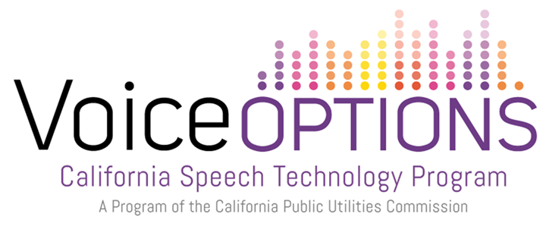

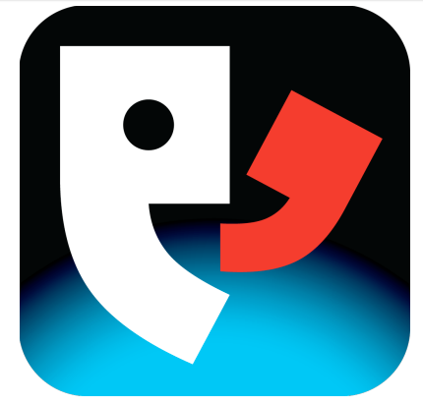

Setting Up & Using Proloquo4Text

The Interface: Onscreen Tools

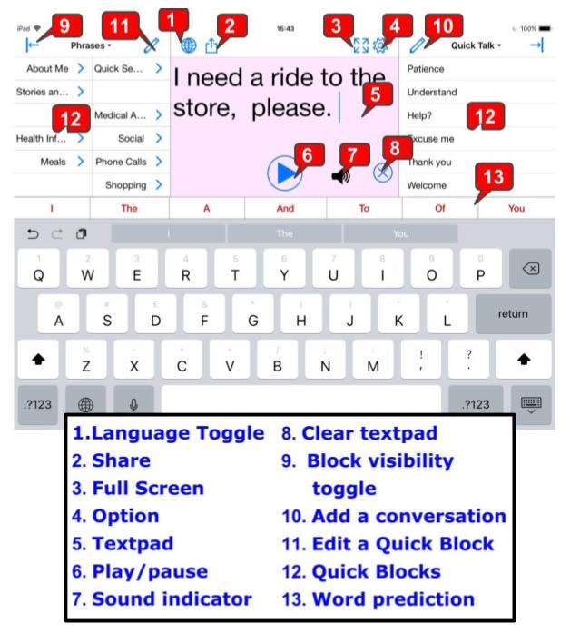

Set Up
When you first launch Proloquo4Text, a Setup Wizard will guide you through the initial configuration.

Start-Up Wizard: Create New User
- Select the Create a User Name during the Startup Wizard.
- Enter the Name of the user, then tap the Next button.
- Select an installed voice or downloadable voice from the scroll list
- Tap on the Voice you prefer.
- Then press Next.
- Then select Finish to exit the Startup Wizard.

Setting Up/Personalizing Language and Voice
- To change a voice, tap on the Options menu icon (gear).
- Select Language and Speech.
- Select Manages Languages, toggle Automatic off.
- Select desired language. English and Spanish come active in the app.
- If your desired language is not English or Spanish select your language, tap Voice.
- To listen to the installed voice, tap Voice, tap on the checked name.
- To preview downloadable voices by tapping on the Speaker icon.
- When ready to download a voice tap on the name, then tap Download.
- Select your new voice and a check mark will appear at the right.
- Go back to the language menu, tap the top left arrow next to your selected language.
- Toggle Active to green.
- This language menu provides options to alter speech rate and pitch.
- To exit settings menu, tap on the text pad.

Deactivate A Language
- Tap Options menu icon, tap Language and Speech.
- Tap Manage Languages under the Languages section.
- Toggle Automatic to grey to view or edit other languages available.
- To deactivate a language, select an active language and toggle Active to grey.
- If you are bilingual multiple languages and keyboard can be active.
- See Setting Up/Personalizing Language and Voice for activating a language.

Changing Keyboard Languages
A user can have separate User files for different language settings or a User can have multiple languages available within one User file. To add languages, see the Language and Speech settings section.
- To edit Keyboard settings, tap on the text pad to view the keyboard, press down on the globe until the keyboard list appears, select Keyboard Settings.
- To add a new keyboard in the iOS Keyboards Menu, select Keyboards, tap Add New Keyboard, scroll down and select a new keyboard language.
- Press the home button on the iPad to exit iOS settings.
- Tap on Proloquo4Text open the app.
- Tap on the keyboard globe to switch the keyboard or press and hold the globe to open the keyboard list, select the keyboard.
- Create a message with a different language, ensure the User Profile has downloaded the correct languages and activated them (See Setting Up/Personalizing Language and Voice).
- Press Play in the text pad to speak a bilingual message.

Navigation

Basic Commands for Text Pad
- Tap on the Text Pad and type to enter a message.
- Tap the Play/Pause button (triangle) to speak the message.
- Tap the X icon to clear the text pad.
- Tap the X icon with four arrows (expansion view button) to make the text pad fit the full screen.
- In full expanded view tap the hourglass icon to return to flip the message to face the conversation partner.
- Tap the X icon to exit full screen mode.
- Tap on Options icon to edit settings within the app.
- Word and Sentence Prediction appear at the top of the keyboard.
- To hide the keyboard, tap on the keyboard icon.
- Tap on the circular arrow to make to most recently deleted message reappears on the text pad.

Six Quick Blocks: Speed Up Conversations
Give rapid access to customizable categories.
- Quick Block #1, on the left, is comprised of Phrases, Conversations, and Sentence Prediction.
- Quick Block #2, on the right, is comprised of History and Quick Talk.
- Word Prediction can be used both to the right or above the keyboard for most commonly used words.
- To switch between the Quick Blocks, tap on the titles.

Quick Blocks Commands
- Tap the Pencil icon to edit labels.
- Tap Add to add labels, item, and categories.
- Tap Select to be able to delete or move items.
- Tap the Arrow icon to hide and retrieve the Quick Block window.
- Tap the Plus icon to store text pad content into a new conversation.
Phrases and Conversations

Adding/ Editing
- Tap the pencil icon in the Phrases Quick Block.
- Select the category you wish to edit or tap Add to add an Item.
- In the Text to Speak text box, type the message.
- Tap the keyboard icon to exit the keyboard or scroll through the Item menu with your finger.
- Give the Item a name within Label.
- Within the Item menu, you will be able to edit the message, label, background color, whether it is hidden or not, and voice properties specific for that category.
- Select Done when you are finished editing the Item.

Phrases: Store Text Pad Messages
- Type a message in the text pad.
- Press and hold on the text.
- Tap Select All, or Select, widen or narrow the selection with the blue highlight cursor.
- Tap Create Phrase.

Phrases: Deleting
- Enter the Phrase Quick Block.
- Tap the pencil icon in the Phrases Quick Block.
- Press Select, tap a category label, tap Action, then Delete.
- Select Done in the Phrase Block and Done in the top right corner to exit edit mode.

Phrases: Duplicating and Relocating
- Tap the pencil icon in the Phrases Quick Block.
- Press Select, tap a category label, tap Action, tap Copy.
- To relocate the copied item to a different category or quick block, tap Back, tap on the blue arrow next to the category name, then tap Action, tap Paste.
- To copy the category within the same category, tap Action, tap Paste.
- Tap Done.

Phrases: Hide Categories
- Within Phrase Quick Block press Select.
- Then select the category you wish to edit from the scroll menu, a checked blue circle will appear upon selection.
- Toggle the Hidden settings to green to Hide a category.
- Toggle the settings to grey to unhide a category.
- Tap Done.

Conversations: Editing
Conversations are created within the Text Pad and can be used to store longer messages.
- Tap on the text pad and use the keyboard to type a new message.
- Tap the Plus icon to add the current text pad content to the Conversation Quick Block.
- To create a conversation with stored Phrases, tap the phrase you wish to enter the text pad.
- Then press the Plus icon.
- To delete a conversation, select the conversation within the Conversation Quick Block to appear in the Text Pad.
- Then tap the X icon to delete the text pad and conversation from the Quick Block.

Switching Between Phrases and Conversation
- Start by selecting a message from the phrase or conversation quick blocks or typing within the text pad.
- Toggle between Conversation Quick Blocks by tapping on Conversation.
- Then Sentence Prediction Quick Block will appear.
- Tap on Sentence Prediction to enter the Phrases Quick Block.
- When the message appears in the text pad, you can tap on the text pad to begin typing more to the message.
- Tap the Play (triangle) button to speak the message presented in the text pad.
Quick Blocks

Quick Talk
Use Quick Talk for interjections and expressions that you want quick access to while communicating.
- By default, a tap on a Quick Talk item speaks immediately and does not insert the text into the Text Pad.
- Touch and hold for a popup with a list of Quick Blocks to quickly switch to a specific one.
- You can change this behavior in the Speak Items section of the Language and Speech Options.

History Quick Block
Use History to easily say something you said before.
- Tapping will insert text in the Text Pad.
- Touching and holding will speak it immediately.
- You can change this behavior in the Speak Items section of the Language and Speech Options.

Rate Enhancement

Prediction Settings
Select Quick Talk to use the most common words and expressions.
- Tap on the Options icon.
- Select Appearance.
- Scroll down to keyboard prediction section.
- Edit text font size, color, and style.
- Word prediction can be set to learn all words, correctly spelled words, or off.
- You can change the max suggestions from two words to as many as fit.
- Sentence prediction can be arranged alphabetically and by likelihood.
- Alter the max suggestions from two words to as many as fit.

Appearance

Modifying Appearance: Color Contrast
- Tap the Options icon.
- Select Appearance.
- You can edit the font, background color, location of controls, and text highlight.
- Tap the text pad to exit the Options menu.

Backups

Backup and Restore
It is important to regularly make backups to store outside of your device.
There are multiple options for backing up and restoring previous backups of the device.
We will be focusing on using Dropbox.
- Backups and Restoring Users are done through a Dropbox account.
- To back up the device, go into Options.
- Tap on Backups.
- Select Backup All Users or the current User.
- This creates an internal backup onto the device.
- To restore an existing back, use Restore and Backup.

Export and Import Backups using Dropbox
Regularly export a backup to Dropbox to avoid losing customizations of Quick Boxes. To Backup to Dropbox, a Dropbox account must already be created on the device within the Dropbox app.
- To link Proloquo4Text with Dropbox, tap the Options menu, then Backups, and toggle Dropbox integration to green.
- To Export a file to Dropbox, tap Export Backups, select the backup file to exported, then select Export to Dropbox.
- To Import a backup from Dropbox, tap Import Backups, tap Dropbox, select the document file (.p4tbk) in the Dropbox menu, tap Import.

Resources
For more information on Proloquo4Text please visit https://www.assistiveware.com/support/proloquo4text/tutorials
For product support within the app access Support Options by tapping on the Options menu icon (gear) and select Support.
For more information, or to view instructional videos for this app, visit https://www.youtube.com/user/assistiveware/search?query=Proloquo4Text
Information in this guide was gathered and assimilated for the Voice Options project by CTEC, Communication Technology Education Center or visit www.ctecaac.org

