Setting Up & Using Apple Accessibility Features

Setup

Guided Access
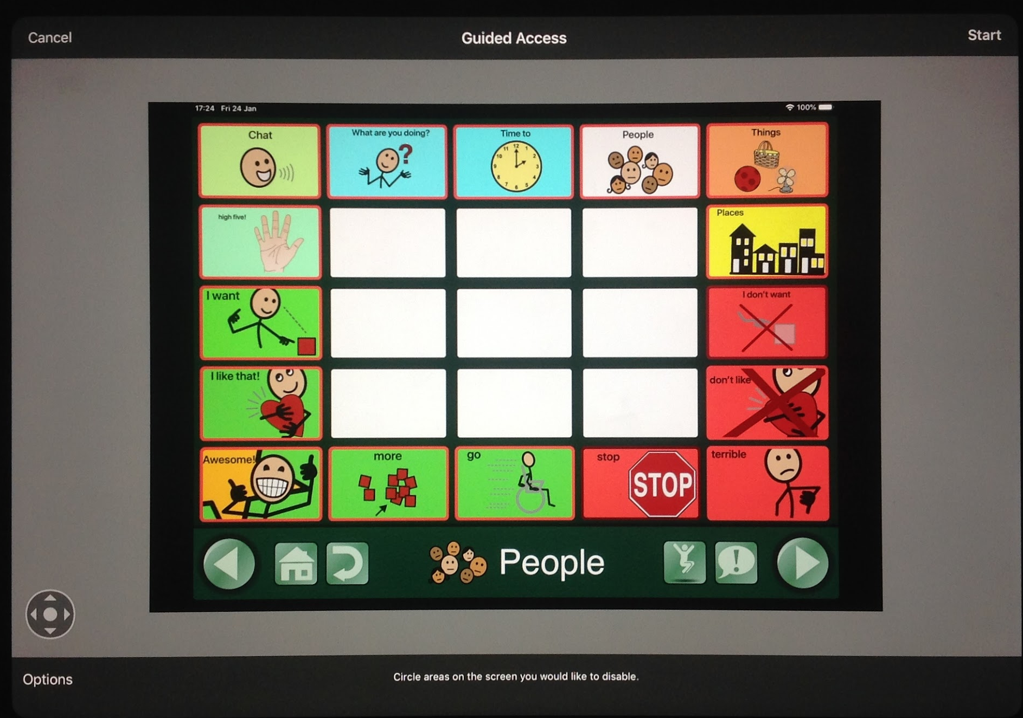
Guided access helps restrict the features available to the user, and can lock a user in an app. This is helpful if an iPad is being used as a dedicated communication device.

How to Turn on Guided Access:
- Open settings from the main iOS gear on the home screen
- Tap Accessibility
- Scroll down, and tap Guided Access below the Learning section
- To turn on guided access, tap the toggle switch to green.
- Set a passcode to turn on and off guided access by tapping Passcode Settings

How to Use Guided Access:
- Open the app you wish to restrict access to
- Triple click the top button (or home button), then tap Start (or Resume) at the top right to use Guided Access
- The first time you use guided access, a screen End, Guided Access, and Resume will appear at the top with text below stating Hardware Button Options, Touch enables, and Time Limit Options.
- Make sure touch is enabled and green.
- Tapping Options allows you to choose if the volume buttons, device keyboard, etc. can be used during guided access.
- To set how long the app will be used, tap Time Limit, and choose an amount of time.
- Toggle Time Limit to green (on), then scroll to set a time.
- To disable certain parts of the screen, draw a circle around the area you want disabled. A grey circle will appear on the screen and will be visible during guided access.
- To end guided access, tap End in the upper left-hand corner.
To resume guided access, tap Resume in the upper left-hand corner.

Touch Accommodations
Touch accommodations are helpful to slow down the sensitivity of the iPad screen and help users who have motor impairments. They are also helpful to prevent accidental activation of buttons, for example if a user is impulsive.
WARNING: Some of the communication apps have their own touch accommodations. Using the iOS and app accommodations simultaneously may conflict. This might cause a rift in the time space continuum causing the universe to implode. :)

How to turn on touch accommodations settings
  - Tap Settings
  - Tap Accessibility
  - Tap Touch
  - Tap Touch Accommodations
  - Tap the toggle switch next to touch accommodations to turn it on

Features Available
Hold duration: Sets an amount of time a button must be pressed before it is activated. The amount of time can be changed.
Ignore repeat: Ignores multiple key presses within a set period of time. The amount of time can be changed
Tap Assistance: There are two options; "initial touch location" and "final touch location". "Initial touch location" means the iPad will activate the button that is first pressed. "Final touch location" means the iPad will activate the place where you lift your finger. Set a "gesture delay" time to delay the time between a tap and activation.
*Helpful hint: When setting the time delay for each feature, start at .5 seconds or higher.
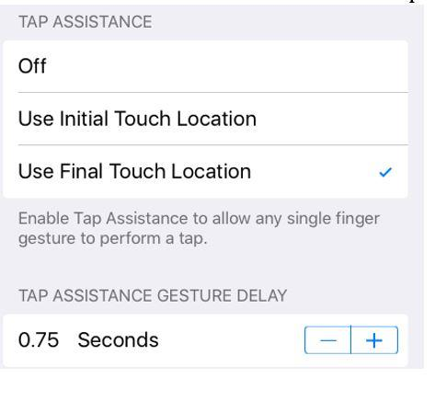

Zoom
The Zoom feature helps magnify the entire screen and Zoom in on portions the screen. This feature is helpful for users who have visual impairments.
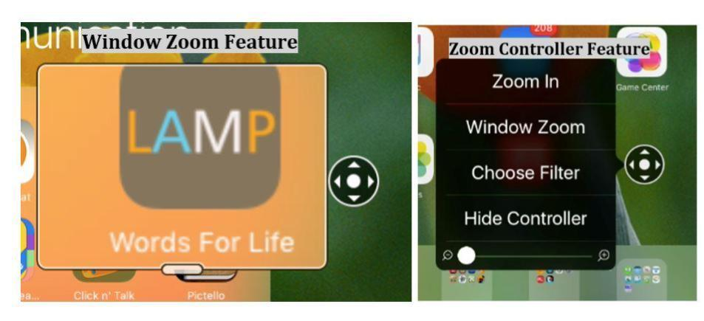

How to turn on Zoom
- Open Settings
- Tap Accessibility
- Tap Zoom
- Next to the word Zoom, tap the toggle switch to green to turn it on

How to Magnify the Entire Screen
- Using three fingers, double tap the screen.
- Tap Choose Region, the Full Screen Zoom
- Tap Zoom in
- To control Zoom with the control screen, use Show Controller
- Using three fingers, double tap the screen.
- Tap Show Controller, then tap on the screen outside of the options menu
- Press and drag the grey circle icon with arrows to move the magnification view about the full screen.
- Using three fingers, double tap the screen.
- Tap Zoom Out to exit Zoom

How to Control Zoom
Access Zoom settings by using three finger and double tapping the screen or open Settings, then tap Accessibility
- In the Zoom settings, to turn on Zoom controller.
- Tap the toggle switch next to Show Controller to green.
- A small grey compass should appear on the screen. This is the Zoom controller and can be dragged around the screen.
- To control the Zoom settings, tap the grey compass.
- A menu of options should open.
- Tap Zoom In to zoom in on the screen. To zoom out after pressing Zoom in, tap the compass again and tap Zoom Out.
- Choose Filter opens a list of color filters, for example gray scale and inverted, which inverts the colors of the screens.
- Window Zoom opens a small zoom window that allows you to zoom in on part of the screen. To move around the window, press near bottom center of the zoom window frame and drag around the screen.
- Hide controller hides the grey compass from being seen on the screen. To see the controller again, go back into the Zoom settings and turn on show controller again.

Quick Tips
- Remember that features may vary by the iPad and the iOS version, for specifics on a certain iPad and more information, visit the Apple Accessibility website at: www.apple.com/accessibility/
- Accessibility features can be quickly accessed by triple clicking the top button (or home button). To adjust which features will be available by triple clicking the top button (or home button), go to settings 🡪 accessibility 🡪 accessibility shortcut. Tap the features you wish to be available by triple clicking the home button.
- Some accessibility features may not enable all selected features and feature options if multiple features are turned on.
- If you are using a communication app, like TouchChat, it would be best to turn off gestures to prevent accidental activations.

Resources
- Video demonstrations and explanations of the guided access feature please visit https://www.youtube.com/watch?v=FRTNiCnC-nw
- A video demonstration and explanation of the Zoom feature please visit: https://www.youtube.com/watch?v=DPjn6BCjmGA:
- For iPad Accessibility features and updates please visit the Apple website for accessibility or https://www.apple.com/accessibility/ipad/
- Information in this guide was gathered and assimilated for the Voice Options project by CTEC, Communication Technology Education Center. Visit the CTEC website at this address www.ctecaac.org

