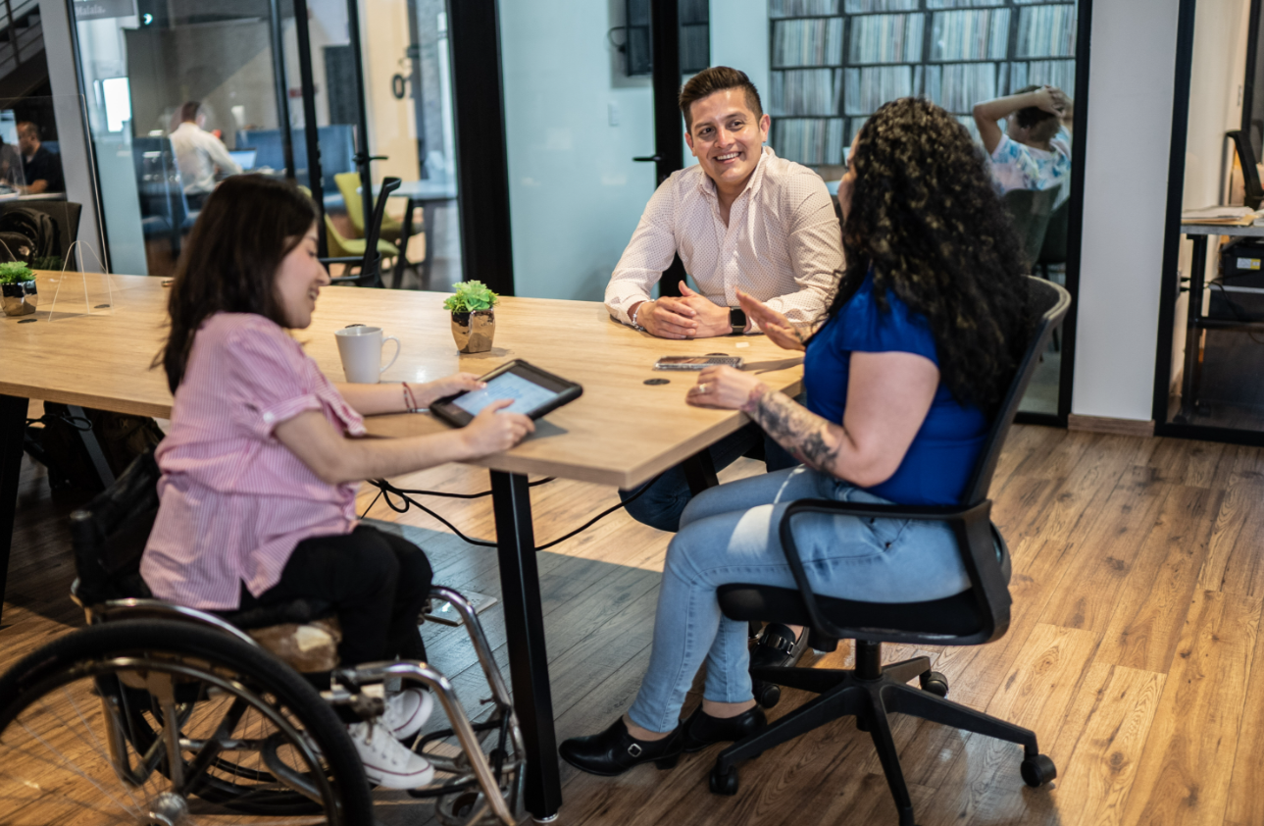

Voice Options Program
Annual Report
July 2024 – June 2025

A partnership with the
California Public Utilities Commission’s
Deaf and Disabled Telecommunications Program

Table of Contents
Voice Options Program Background 2
Success Stories 3
Annual Highlights 7
Accomplishments 7
Noteworthy Achievements 7
Challenges 7
Data Points 8
Number of Applications Received 8
Number of providers and Speech Generating Devices distributed per region 8
Distribution and Cost Figures Per App 9
Phone Call Related Data 10
Distribution and Cost Figures Per Accessory 10
Demographic Data 10
Outreach Efforts 11

Voice Options Program Background

The Voice Options Program (VOP) originated from Assembly Bill 136, signed by Governor Edmund G. Brown Jr. in 2011, amending the Public Utilities Code to provide Speech Generating Devices (SGDs) under the Deaf and Disabled Telecommunications Program. The California Public Utilities Commission (CPUC) was tasked with implementing this by 2014.

The Voice Options pilot program, initiated in 2017, allowed individuals with speech disabilities to self-select assistive devices, distributing iPads for short- and long-term loans. In 2020, another phase of the VOP began with the California Department of Rehabilitation (DOR) to distribute the iPads.

In 2023, CPUC made VOP a permanent part of the Deaf and Disabled Telecommunications Program, further collaborating with DOR to refine its structure. On July 1, 2024, a Memorandum of Understanding between the CPUC and the DOR was executed.

In evaluating the progress of the program from July 1, 2024, to the end of the fiscal year, June 30, 2025, DOR succeeded in achieving our objective of distributing 1,260 speech generating devices to consumers of a variety of ages, genders, ethnic backgrounds, and disability types, and exceeded the objective by distributing 93 additional devices for a total of 1,353 devices. DOR received multiple success stories from consumers through our partners and is excited to continue providing much needed devices to Californians with disabilities through the Voice Options Program.

Success Stories
Success Story - Resources for Independence Central Valley

“In the fall of 2024, a 23-year-old resident of Fresno County was referred to Resources for Independence Central Valley (RICV) by his Speech-Language Pathologist.

While this young man’s mother had successfully involved him in numerous community activities—ranging from family outings to events with his Adult Transitions class peers, he faced significant challenges communicating effectively with people outside of his immediate family circle. He had previously used an assistive speech device in late primary school, which provided essential support, but he no longer had access to the technology after transitioning out of the school system.

RICV, in collaboration with the mother began the process of identifying a suitable Augmentative and Alternative Communication (AAC) solution through the Voice Options program. Following a consultation with an RICV program specialist, and after careful consideration of this young man specific communication needs and preferences, they determined that the Proloquo2Go application was the best fit.

A few months later, this young man received his speech-generating device from RICV. This technology immediately transformed his ability to connect with others, allowing him to communicate with his mother, father, and siblings. This young man continues to use his device daily and often engages in conversations about his favorite topics, including food and his current emotional state.”

Success Story: Empowering Independence Through Voice Options

“One of the stories that continues to stand out to me from my work at United Cerebral Palsy (UCP) of San Diego Assistive Technology Center involves a young man in his early 20s living with Cerebral Palsy. I was contacted by a Speech-Language Pathologist (SLP) from Sharp who was looking for support in exploring speech-generating devices for her patients. He had no functional speech and limited access to typical forms of communication. From the beginning, it was clear that this young man had so much to say—he just needed the right tools to say it.

I traveled to Sharp to meet with the SLP and the family, and together we walked through a comprehensive demonstration of the seven communication applications available through the Voice Options Program. It quickly became apparent that our focus would be on two text-based speech apps: Proloquo4Text and Predictable.

We conducted a thorough hands-on trial, and the family left with a short-term loan device to explore both apps in their day-to-day lives. Throughout the loan period, I kept in close contact with his mother to check in on their experience. She shared some remarkable moments—one that particularly struck me was hearing that her son had, for the first time, independently ordered his own food at a restaurant. These moments of self-expression, things so many of us take for granted, were monumental steps toward his independence.

When the trial period ended and we met again to decide on the next steps, the transformation was undeniable. The young man came prepared, clearly articulating what he wanted—from the speech app he preferred (Proloquo4Text), to the color of the iPad case. I watched him navigate the app with confidence, using features like quick phrases, word prediction, and abbreviation expansion. He was communicating—on his terms.

After we wrapped up the case, his mother reached out again, this time to express how grateful she was for the Voice Options Program. She told me she wished she had known about it sooner, and that she’s now telling everyone she can. Since receiving his own device, her son has started taking college courses, is traveling the U.S. with his family in their RV and continues to expand his communication circle in ways that weren’t possible before.

This is exactly why we do what we do. Programs like Voice Options aren’t just about technology—they’re about giving individuals a voice, autonomy, and the ability to engage more fully in their lives. Witnessing that transformation firsthand is something I’ll never forget.”

Voice Options Program: A Journey of Empowerment and Hope

“When I first learned about the Voice Options Program, I felt a mix of hope and urgency. My daughter had been waiting a long time for an AAC device through her school and has not responded to us, and the delay had become increasingly frustrating, not just for her, but for our entire family. Her ability to communicate was limited, and each day without a proper tool felt like a missed opportunity for growth and connection.

That changed the moment I reached out to Ms. Samantha. Her same-day response was not only prompt but incredibly kind and reassuring. She guided me through every step of the process with clarity and compassion, making what could have been a complicated experience feel seamless and supportive.

Thanks to her help and the generosity of the Voice Options Program, my daughter received a brand-new iPad Pro 11. It came fully equipped with a protective case cover, screen protector, shoulder strap, and even a keyboard, every detail thoughtfully included to support her needs. But the most transformative gift was the Touch Chat speech app, pre-installed and ready to use.

Touch Chat has opened a whole new world for my daughter. She transitioned to the app effortlessly, and within days, we saw a dramatic improvement in her ability to express herself. She’s now forming longer, more fluid sentences with greater speed and confidence. The app’s intuitive design and customizable features have made it easier for her to communicate her thoughts, feelings, and needs, something of which we had long dreamed.

As parents, we’re learning alongside her, exploring the app, discovering new ways to support her communication, and celebrating every milestone. The impact has been profound. My daughter is not only speaking more clearly, but she’s also engaging more fully with the world around her.

On behalf of my daughter and our entire family, we extend our deepest gratitude to Ms. Samantha and the Voice Options Program. This initiative has given our daughter a voice, and with Touch Chat, she’s using it to thrive. We are truly thankful and excited for what lies ahead.”

Annual Highlights

Accomplishments
- Completed grant amendments with 28 providers for next fiscal year.
- Four provider meetings.
- Purchased and installed a new application, TD Snap, on short-term loan devices.
- Exceeded the State Fiscal Year 2024- 2025 objective of serving 1,260 consumers.

Noteworthy Achievements
- Expanding Access to Speech Generating Devices (SGDs): Since the program’s initiation at DOR in 2020, SGDs and related equipment have been served to over 4,769 individuals with speech disabilities.
- Adopted as a Permanent Program. The CPUC adopted the VOP pilot as a permanent part of the Deaf and Disabled Telecommunications Program, ensuring long-term support for individuals with speech disabilities​.

Challenges
- The TD Snap application, created by Tobii Dynavox, moved from a one-time purchase to a monthly purchase. The monthly purchase no longer allows VOP providers to purchase the TD Snap application. Therefore, VOP is currently purchasing the app directly from Tobii-Dynavox company and distributes to the providers.
- VOP providers are adjusting from SGDs being allocated on a first come first serve process, to a monthly regional allocation distribution. This new process resulted in a delay in distributing SGDs due to adjusting internal processes.

Data Points

From July 1, 2024 – June 30, 2025, approximately 1,353 consumers completed the short-term loan and entered the long-term device process.

Number of Applications Received
1,353 consumers completed the short-term loan and entered the long-term device process.

Number of providers and Speech Generating Devices distributed per region
The VOP serves eligible Californians through 28 providers in all counties and offers services virtually and in-person to ensure comprehensive state-wide coverage. VOP Allocations are distributed regionally in 10 regions.
- Region 1: 144 Long-Term Devices Distributed
  - Counties Served: Butte, Colusa, El Dorado, Glenn, Lassen, Modoc, Nevada, Placer, Plumas, Sacramento, Shasta, Sierra, Siskiyou, Sutter, Tehama, Yolo, Yuba
- Region 2: 58 Long-Term Devices Distributed
  - Counties Served: Del Norte, Humboldt, Lake, Mendocino, Napa, Sonoma, Trinity
- Region 3: 105 Long-Term Devices Distributed
  - Counties Served: Alameda, Contra Costa, Marin, San Francisco, San Mateo, Santa Clara, Solano
- Region 4: 40 Number of Long-Term Devices Distributed
  - Counties Served: Alpine, Amador, Calaveras, Madera, Mariposa, Merced, Mono, San Joaquin, Stanislaus, Tuolumne
- Region 5: 124 Number of Long-Term Devices Distributed
  - Counties Served: Monterey, San Benito, San Luis Obispo, Santa Barbara, Santa Cruz, Ventura
- Region 6: 53 Number of Long-Term Devices Distributed
  - Counties Served: Fresno, Inyo, Kern, Kings, Tulare
- Region 7: 146 Number of Long-Term Devices Distributed
  - Counties Served: Riverside and San Bernardino
- Region 8: 153 Number of Long-Term Devices Distributed
  - County Served: Los Angeles
- Region 9: 103 Number of Long-Term Devices Distributed
  - County Served: Orange
- Region 10: 270 Number of Long-Term Devices Distributed
  - Counties Served: Imperial and San Diego

Distribution and Cost Figures Per App

Average Cost Per Application; $261.06

Go Talk Now Plus
- Cost Per Application: $169.99
- Percent of Apps Distributed: 3%

LAMP
- Cost Per Application: $299.99
- Percent of Apps Distributed: 4%

Predictable
- Cost Per Application: $159.99
- Percent of Apps Distributed: 1%

Predictable Spanish
- Cost Per Application: $159.99
- Percent of Apps Distributed: 0%

Proloquo2Go
- Cost Per Application: $249.99
- Percent of Apps Distributed: 37%

Proloquo4Text
- Cost Per Application: $119.99
- Percent of Apps Distributed: 3%

Touch Chat HD
- Cost Per Application: $299.99
- Percent of Apps Distributed: 52%

TD Snap
- Cost Per Application: $150
- Percent of Apps Distributed: 1%

Phone Call Related Data

Purpose for Phone Call
- 64% Practice Language
- 20% Call Friend or Family
- 13% Speech Therapy
- 2% Other
- 1% Attend Class
- 1% Video Call
- 1% Schedule Appointment

Distribution and Cost Figures Per Accessory

Protective Case
- Average Cost Per Accessory: $44.25
- Percent distributed: 96%

Mounts
- Average Cost Per Accessory: $198.22
- Percent distributed: 80%

Speakers
- Average Cost Per Accessory: $58.36
- Percent distributed: 30%

Keyboards
- Average Cost Per Accessory: $96.31
- Percent distributed: 20%

Demographic Data
Gender
  - 72% Male
  - 27% Female
  - 1% Decline to State

Disability Type
  - 68% Autism
  - 9% Speech Delay
  - 7% Developmental Disability
  - 4% Other
  - 3% Apraxia
  - 3% Cerebral Palsy
  - 3% Down Syndrome/T-21
  - 1% Aphasia

Age
  - 63% Age 0 to 6
  - 19% Age 7 to 17
  - 3% Age 23 to 29
  - 8% Age 18 to 22
  - 2% Age 30 to 39
  - 2% Age 60 or Older
  - 1% Age 40 to 49
  - 1% Age 50 to 59

Race and Ethnicity
  - 47% Hispanic/Latinx
  - 28% Caucasian/White
  - 8% African American/Black
  - 8% Asian/Pacific Islander
  - 3% Southeast Asian
  - 2% Other
  - 1% Decline to State
  - 0% South East Indian
  - 1% Native American
  - 1% Pacific Islander

Outreach Efforts

  - Distributed VOP posters, flyers, and brochures to VOP providers.
  - Convened four Quarterly Providers meetings.
  - Maintained the VOP website.
  - Presented monthly at the Equipment Program Advisory Committee and Deaf and Disabled Telecommunications Program committee meetings.

Department of Rehabilitation
Voice Options Program
721 Capitol Mall
Sacramento, CA 95814
VoiceOptions@dor.ca.gov

