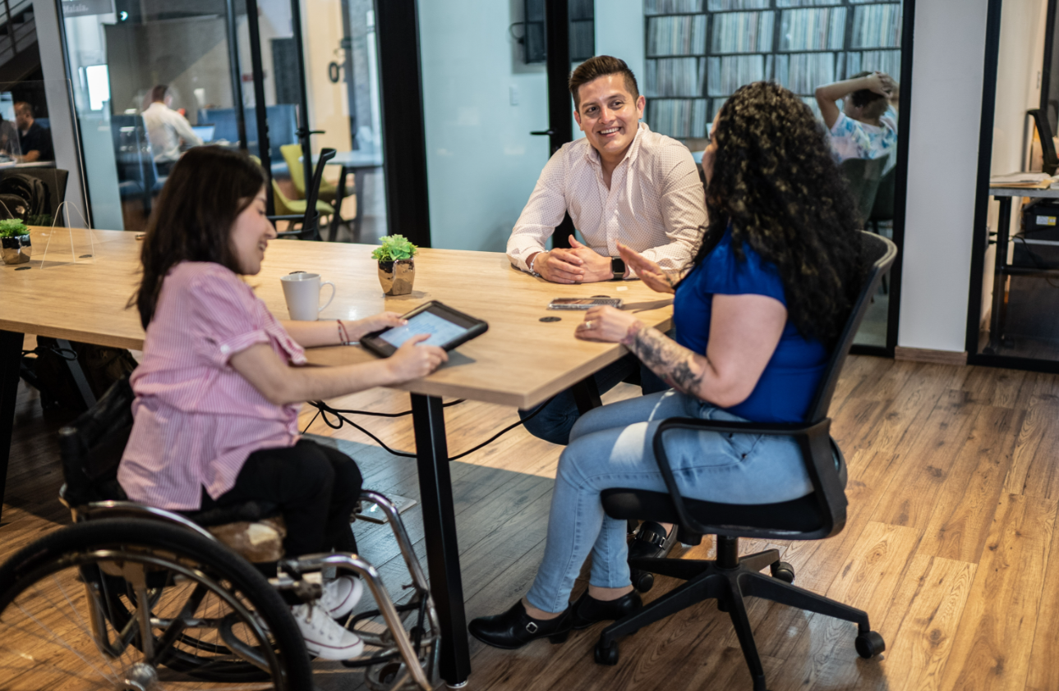

Voice Options Program
Annual Report
July 2023 – June 2024

A partnership with the
California Public Utilities Commission’s
Deaf and Disabled Telecommunications Program

Voice Options Program Background

The Voice Options Program (VOP) originated from Assembly Bill 136, signed by Governor Edmund G. Brown Jr. in 2011, amending the Public Utilities Code to provide Speech Generating Devices (SGDs) under the Deaf and Disabled Telecommunications Program. The California Public Utilities Commission (CPUC) was tasked with implementing this by 2014.

The Voice Options pilot program, initiated in 2017, allowed individuals with speech disabilities to self-select assistive devices, distributing iPads for short- and long-term loans. In 2020, another phase of the VOP began with the California Department of Rehabilitation (DOR) to distribute the iPads.

In 2023, CPUC made VOP a permanent part of the Deaf and Disabled Telecommunications Program, further collaborating with DOR to refine its structure. On July 1, 2024, a Memorandum of Understanding between the CPUC and the DOR was executed.

Annual Highlights

Accomplishments
- Completed grant amendments with 28 providers for next fiscal year.
- Convened three provider meetings.
- Purchased and installed a new application, TD Snap, on short-term loans.
- Met the State Fiscal Year 2023- 2024 goal of serving 1,260 consumers.

Noteworthy Achievements
- Expanding Access to Speech Generating Devices (SGDs): Since the program’s initiation at DOR in 2020, SGDs and related equipment to over 3,430 individuals with speech disabilities.
- Adopted as a Permanent Program. The CPUC adopted the VOP pilot as a permanent part of the Deaf and Disabled Telecommunications Program, ensuring long-term support for individuals with speech disabilities​.

Challenges
- The TD Snap application, created by Tobii Dynavox, moved from a one-time purchase to a monthly purchase. The monthly purchase no longer allows VOP providers to purchase the TD Snap application. The VOP is currently working with the Tobii-Dynavox company to negotiate a one-time purchase.
- VOP providers are adjusting from SGDs being allocated on a first come first serve process, to a monthly regional allocation distribution. This new process resulted in a delay in distributing SGDs due to adjusting internal processes.

Data Points

From July 1, 2023 – June 30, 2024, approximately 1,262 consumers completed the short-term loan and entered the long-term device process.

Number of Applications Received
1,262 consumers completed the short-term loan and entered the long-term device process.

Number of providers and AAC devices distributed per region
The VOP serves eligible Californians through 29 providers in all counties and offers services virtually and in-person to ensure comprehensive state-wide coverage. VOP Allocations are distributed regionally in 10 regions.
- Region 1: 107 Long-Term Devices Distributed
  - Counties Served: Butte, Colusa, El Dorado, Glenn, Lassen, Modoc, Nevada, Placer, Plumas, Sacramento, Shasta, Sierra, Siskiyou, Sutter, Tehama, Yolo, Yuba
- Region 2: 58 Long-Term Devices Distributed
  - Counties Served: Del Norte, Humboldt, Lake, Mendocino, Napa, Sonoma, Trinity
- Region 3: 71 Long-Term Devices Distributed
  - Counties Served: Alameda, Contra Costa, Marin, San Francisco, San Mateo, Santa Clara, Solano
- Region 4: 53 Number of Long-Term Devices Distributed
  - Counties Served: Alpine, Amador, Calaveras, Madera, Mariposa, Merced, Mono, San Joaquin, Stanislaus, Tuolumne
- Region 5: 44 Number of Long-Term Devices Distributed
  - Counties Served: Monterey, San Benito, San Luis Obispo, Santa Barbara, Santa Cruz, Ventura
- Region 6: 35 Number of Long-Term Devices Distributed
  - Counties Served: Fresno, Inyo, Kern, Kings, Tulare
- Region 7: 108 Number of Long-Term Devices Distributed
  - Counties Served: Riverside and San Bernardino
- Region 8: 117 Number of Long-Term Devices Distributed
  - County Served: Los Angeles
- Region 9: 86 Number of Long-Term Devices Distributed
  - County Served: Orange
- Region 10: 115 Number of Long-Term Devices Distributed
  - Counties Served: Imperial and San Diego

Distribution and Cost Figures Per App

Average Cost Per Application $255.09

Go Talk Now Plus
- Cost Per Application: $169.99
- Percent of Apps Distributed: 6%

LAMP
- Cost Per Application: $299.99
- Percent of Apps Distributed: 5%

Predictable
- Cost Per Application: $159.99
- Percent of Apps Distributed: 1%

Predictable Spanish
- Cost Per Application: $159.99
- Percent of Apps Distributed: 0%

Proloquo2Go
- Cost Per Application: $249.99
- Percent of Apps Distributed: 43%

Proloquo4Text
- Cost Per Application: $119.99
- Percent of Apps Distributed: 2%

Touch Chat HD
- Cost Per Application: $329.99
- Percent of Apps Distributed: 42%

TD Snap
- Cost Per Application: $49.99
- Percent of Apps Distributed: 2%

Phone Call Related Data

Purpose for Phone Call
- 34% Speech Therapy
- 33% Practice Language
- 21% Call Friend or Family
- 6% Attend Class
- 3% Video Call
- 2% Other
- 1% Schedule Appointment

Distribution and Cost Figures Per Accessory

Protective Case
- Average Cost Per Accessory: $44.25
- Percent distributed: 96%

Mounts
- Average Cost Per Accessory: $198.22
- Percent distributed: 1%

Speakers
- Average Cost Per Accessory: $58.36
- Percent distributed: 1%

Keyboards
- Average Cost Per Accessory: $96.31
- Percent distributed: 2%

Demographic Data
Gender
  - 69% Male
  - 28% Female
  - 3% Decline to State

Disability Type
  - 55% Autism
  - 15% Speech Delay
  - 10% Developmental Disability
  - 5% Apraxia
  - 4% Cerebral Palsy
  - 3% Down Syndrome/T-21
  - 3% Other
  - 2% Aphasia

Age
  - 53% Age 0 to 6
  - 26% Age 7 to 17
  - 6% Age 23 to 29
  - 7% Age 18 to 22
  - 4% Age 30 to 39
  - 2% Age 60 or Older
  - 2% Age 40 to 49
  - 1% Age 50 to 59

Race and Ethnicity
  - 44% Hispanic/Latinx
  - 25% Caucasian/White
  - 8% Southeast Asian
  - 8% African American/Black
  - 7% Asian/Pacific Islander
  - 3% Decline to State
  - 3% South East Indian
  - 1% Native American
  - 1% Pacific Islander

Outreach Efforts

  - Distributed VOP posters, flyers, and brochures to VOP providers.
  - Convened three provider meeting.
  - Maintained the VOP website.
  - Presented monthly at the Equipment Program Advisory Committee and Deaf and Disabled Telecommunications Program committee meetings.

Department of Rehabilitation
Voice Options Program
721 Capitol Mall
Sacramento, CA 95814
VoiceOptions@dor.ca.gov

