California Department of Rehabilitation VR Connections Portal Verification of Goods and Services – Consumer Reference Guide
Consumers receiving goods or services from the Department of Rehabilitation (DOR) may now complete the verification process through the VR Connections Portal. This guide provides instructions on how to complete the verification process. Verification of Goods and Services (VGS) submitted through the Portal is instantly visible by DOR staff.
Depending on the type of good/service, 14-28 days after an authorization has been issued, consumers receive an email containing a link titled “Enter VGS information here.” Click on that link to be taken to a site to verify goods or services received.
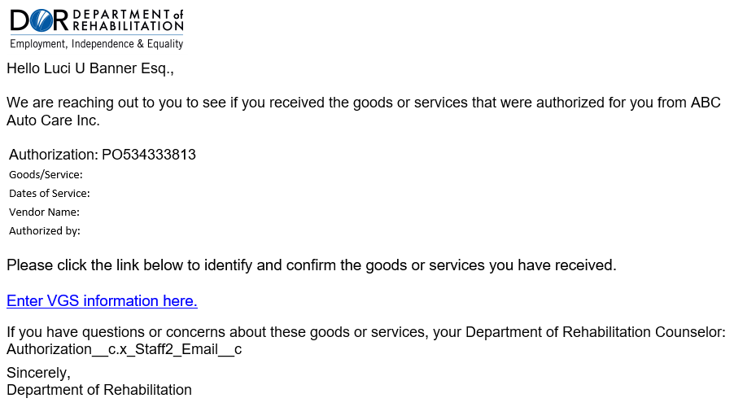

Consumers are then presented with a list of expected goods/services that were authorized by DOR. Select one of the following options for each item:
- I received everything
- I received some (opens another field to enter missing items)
- I received nothing
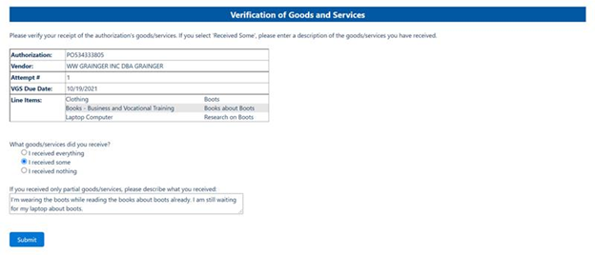
Click “Submit” to complete your verification of the goods/services received. The VGS process is now finished, and the browser window can be closed.

