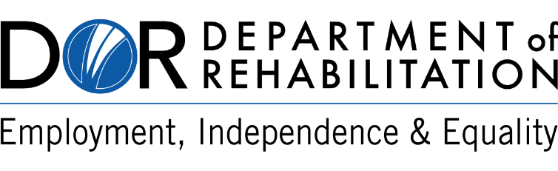

Department of Rehabilitation
Vocational Rehabilitation Connections Portal

Dear Vendor,

In January 2021, the Department of Rehabilitation (DOR) launched the Vocational Rehabilitation (VR) Connections Portal. Phase 1 featured Expedited Authorizations (electronic), in which the VR Connections Portal automatically emailed authorizations directly to vendors.

DOR is planning to launch the first set of features for Phase 2 on November 1, 2021. As part of this launch, the DOR is pleased to announce the following update for vendors:

  - Secure Access to VR Connections Portal via Multi-Factor Authentication (MFA):
    - VR Connections Portal MFA feature is a two-step authentication process that allows vendors to securely access DOR Authorizations via the Portal. This feature is similar to current banking and healthcare systems requiring users to prove their identity with two verification factors to gain access to their account. The MFA feature is being introduced in the VR Connections Portal in accordance with the California Government Code Regulation 11549.3, which states that sensitive/personal information must be protected. Following the valuable feedback received by our DOR from vendors, every reasonable effort has been made to make the MFA process as easy and efficient as possible.
    - Vendors will be required to prove their identity with two verification factors to gain access to their account, using one of the following three MFA options: email, text, or the Salesforce Authenticator iOS or Android app.

- Secure Access to Authorizations:
  - To ensure secure access to sensitive information, Authorization documents will no longer be sent electronically to vendors. Instead, vendors will be able to access Authorizations by logging into the VR Connections Portal, utilizing MFA. While vendors will continue to receive email notifications of Authorizations, the email will contain a link to login to the VR Connections Portal to access Authorization details.

- New Payment Status for Vendors
- Beginning November 1, 2021, vendors may obtain invoice-related information from the Portal. Vendors will be able to obtain the status of invoices submitted to DOR for payment.
- With a few short clicks within the Portal, vendors will be able to:
  - Verify that their invoice has been received
  - Track progress within the reconciliation phase
  - Check if an invoice has been approved for payment by the DOR and the State Controller’s Office
  - Obtain corresponding warrant information (amount, release date, etc.)
- Please note, access to the VR Connections Portal will require vendors to login to ensure that financial and business information is protected. At this time, the Payment Status feature is limited to invoice authorizations released to our vendors. Currently, consumer travel authorizations, immediate payment authorizations, and Cal-Card are not included in this feature.

To learn more about Payment Status, MFA, and how vendors can access their Authorizations on the VR Connections Portal, please visit the VR Connections webpage at https://dor.ca.gov/Home/VrcIntro. The following resources are provided:
- MFA Vendor Reference Guide
- MFA Via Email Video
- MFA Via Text Video
- MFA Salesforce Authenticator App Video
- Accessing Authorizations and Payment Status Vendor Reference Guide

Note – Once a vendor has established a VR Connections Portal account, they may access the Portal at www.dor.ca.gov/vrconnections.

The VR Connections Portal is an ongoing project that will continually evolve to best serve the needs of DOR consumers, vendors, and staff. For questions regarding the VR Connections Portal, please contact your local DOR office or visit https://dor.ca.gov/Home/VrcIntro.

Sincerely,

Department of Rehabilitation

