California Department of Rehabilitation
Vendor Invoicing 1.0 – Vendor Reference Guide
Vendor Invoicing 1.0 enables vendors to submit invoices through the VR Connections Portal. Once a vendor logs into the portal using the current Multi-Factor Authentication (MFA) feature, the vendor will be able to view their authorizations and access the new Vendor Invoicing feature.
The following steps outline the Vendor Invoicing feature.
- After logging into VR Connections Vendor Portal, navigate to the “Submit Invoice” tab.
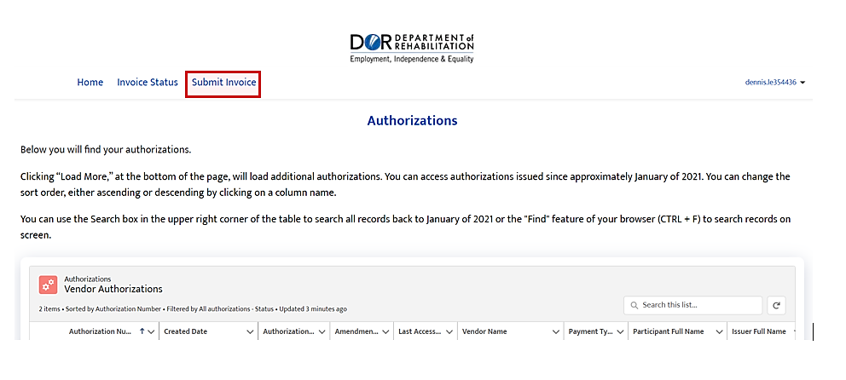
On the Submit Invoice page, users can view all their previously submitted invoices and their respective statuses.
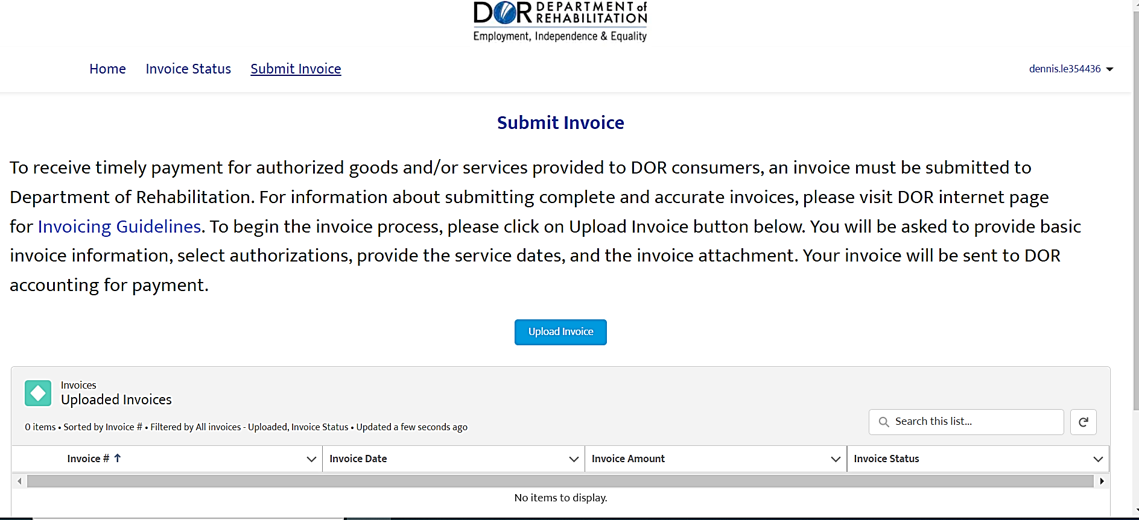
- On the Submit Invoice page, select “Upload Invoice” to initiate the invoicing process.
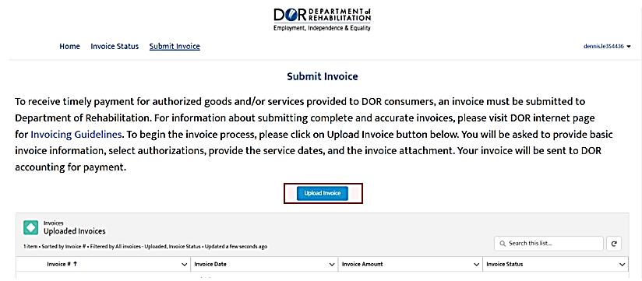
- In the “Invoice Info” pop-up complete required fields: Invoice Number, Invoice Date, and Invoice Amount. Click “Next” to save and continue. 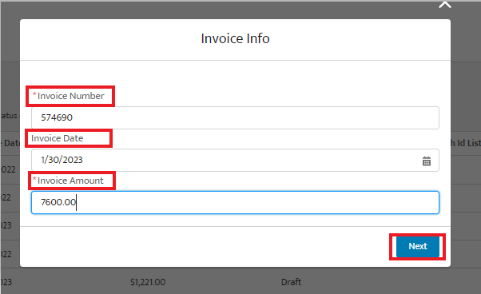
- On the “Authorizations” tab, link authorization(s) to the invoice by clicking on the arrow in the Add column. The authorizations can be sorted by Authorization, Consumer, and Authorization Start Date. You can also use the search bar to search the list by authorization number or consumer name. To unlink the authorization from the invoice, click on the Remove arrow next to the authorization.
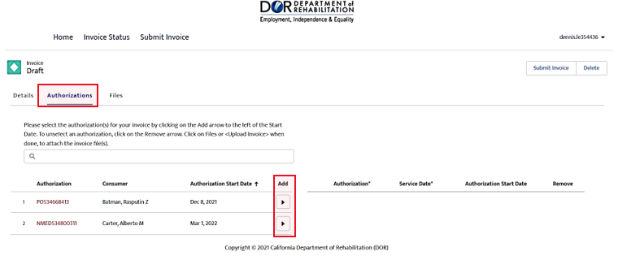
  - A “Service Date” pop-up will display when a service authorization is selected. Please enter a service date of when the invoiced service was provided to the consumer and click “Save” to continue. You can select the date using the calendar icon or enter it in the mm/dd/yyyy format and the date will display as month name, day, and year.
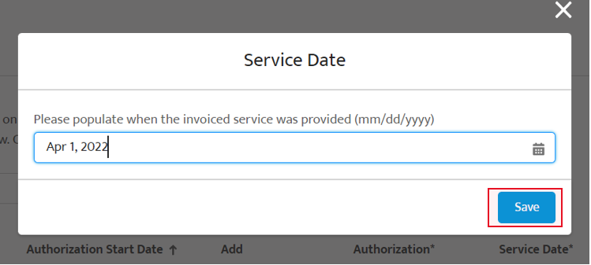
- After all appropriate authorization(s) are linked to the invoice, navigate to the “Files” tab to upload the invoice attachment and corresponding supporting documents if any (i.e., reports, receipts, delivery, etc.). Click on “Upload Files” under Invoice File(s) to add the attachments. Please note that the invoice attachment is required.
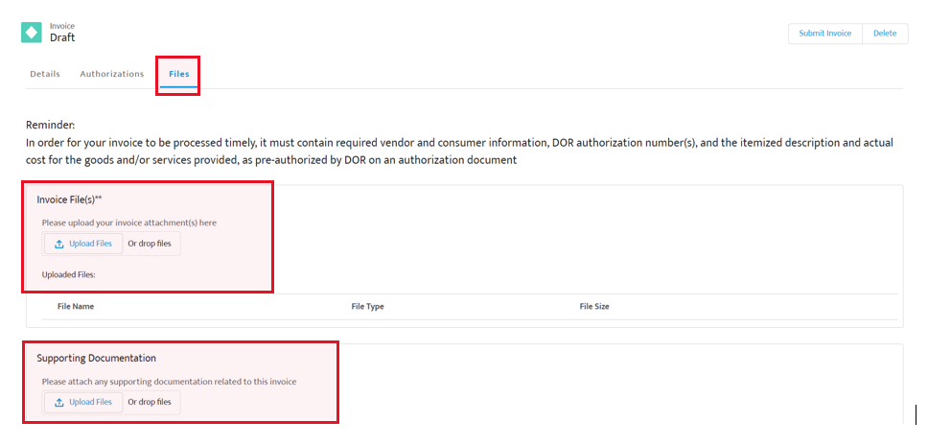
  - IMPORTANT NOTE: If multiple authorizations were linked to the invoice, the “Supporting Document” upload link will not be available due the nature of authorizations being linked to different offices. As a result, we ask these supporting documents to be sent to the counselors (VR Team) directly.
- After invoice attachment and supporting documents (if any) are uploaded, click on “Submit Invoice” to send the invoice to Department of Rehabilitation (DOR) Accounting. Alternatively, you can remove the attachments or click “Delete” if the invoice is not ready to be submitted. Please note, after the invoice is submitted, changes cannot be made to the invoice.
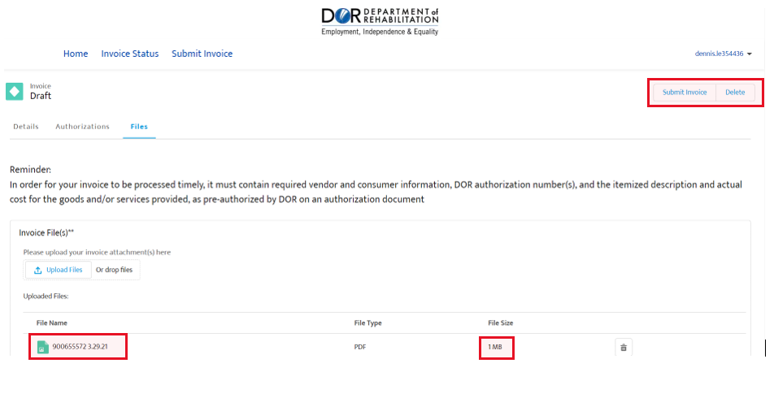
- When Submit Invoice is selected, click “Save” in the Submit Invoice pop-up to confirm submission of invoice.
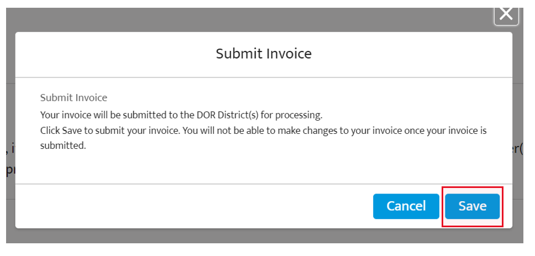
- Next, you can click on “Submit Invoice” tab to submit another invoice and/or to view and confirm which invoices were submitted to DOR through the VR Connections Portal.
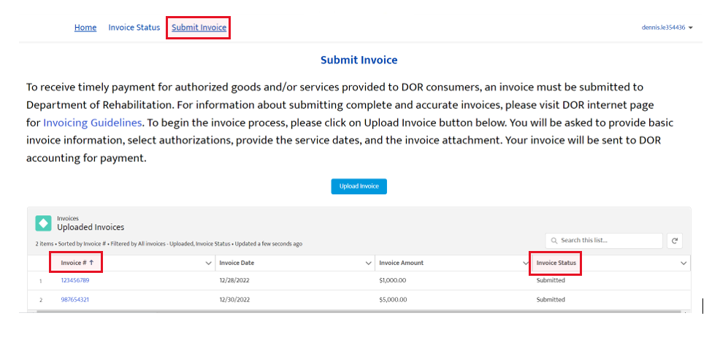
- If you need to make any corrections to the submitted invoice, please submit a revised invoice under a new invoice number and contact the district office to let them know that a revised invoice was submitted.

