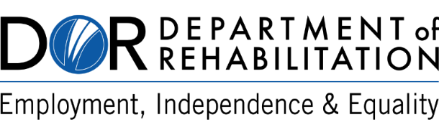 | Gavin Newsom  Governor  State of California  Health and Human Services Agency
Introducing the Department of Rehabilitation
Vocational Rehabilitation Connections (VRC)
Portal

Dear Vendor,

The Department of Rehabilitation (DOR) is pleased to announce the initial implementation of the Vocational Rehabilitation Connections (VRC) Portal. The VRC Portal is an online web-based portal that will support the automation of business processes and workflows. Once fully implemented, the portal will help DOR consumers and vendors save time and increase efficiency and accuracy by automating tasks. Some DOR consumers and vendors will start noticing minor changes in processes beginning January 19, 2021.

Why is DOR making this change?
- To improve our customer service to you.
- Improve and eliminate cumbersome manual processes.

What change can you expect?
As part of the initial VRC Portal implementation, authorizations sent to vendors via email will now be sent from noreply@dor.ca.gov. This feature will reduce current DOR manual processes by automatically sending authorizations to vendors after they are issued, expediting services to the individuals we serve.

Please note, vendors who prefer not to receive authorizations via email will see no changes in current processes.

Benefits to you?
Although small changes are occurring with this initial VRC Portal implementation, future development of the portal will allow vendors to:
- Submit invoices.
- Check invoice payment status(es).
- View and update vendor contact information and mailing/business address(es) on file with DOR.
- Complete an electronic version of the Payee Data Record (STD204) form.

What can you do to help ensure a smooth transition?
To take advantage of the VRC Portal features, please contact your local DOR office to ensure the following information is up to date:
- Mailing address(es) for invoice payments.
- Business address(es) where services are provided.
- Email address(es) for each business location where authorizations are to be sent.
- Contact name.
- Contact phone number.

The VRC Portal is an ongoing project and will continually expand to serve the needs of DOR consumers and vendors. For questions regarding the VRC Portal, please contact your local DOR office or visit www.dor.ca.gov.

