California Department of Rehabilitation VR Connections Portal

Accessing Authorizations and Payment Status
Vendor Reference Guide
Through the Department of Rehabilitation’s VR Connections Portal vendors can access Authorizations and view Payment Status of Invoices. This Reference Guide provides instructions on how to access both features.
A vendor can login to the VR Connections Portal by following the “YOU CAN SIGN UP OR LOG INTO THE PORTAL” link within any Authorization email a vendor receives. If a vendor has not established a VR Connections Portal account, the vendor will need to complete the Multi-Factor Authentication (MFA) process first to establish an account and create a password – Click HERE to access a video explaining how to complete the MFA process and an MFA Vendor Reference Guide. To login, please follow the steps below.

Logging In
Once the vendor has established an account, the link within the Authorization email will take the vendor to the Portal login screen. The vendor will enter the email and corresponding password and click “Log in”:
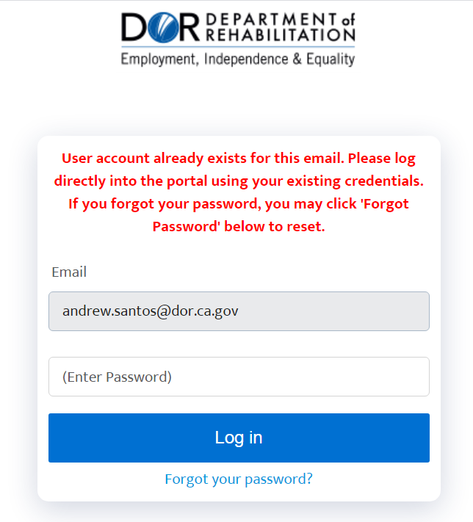
Vendors will then receive a message via their chosen MFA method, enter the Verification Code, and click “Verify” to be directed to the Authorization page.

Checking Authorizations
On the Authorization page, previous Authorizations received by the vendor can be viewed (up to 500). JAWS users may review guide on navigating tables HERE. Tables mode: JAWS key + Space then T
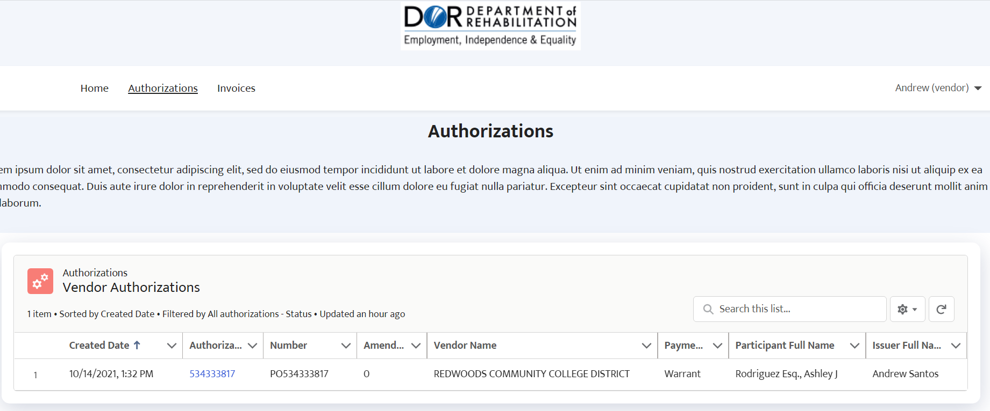

Clicking the Authorization Number (by default the second column from the left) will display the Authorization details under the “Details” tab.
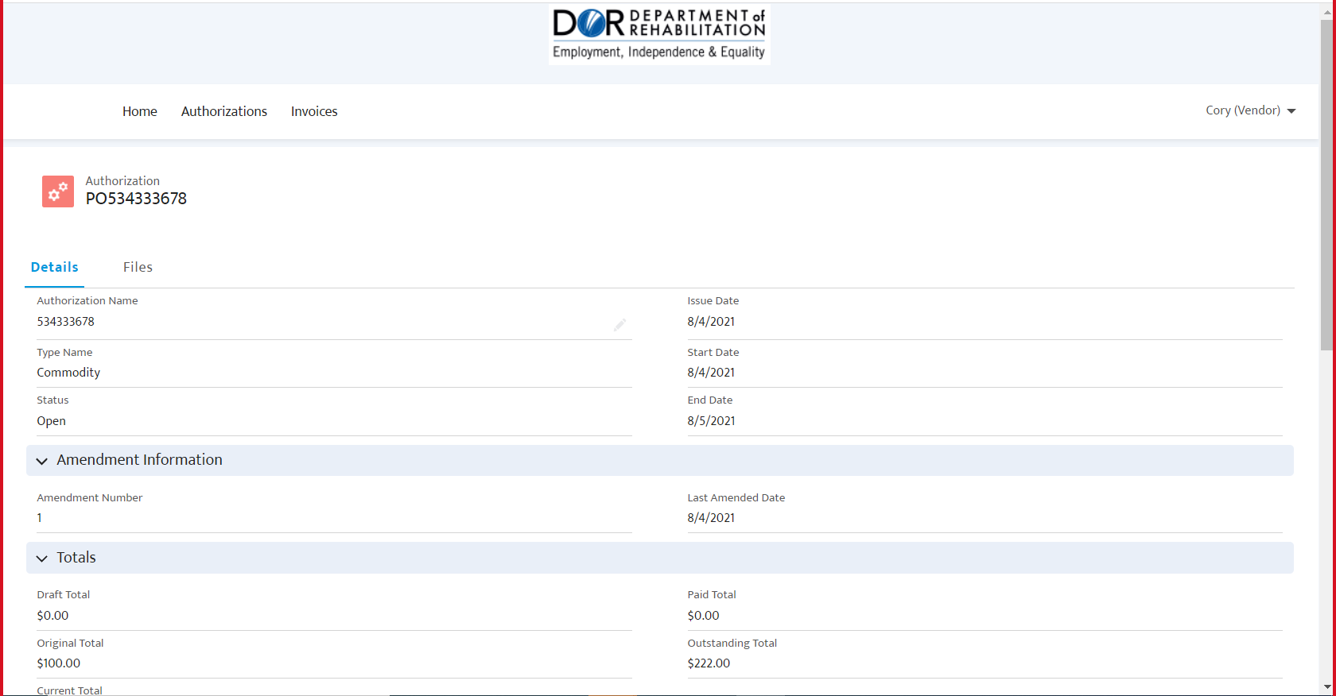
To see a PDF version of the original Authorization, click “Files.” Then click “View” under the View Descriptions column.
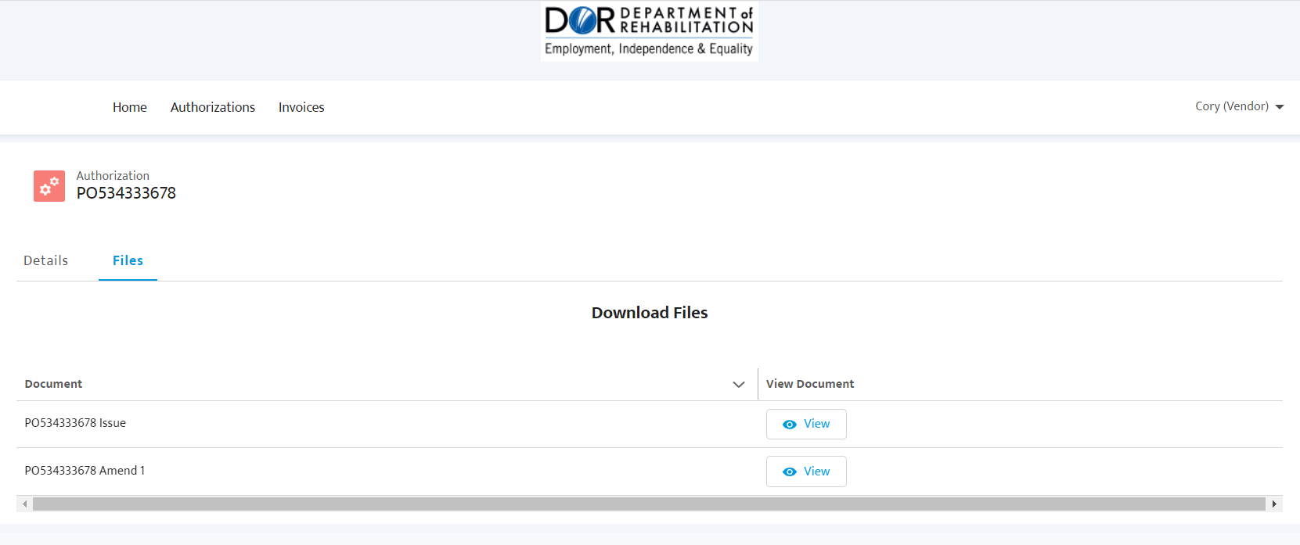

A box will appear to present our Terms for this download, please read and click the Accept button to view the PDF version of the Authorization.
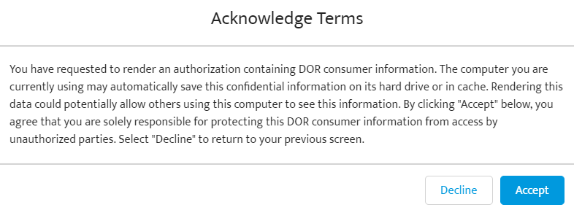
A PDF version of the Authorization will automatically appear in the browser. Clicking the “Download” link will download a copy of the PDF.
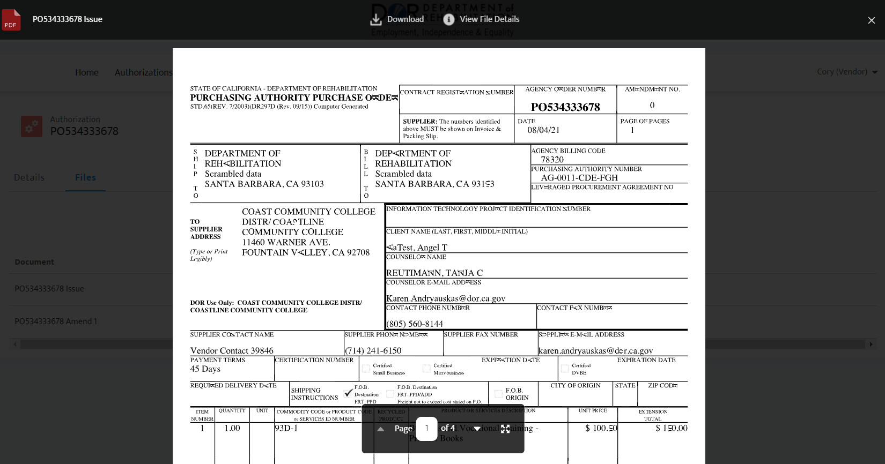

Checking Payment Status
At the top left of the screen are three buttons, Home, Authorizations, and Invoices. Click “Invoices” to see the Invoice/Payment Status Screen. This screen contains a list of each invoice and its respective consumer, invoice amount, amount paid, status, DOR Office location and other information.
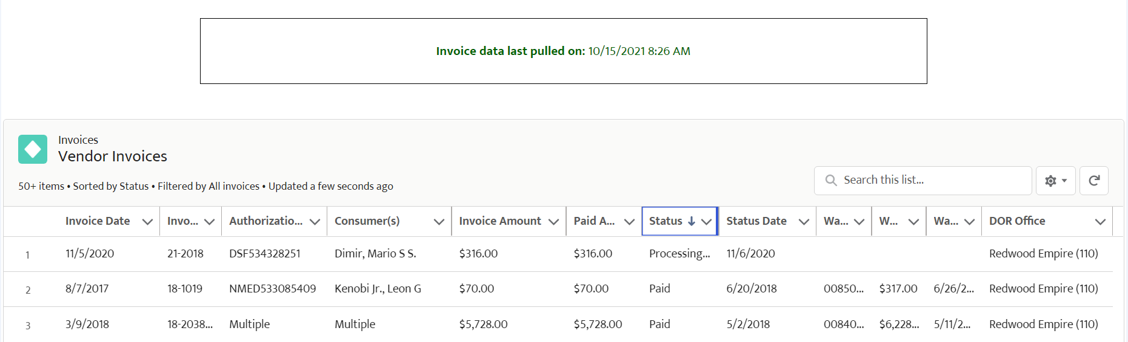

JAWS users may review guide on navigating tables HERE. Tables mode: JAWS key + Space then T

