Brain Injury
Support
Support Groups
Meditation
Psychotherapy
Neuropsychotherapy
Physical Therapy
Occupational Therapy
Vestibular Therapy
Vision Therapy
Speech Therapy
Audiology
Cognitive Rehab
Nutrition
Biofeedback

Start Here

California Department of Rehabilitation
www.dor.ca.gov/home/tbi

Brain Injury Association of America
www.biausa.org
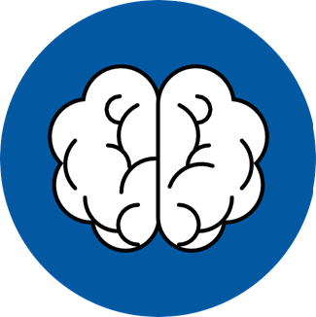

Experienced a brain injury?

Now what…


You are not alone.
Being diagnosed with a brain injury can be a frightening, confusing, and stressful time.
You will experience so much during your recovery journey and have many questions.
The CA Department of Rehabilitation is dedicated to providing encouragement, resources, and support during this challenging time.

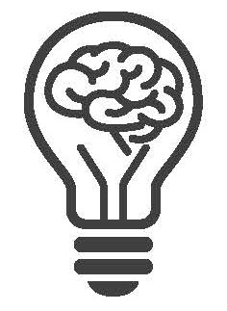

Symptoms you may experience:
- Fatigue
- Brain Fog
- Vision Changes
- Speech Changes
- Headaches
- Memory Issues
- Confusion
- Behavioral Changes
- Depression/Anxiety
- Light & Noise Sensitivity

Self-care is important in your healing journey.
Give yourself grace
Seek out support
Acknowledge your
accomplishments
Make time for fun
Take time alone and rest when needed
Pace yourself
Recognize your limits and adjust accordingly
Brainline
www.brainline.org

