State of California Office of Administrative Law

In re:
Department of Rehabilitation Regulatory Action:
Title 09, California Code of Regulations

Adopt sections:
Amend sections: 7214.2, 7214.3, 7214.4 Repeal sections:
NOTICE OFAPPROVAL OF REGULATORY ACTION

Government Code Section 11349.3

OAL Matter Number: 2026-0303-03

OAL Matter Type: Regular (S)

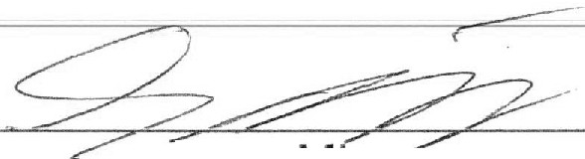
Date: April 15, 2026
Sam M1con

In this rulemaking action, the Department of Rehabilitation (DOR) updates its regulations regarding the Business Enterprises for the Blind program to clarify that business plans are not a required part of the application process for Department of Defense vending facilities. •

OAL approves this regulatory action pursuant to section 11349.3 of the Government Code. This regulatory action becomes operative upon the approval of the Secretary of the United States Department of Education, in accordance with title 34, Code of Federal Regulations, section 395.4(a).

Senior Attorney For: Kenneth J. Pogue
Director

Original: Joe Xavier, Director Copy: Michele M. Welz

