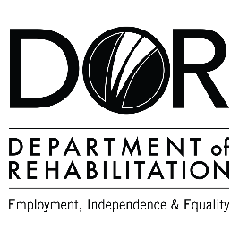
DEPARTMENT OF REHABILITATION
Danielle Hackworth, PSP Team Manager
Donnell Perry, PSP Counselor
Ricardo Perez, PSP Sector Business Consultant
Email: psp@dor.ca.gov

Pathways to Success Project (PSP) – Information Technology and Communications
- Are you interested in a high-wage, high-skilled occupation and/or career advancement within the information technology & communications field?
- Do you want to find out if you are eligible to receive Vocational Rehabilitation Services by a team specializing in the information technology & communications career pathway?
- Are you interested in joining an evaluation that examines outcomes to achieve meaningful work in strong careers?
- If you answered “YES” to these questions, you may qualify for DOR’s Pathways to Success Program.

The Pathways to Success Program may be able to assist you with:

- Training Services Cost
- Job Development and Placement
- Retention Support

Vocational Training Certificates in:
- Information Security
- Network Architect
- IT Help Desk
- Support specialist Web/Graphic
- design & developer

Associate Degrees in:
- Database Administrators:
- Customer Relations Management
- Trailhead
- Google IT Support
- Coursera

Bachelor’s Degree in:
- Software developer:
  - Windows, Linux,
  - MacOS
  - Android, iOS Java
  - Python UX & UI
Masters Degree in:
- Computer
- Programmer/ Computer:
  - Engineer
  - Hardware
  - Software

Have a question? Please email us at psp@dor.ca.gov

