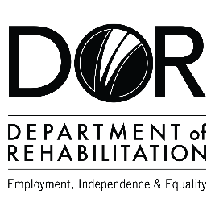
DEPARTMENT OF REHABILITATION
Danielle Hackworth, PSP Team Manager
Renee Florence Williams, PSP Counselor
Stacie Gubler, PSP Sector Business Consultant
Email: psp@dor.ca.gov
Pathways to Success Program (PSP) – Healthcare
- Are you interested in a high-wage, high-skilled occupation and/or career advancement within the healthcare field?
- Do you want to find out if you are eligible to receive Vocational Rehabilitation Services by a team specializing in healthcare career pathways?
- Are you interested in joining an evaluation that examines outcomes to achieve meaningful work in strong careers?
- If you answered “YES” to these questions, you may qualify for DOR’s Pathways to Success Project.
The Pathways to Success Program may be able to assist you with:
- Training Services Cost
- Job Development and Placement
- Retention Support

Vocational Training Certificate:
- Pharmacy Technician
- Medical Billing
- Phlebotomist
- Medical Assistant
- CNA / LVN
Associate Degree:
- Registered Nurse
- Sonographers
- PT Assistant
- OT Assistant
- Respiratory Therapist
Bachelor’s Degree:
- BSN Nursing
- Physician Assistant
- Hospital Administration
- Dietician /Nutritionist
Master’s or Professional Degree:
- Doctor
- Nurse Practitioner
- Physical Therapist
- Occupational Therapist
- Pharmacist

Have a question? Please email us at psp@dor.ca.gov
The contents of this document were developed under a grant number H421C210011 from the Department of Education. However, those contents do not necessarily represent the policy of the Department of Education, and you should not assume endorsement by the Federal Government. (Authority: 20 U.S.C. §§ 1221e-3 and 3474)

