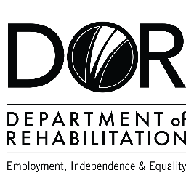
DEPARTMENT OF REHABILITATION
Danielle Hackworth, PSP Team Manager
Teresa Viramontes, PSP Counselor
Ricardo Perez, PSP Sector Business Consultant
Email: psp@dor.ca.gov
Pathways to Success Project (PSP) – Green Energy
- Are you interested in a high-wage, high-skilled occupation and/or career advancement within the Green Energy field?
- Do you want to find out if you are eligible to receive Vocational Rehabilitation Services by a team specializing in the Green Energy career pathway?
- Are you interested in joining an evaluation that examines outcomes to achieve meaningful work in strong careers?
- If you answered “YES” to these questions, you may qualify for DOR’s Pathways to Success Project.

The Pathways to Success Program may be able to assist you with:
- Training Services Cost
- Job Development and Placement
- Retention Support

Vocational Training Certificates in:
- HVAC
- Technology Electrical
- Engineer Arborist
- Technician
- Building Energy Consultant

Associate Degrees in:
- HVAC Technology
- Environmental
- Science Electrical Engineer
- Building & Energy Systems
- Professional

Bachelor’s Degree in:
- Mechanical Engineer
- Environmental Resources
- Management Environmental Sciences
- Industrial
- Technology

Master’s Degree in:
- Electrical Engineer
- Environmental Science
- Materials Science & Engineer

Have a question? Please email us at psp@dor.ca.gov
The contents of this document were developed under a grant number H421C210011 from the Department of Education. However, those contents do not necessarily represent the policy of the Department of Education, and you should not assume endorsement by the Federal Government. (Authority: 20 U.S.C. §§ 1221e-3 and 3474)

