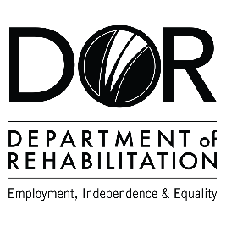
DEPARTMENT OF REHABILITATION
Danielle Hackworth, PSP Team Manager
Inez DeOcio, PSP Counselor
Stacie Gubler, PSP Sector Business Consultant
Email: psp@dor.ca.gov
Pathways to Success Program (PSP) – Construction and Transportation
- Are you interested in a high-wage, high-skilled occupation and/or career advancement within the construction or transportation field?
- Do you want to find out if you are eligible to receive Vocational Rehabilitation Services by a team specializing in construction and transportation career pathways?
- Are you interested in joining an evaluation that examines outcomes to achieve meaningful work in strong careers?
- If you answered “YES” to these questions, you may qualify for DOR’s Pathways to Success Project.
The Pathways to Success Program may be able to assist you with:
- Training Services Cost
- Job Development and Placement
- Retention Support

Vocational Training Certificate:
- Truck Operator
- HVAC
- Plumber
- Electrician
- Sheet Metal
- Painter
- Drafter
- Carpenter

Bachelor’s Degree:
- Logistician
- Construction Manager
- Architect
- Civil Engineer/Industrial Engineer

Master’s or Professional Degree:
- Urban &Regional Planner
- Operations Research Analyst

Have a question? Please email us at psp@dor.ca.gov
The contents of this document were developed under a grant number H421C210011 from the Department of Education. However, those contents do not necessarily represent the policy of the Department of Education, and you should not assume endorsement by the Federal Government. (Authority: 20 U.S.C. §§ 1221e-3 and 3474)

