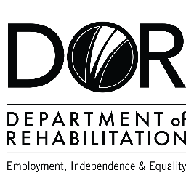
DEPARTMENT OF REHABILITATION
Danielle Hackworth, PSP Team Manager
Marlo Gaston, PSP Sector Counselor
Carla Martinez, PSP Sector Business Consultant
Email: psp@dor.ca.gov

Pathways to Success Project (PSP) – Biotechnology
- Are you interested in a high-wage, high-skilled occupation and/or career advancement within the biotechnology field?
- Do you want to find out if you are eligible to receive Vocational Rehabilitation Services by a team specializing in biotechnology career pathways?
- Are you interested in joining an evaluation that examines outcomes to achieve meaningful work in strong careers?
- If you answered “YES” to these questions, you may qualify for DOR’s Pathways to Success Program.

The Pathways to Success Program may be able to assist you with:
- Training Services Cost and Tuition Assistance
- Paid Internship and Work Experience Opportunities
- Job Placement and Retention Support

Vocational Training Certificates in:
- Biotechnology Laboratory Assistants
- Biotechnology Research Laboratory Assistants
Associate Degrees in:
- Chemical Technicians
- Agricultural and Food Technicians
- Biological Scientists

Bachelor’s Degrees in:
- Microbiologists
- Clinical Laboratory Technologists and Technicians
- Agricultural and Food Scientists
Master’s Degrees in:
- Biochemists
- Biophysicists
- Epidemiologists
To apply or for more information, please inquire at:
Email: PSP@dor.ca.gov
Phone: 661-799-1022

The contents of this document were developed under a grant number H421C210011 from the Department of Education. However, those contents do not necessarily represent the policy of the Department of Education, and you should not assume endorsement by the Federal Government. (Authority: 20 U.S.C. §§ 1221e-3 and 3474)

