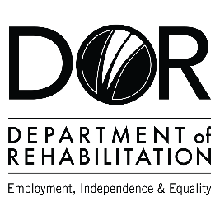
DEPARTMENT OF REHABILITATION
Danielle Hackworth, PSP Team Manager
Inez De Ocio, PSP Sector Counselor
Carla Martinez, PSP Sector Business Consultant
Email: psp@dor.ca.gov

Pathways to Success Project (PSP) – Advanced Manufacturing
- Are you interested in a high-wage, high-skilled occupation and/or career advancement within the advanced manufacturing field?
- Do you want to find out if you are eligible to receive Vocational Rehabilitation Services by a team specializing in the advanced manufacturing and engineering career pathway?
- Are you interested in joining an evaluation that examines outcomes to achieve meaningful work in strong careers?
- If you answered “YES” to these questions, you may qualify for DOR’s Pathways to Success Program.

The Pathways to Success Program may be able to assist you with:
- Training Services Cost and Tuition Assistance
- Paid Internship and Work Experience Opportunities
- Job Placement and Retention Support

Vocational Training Certificates:
- Welders
- Industrial Machinery Mechanics
- CNC Workers
Associate Degrees:
- Robotic Maintenance Technicians
- Industrial Engineering Technicians

Bachelor’s Degrees:
- Industrial Engineers
- Manufacturing Engineers
- Electronics Engineers
Master’s Degrees:
- Mechanical Engineers
- Purchasing Managers
- Safety Engineers
- Manufacturing Engineers

To apply or for more information, please inquire at:
Email: PSP@dor.ca.gov
Phone: (559) 735-3846
The contents of this document were developed under a grant number H421C210011 from the Department of Education. However, those contents do not necessarily represent the policy of the Department of Education, and you should not assume endorsement by the Federal Government. (Authority: 20 U.S.C. §§ 1221e-3 and 3474)

