The OCB campus is  located in Albany, CA, near  Berkeley, Oakland and  San Francisco.  - Our urban setting  offers easy access  to shops and public  transportation.  Our services are provided at no cost to our participants.  - OCB is operated by  the California State  Department of  Rehabilitation (DOR). See back cover for more information on signing up for services.  Visit OCB to learn how our program can benefit you.  - Please call OCB today  for more information or  to arrange a campus  tour: 510-559-1200. |  | Eligibility  An Individual may be eligible for services if the following two conditions are met:  - Has a visual impairment that makes it significantly difficult to be independent and to get or keep a job.  - Vocational rehabilitation services are needed to get, keep, or advance in a job.  To find a counselor near you, contact the Blind Field Services (BFS) section at 916-558-5480 or email Blind.Services@dor.ca.gov.  Blind Field Services maintains a core group of Counselors and Managers skilled in understanding the barriers people who are blind and visually impaired face in achieving meaningful employment and independence.  Contact us today!  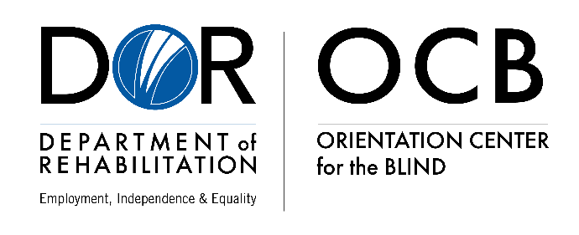 |  | 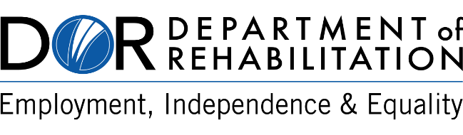  Orientation  Center  for the Blind  ___________________  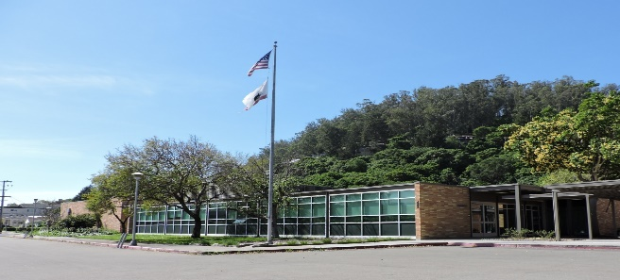  Established in current location in 1964  400 Adams Street  Albany, CA 94706  510-559-1200  www.dor.ca.gov/Home/OCB  ocbinfo@dor.ca.gov
Training & Assessment in:  Independent travel, including Orientation and Mobility  Braille (Unified English Braille)  Non-visual skills such as money handling and personal note taking methods  Computer and related technologies including iPhone  Daily living skills, including cooking and organization  Work-readiness training and preparation  Adjustment counseling |  | Facts:  Residential facilities for up to 20 participants while they receive immersion training services  The training is tailored to meet consumers’ individualized needs, and the average length of training is twelve weeks. Depending on the consumer’s progress, it may be determined to be appropriate to receive additional training.  There is no cost to participants, such as tuition, lodging, or meals  Non-residential training options for local DOR consumers  Comprehensive work-behavior and skills assessment services  Any Department of Rehabilitation consumer who is blind or severely visually impaired may be considered for participation  400 Adams Street  Albany, CA 94706  510-559-1200  www.dor.ca.gov/Home/OCB  ocbinfo@dor.ca.gov |  | Program Overview:  The California Department of Rehabilitation (DOR) established the Orientation Center for the Blind to assist individuals to adjust to vision disabilities by immersion in an environment that is respectful, knowledgeable, and empowering. Credentialed teachers, instructors, and qualified rehabilitation professionals provide a full range of classes and experiences individually tailored to assist each participant to reach their full potential for competitive integrated employment.

