California Department of Rehabilitation
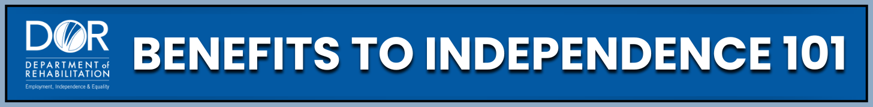YOUTH RECEIVING SOCIAL SECURITY DISABILITY BENEFITS
Learning how to work while receiving Supplemental Security Income (SSI) is a smart way to build your future. Whether you're exploring part-time work, a summer job, or gaining experience while in school, you can earn money, stay in school, and keep your benefits, all while moving toward greater independence and financial stability.
Programs and Support:
- SSI: A disability benefit administered by the Social Security Administration (SSA). SSI is a monthly benefit for people who have very low income and limited resources. Work Incentives can help you keep more of your SSI cash benefit.
- Student Earned Income Exclusion (SEIE): A special rule only for students under 22 who are regularly attending school that allows you to keep your full SSI check while you are working. You can earn up to a certain amount per month (with an annual limit) without lowering your monthly SSI payment. Learn more on the Social Security website or on the California Disability Benefits 101 (DB101) website.
- Plan to Achieve Self-Support (PASS): Helps you save money for goals like school or a car without losing SSI. For everything you need to know about a Plan to Achieve Self-Support, visit the Disability Benefits 101 website.
- Achieving a Better Life Experience (ABLE) Accounts: Special savings accounts for people with disabilities to allow you to save money without affecting your SSI eligibility or cash benefit. Learn more on the CalABLE website.
- Work Incentive Planning Assistance (WIPA) Projects: Free help from benefits counselors who understand Social Security rules. They guide you through SEIE, reporting income, and other work incentives. Find your local Work Incentive Planning Assistance project on the Ticket to Work website at www.ChooseWork.ssa.gov.
- California Department of Rehabilitation (DOR): Contact your local DOR office and ask to speak with a Work Incentive Planner (WIP) who can help you navigate these programs. You can also visit the Department Of Rehabilitation Social Security Programs and Disability Benefit Planning Services page for more information on how DOR can help and find additional resources.

Practical Steps:
- Apply for SEIE:
  - Gather your documents and put together your SEIE packet with proof of age, proof of school attendance (schedule, transcript, or letter), recent paystubs.
  - Submit your SEIE packet to Social Security in person if possible. If not, other options include mail or fax.
  - Make sure to follow up with Social Security if you do not hear back about your request. If it has been 2 weeks, call a Work Incentives Liaison (WIL) or a Claims Specialist at your local SSA office. If after 1 month you still have no response, ask to speak to a supervisor.
  - Need more help? Contact a benefits counselor at your local WIPA project or a WIP through a referral from your counselor at the Department of Rehabilitation.
- Report your wages to Social Security each month by the 6th. Choose the option that works best for you:
  - Online on the Social Security website at www.ssa.gov through your “mySSA account” portal
  - Using the SSA Mobile Wage Reporting phone app: Download from the Apple Store (for I-Phones) or Google Play Store (for Android phones)
  - By phone: Call the SSA national number at 800-772-1213 or by using the Automated telephone wage reporting line (available 24 hours a day, 7 days a week) at 866-772-0953.
  - Or by mail, fax, or in person: You can find your local Social Security Administration office by using the ‘Office Locator tool’ on the Social Security website.
Key Takeaways:
- You can work and still get SSI, especially if you're a student.
- SEIE helps you keep your full SSI check while gaining work experience.
- Apply for SEIE early and follow up with Social Security if needed.
- Use other tools like a PASS plan and open an ABLE account to help save for your future.
- Good communication with Social Security protects your benefits. Avoid overpayments by reporting your wages and any changes in income on time.
- Support is available so you do not have to do this alone.
Working while getting SSI is possible because work incentives like the SEIE help you keep your benefits while gaining experience. You are building skills, independence, and a stronger future. Want to learn more and stay motivated? Visit the Department Of Rehabilitation website to explore tools made just for you. Check out the 'Spotlight on Social Security' YouTube channel, where you will find videos on SSI and work, Work Incentive Planning (WIP) Services, student supports, and real stories from young people who have been where you are. These resources are here to guide your journey and help you take the next step forward with confidence.

