California Department of Rehabilitation
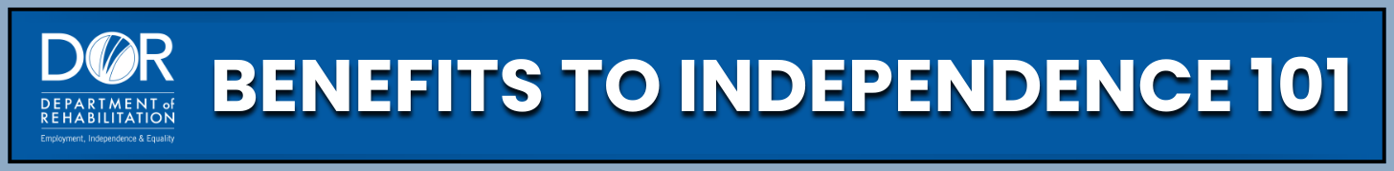
USING SUPPLEMENTAL SECURITY INCOME (SSI) WORK INCENTIVES
Work incentives are special rules that help people who receive SSI try working without losing their benefits right away. These rules make it easier to earn money while still having support. They are designed to help you move toward being more independent and building a better future. These resources explain how these rules work, how they affect SSI payments, and how working can help you earn more while reaching your goals.
Programs and Support:
- SSI Work Incentives: Supportive rules are designed to help you work, earn income, and maintain your SSI benefits for greater financial stability. Learn more about all the work incentives available on the Social Security Administration (SSA) website and in the Social Security Red Book.
- Income Exclusions: Social Security does not count all your income. They ignore the first $20 of most income and the first $65 you earn from work. After that, only half of what’s left is counted. This means you still end up with more money when you work.
- Student Earned Income Exclusion (SEIE): If you are under age 22 and regularly attend school or a training program, SSI lets you earn some money without it reducing your SSI cash benefit. You get to keep your full SSI while gaining work experience! You can find more information and see how the SEIE works by watching the short video on the Department of Rehabilitation (DOR) 'Spotlight on Social Security' YouTube channel.
- Impairment-Related Work Expenses (IRWEs): If you pay for items or services needed for work, the cost of these items is subtracted from income before SSI is calculated.
  - Examples: Accessible transportation, personal care, medical equipment, medications, adaptive technology. *Note: For a more comprehensive list of possible IRWEs, check out the Social Security Red Book.
- Blind Work Expenses (BWEs): If you meet Social Security’s definition of blindness, and if you pay for items or services needed for work, the cost of these items is subtracted from income before your monthly SSI benefit is calculated.
  - Examples: Taxes, uniforms, meals at work, animal service expenses, medical devices, supplies, and therapy.

Practical Steps:
- Report your wages to Social Security by the 6th of each month. This helps them apply the right work incentives and keep your benefits accurate.
- Save receipts for work-related expenses. If you pay for things like transportation, medical devices, or support services to help you work, keep those receipts. These may count as IRWEs or BWEs, which can lower the income Social Security counts.
- If you are a student under 22: request the SEIE to maximize your SSI cash benefit payment.
- Get help from a benefits expert. A Work Incentive Planner (WIP) from DOR or a benefits counselor from your local Work Incentive Planning and Assistance (WIPA) Project can help you understand which rules apply to you and how to use them. Visit the Department Of Rehabilitation website or the Ticket To Work website at ChooseWork.ssa.gov to find help near you.
Key Takeaways:
- SSI work incentives are designed to allow you to work and earn more without immediately losing benefits.
- Not all your income counts. With income exclusions, you will always come out ahead when you work.
- Different incentives apply to different situations, Work incentives like SEIE, IRWEs, and BWEs reduce the income Social Security counts.
- Using these incentives helps you keep a higher SSI payment and become more financially self-sufficient.
- Keeping records helps you get the most out of your benefits. Track your income, save receipts for work-related expenses, and report your earnings to Social Security by the 6th of each month.
- You don’t have to figure it out alone. Benefit counselors and WIPs can help you understand the rules and make the most of the work incentives.
- Starting work while receiving SSI can feel overwhelming. Want to learn more and stay inspired? The Department Of Rehabilitation website offers many valuable resources. One of the most powerful tools is our 'Spotlight on Social Security' YouTube channel. There you will find webinars and workshops featuring topics such as SSI and Work, Students with Disabilities, and Work Incentive Planning (WIP) Services. You can also explore inspiring consumer success stories from your peers. These resources are designed to guide your journey, help you thrive, and support your success.

