California Department of Rehabilitation
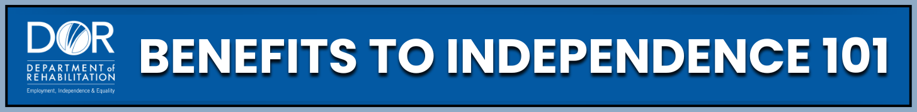
SUPPLEMENTAL SECURITY INCOME (SSI) INCOME & RESOURCES
Understanding how income and resources affect your SSI benefits is key to staying eligible and planning for independence. Social Security has rules about income and resources, but these rules are not meant to hold you back. They are designed to help you plan and move forward.
Programs and Support:
- Social Security Administration (SSA): The federal agency that manages the SSI program, including applications, eligibility rules, and benefit payments. Visit the Social Security Administration website to use the Office Locator tool and find your local office.
- California Department of Rehabilitation (DOR): Offers webinars and resources on SSI and work. Work Incentive Planners (WIPs) are available to update you on the latest income limits and thresholds, the current Federal Benefit Rate (FBR) and State Supplement Payment (SSP) amounts and can explain work incentives to help you plan for the future.
- Disability Benefits 101 (DB101) Website: Offers easy-to-understand information on SSI, work incentives, and benefits planning. For details specific to California, visit the California Disability Benefits 101 website.
Main points about SSI Income and Resources:
- SSI is a monthly benefit from the SSA for people with disabilities who have very low income and limited resources. For a full Supplemental Security Income Overview, go to the Social Security Administration website. There you can find more details about SSI Income & Resource Rules to help you remain eligible.
  - SSI Base Rate: Understanding how Social Security calculates your monthly SSI benefit payment is important. Since SSI is a “needs based” program, there are many rules to follow to maintain eligibility.
  - The FBR sets the base SSI payment nationwide. You can find the Current benefit rates on the Social Security website. Also, some states, like California, add an extra payment called the SSP. Social Security, a WIP, or another benefits counselor can provide you with the SSP amount.
  - SSI State’s Base Rate: FBR (+ SSP if applicable) – Countable Income = Monthly SSI benefit payment
- Income: Any money or help you get that you can use to pay for food or a place to live. SSI looks at Earned Income and Unearned income differently when calculating your “countable income". Your countable income is important in how Social Security calculates your monthly SSI payment.
  - Earned Income: wages, tips, or self-employment income
  - Unearned Income: Social Security disability benefits, unemployment payments, gifts (such as cash), in-kind contributions, and deemed income
- Work Incentives: Several work incentives can help you keep more of your benefits including the Student Earned Income Exclusion (SEIE), General Income Exclusions, Impairment-Related Work Expenses (IRWEs), Blind Work Expenses (BWEs), and PASS (Plan to Achieve Self Support) contributions. For details on what these incentives are and how they work, visit the Social Security website.
- Resource Limits & Exclusions: To stay eligible, you cannot go over $2,000 in countable resources ($3,000 for couples). But many things do not count, including the home you live in, one vehicle, household goods and certain personal items, term life insurance, and money in your ABLE accounts or PASS accounts. Learn more about ABLE Accounts on the ABLE National Resource Center website, or visit the CalABLE website for California’s ABLE account information and to open an account.
Practical Steps:
- Know Your Limits: Keep your income and savings below the SSI limits. Remember, you can use work incentives to exclude countable income (which may increase your SSI benefit payment) and protect your benefits.
- Report your Income Monthly: You must report all income to Social Security by the 6th of each month to keep your benefits accurate. Failing to report can lead to overpayments, which must be paid back. For more information, visit the Social Security website.
- Get Help: If you need help understanding the complexities of SSI Income and Resources, utilize WIP Services at DOR, browse the DB101 website for facts and tools, and check out ABLE accounts for savings options.
Key Takeaways:
- Understanding income and resources is key for SSI eligibility.
- Always report wages and changes in income on time.
- Stay under the $2,000 resource limit ($3,000 for couples).
- Use work incentives to keep more of your SSI benefits.
- Ask for help – free programs or tools and professionals are available.
Want to learn more? The Department Of Rehabilitation website offers many tools including the 'Spotlight on Social Security YouTube channel which features workshops and webinars on SSI, Work Incentives, and more. These resources offer clear insight into how income and resources affect your benefits and are here to help you grow, stay informed, and succeed.

