California Department of Rehabilitation
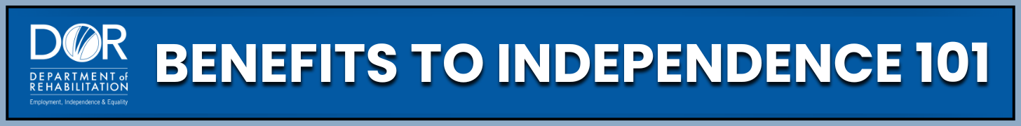
SUPPLEMENTAL SECURITY INCOME (SSI) ELIGIBILITY & APPEALS
SSI is a form of monthly financial support for people with disabilities who have very limited income and resources. These resources help to explain eligibility, reviews, and appeals so you can act with confidence in managing your benefits.
Programs and Support: These rules and processes are designed to help you understand how SSI works and how to respond if your disability benefits are reviewed.
SSI Eligibility:
- Who can receive SSI: You must have a disability, low income, and limited resources (under $2,000 for individuals, $3,000 for couples). Learn more about SSI Eligibility on the Social Security Administration (SSA) website.
- How much you can receive: The monthly Federal Benefit Rate (FBR) is the base SSI amount. Some states, like California, add a State Supplementary Payment (SSP). Your SSI may be reduced if you have other income. See current Payment Rates on the Social Security website.
- Disability rules: Adults must show they cannot work a regular job; children must demonstrate significant challenges supported by medical or school documentation. You can find details about Disability Criteria in the Social Security Administration Blue Book.
- Income and resources: Includes wages, benefits, child support, gifts, cash, savings, extra vehicles, or land. Some income exclusions apply. You can visit the Social Security website to review Income and Resources rules.
- For a complete overview of the SSI program, including who can get it, how much you should get, your reporting responsibilities, and other programs to get more help while on SSI, visit the Social Security website.
Reviews and Redeterminations:
- Medical Continuing Disability Reviews (CDRs): Reviews are conducted every 1–5 years, depending on disability type, to see if your health has improved. If you are still disabled, SSI continues. Visit the Social Security website to learn more about the Medical Continuing Disability Review Process.
- Age 18 Redeterminations: At age 18 your case is reviewed under adult rules. Parental income no longer counts. If you no longer qualify, you can appeal. See more information about the Age-18 Redetermination on the Social Security website or the Disability Benefits 101 website at ca.db101.org/.
Appeals Process:
- If SSI is reduced or stopped: You can appeal within 60 days. In many cases, benefits may continue during the appeal. Visit the Social Security website for an Appeals Overview.
- How to appeal: File online, by mail, or in person. Always keep copies of all documents and mailing proof. Use the Social Security Office Locator to find your local office.
Practical Steps:
- Learn your eligibility: Review SSI eligibility rules and income/resource limits.
- Respond to reviews: Reply quickly to SSA requests for medical updates or redeterminations.
- Appeal on time: File an appeal within 60 days if benefits are denied or stopped.
- Keep records: Save SSA letters, forms, and any evidence you provide.
- Get help: Use the Legal Aid Finder, Disability Rights Directory, or the Protection and Advocacy for Beneficiaries of Social Security (PABSS) Program for support.
Key Takeaways:
- SSI supports people with disabilities who have limited income and resources.
- Not all income and resources count toward eligibility. Know your limits for income and savings.
- Respond promptly to SSA letters and review notices.
- Always appeal if you disagree with a decision—you have rights.
- Free legal and advocacy programs are available to support you.
Remember: Navigating SSI doesn’t have to feel overwhelming. By knowing your rights, staying informed, and using the many resources available, you are building confidence and independence. Each step you take brings you closer to achieving your goals.
Want to learn more and stay inspired? The Department of Rehabilitation website offers many valuable resources. One of the most powerful tools is our 'Spotlight on Social Security YouTube Channel. There you will find webinars and workshops on topics, such as SSI and Work, Social Security Disability Insurance (SSDI) and Work, Students with Disabilities, and Work Incentive Planning (WIP) Services. You can also explore inspiring consumer success stories from your peers. These resources are designed to guide your journey, help you thrive, and support your success.

