California Department of Rehabilitation
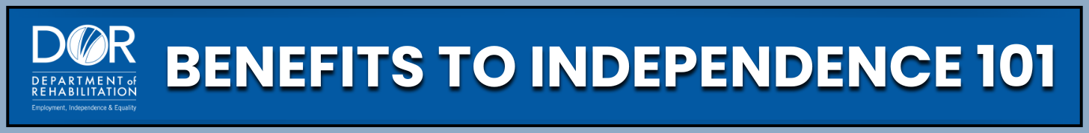
SOCIAL SECURITY DISABILITY INSURANCE (SSDI) ELIGIBILITY AND APPEALS
SSDI is a benefit you have earned through work. Understanding who qualifies, how to apply, and what to do if your benefits are denied or stopped can help you take control of your future. This information outlines the key steps and resources to help you navigate SSDI with confidence.
Programs and Support:
SSDI Eligibility:
- Social Security Administration (SSA): Processes SSDI applications, makes eligibility decisions, conducts medical reviews, and handles appeals. For a complete overview of the Social Security Disability Insurance program, visit the Social Security Administration website.
- Who can qualify for SSDI: An individual must be age 18 or older, have a medical condition expected to last at least 12 months or result in death (see the Social Security Blue Book for more on Disability Criteria), have earned enough work credits based on your age, and be unable to engage in Substantial Gainful Activity (SGA). Learn about Social Security Disability Insurance Eligibility and check current Substantial Gainful Activity levels on the Social Security website.
- Insured Status and Work Credits: SSDI is based on your work history. You must have insured status, which means: You worked and paid Social Security (FICA) taxes, and you earned up to 4 work credits per year (the number of credits needed depends on your age).
- Benefits for Disabled Family Members: Family members may qualify for benefits based on your SSDI record. For adults disabled before age 22 with a parent who is disabled, retired, or deceased, they may qualify for Childhood Disability Benefits (CDB). For surviving spouses aged 50–60, they can qualify for Disabled Widow(er)’s Benefits (DWB). Dependent Parents may also qualify if they relied on your income.
Medical Continuing Disability Reviews (CDRs):
- Medical CDRs: Reviews are conducted every 1–5 years, depending on disability type, to see if your condition has improved. If there is no medical improvement or you are still found to be disabled, SSDI continues. Learn more about the Continuing Disability Review Process on the Social Security website.
- If SSA finds that your condition has improved enough to work at the SGA level, your benefits may stop. Check for current Substantial Gainful Activity levels on the Social Security website, as they increase annually and differ for statutorily blind and non-blind individuals.
- Section 301 Protection may allow benefits to continue if you are participating in an approved vocational rehabilitation program.
Appeals Process:
- If your SSDI application is denied or your benefits are stopped, you have the right to appeal. File an appeal within 60 days of the decision, and if requested within 10 days, benefits may continue during the appeal process.
- How to appeal: File online, by mail, or in person. Always keep copies of all documents and mailing proof. You can use legal aid, advocacy groups, or private attorneys if you need additional assistance, resources, or support.
Practical Steps:
- Check your eligibility: Understand SGA limits and work credit requirements.
- Gather documents: Medical records, work history, education, and personal information.
- Apply for SSDI: Online on the Social Security website or in person by visiting your local Social Security office.
- Respond to SSA notices: Especially for CDRs or requests for information.
- Appeal on time: Don’t miss deadlines, send appeal forms to your local Social Security office by mail, or in person and make sure to keep copies.
- Seek support: Help and guidance are available through free or low-cost legal services and private attorneys who work on contingency. Find local help on the Legal Services Corporation website.
Key Takeaways:
- SSDI is insurance you earned by working and paying Social Security taxes.
- Eligibility requires: Age 18+, sufficient work credits, and a medical condition lasting 12+ months. Family members may also qualify for benefits based on your work record (spouses, children, some parents).
- SGA determines if your earnings are too high to qualify (levels change yearly).
- Medical CDRs happen periodically to check if your condition has improved.
- You have the right to appeal any Social Security decision and benefits can continue.
Navigating SSDI can feel complex, but you don’t have to do it alone. Want to continue learning? The California Department Of Rehabilitation website offers many resources, tools, Work Incentive Planning (WIP) services, including a 'Spotlight on Social Security' YouTube channel, all designed to guide your journey and support your independence.

