California Department of Rehabilitation
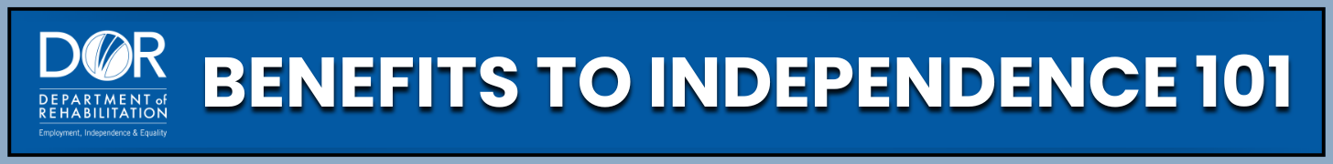
SOCIAL SECURITY DISABILITY BENEFIT OVERPAYMENTS
Receiving an overpayment notice can be stressful, but it is important to know that you have rights and options. The first step is to understand why the overpayment occurred. From there, you can access resources and support services to help you respond. Acting promptly allows you to maintain greater control over the situation.
Programs and Support:
- Social Security Administration (SSA): Process overpayments, notices, appeals, waivers, and payment plans. Visit the Social Security Administration website for more information or find your local office using the Social Security Office Locator tool. You can contact SSA by calling your local office or the National number at 1-800-772-1213.
- Work Incentive Planning and Assistance (WIPA) Projects: Offer free counseling to help you understand how overpayments affect your benefits and guide you through your options. Find Your local WIPA Project on the Ticket To Work Choose Work website. You can also find a WIPA Overview on the Social Security website.
- California Department of Rehabilitation (DOR): Provides Work Incentive Planning (WIP) services for guidance on handling benefits while working. Learn more about DOR WIP Services on the Department Of Rehabilitation website. View past webinars or register for upcoming webinars on the Webinar page.
- Legal Support Services: Offer free or low-cost legal help with appeals and overpayment issues. Disability Rights California (DRC) offers Legal Advocacy Services. You can use Pro Bono Legal Projects which offer free legal help from volunteer attorneys, Law School Clinics for either free or low-cost legal assistance, and other community organizations. Refer to the ADA Resources on the Office of Attorney General website to find local assistance.
Practical Steps:
- Understand why overpayments happen and how to prevent them.
- Do not ignore an overpayment notice. If you do not respond, SSA may begin collecting the full amount from your benefits. Read the notice carefully and note the date.
- You have 3 options for overpayments:
- Option #1: Appeal the Overpayment - If you believe there is no overpayment or the amount is incorrect. File Form SSA-561-U2 (Request for Reconsideration), provide evidence, submit the reconsideration within 60 days from the date on the notice.
- Option #2: Request a Waiver - If the overpayment was not your fault and paying it back would cause financial hardship. This can be an option if the overpayment amount is $2,000 or less, it would be unfair to collect the overpayment, you or a family member receives certain benefits (like SSI, SNAP, TANF), and you cannot afford to pay it back. If you meet these criteria, complete Form SSA-632-BK (Request for Waiver), explain why the overpayment was not your fault, provide proof of financial hardship, and submit the paperwork as soon as possible.
- Option #3: Request a Payment Plan - If you cannot appeal or get a waiver but need affordable monthly payments. Determine an affordable monthly amount, complete Form SSA-634 (Request for Change in Overpayment Recovery Rate), submit to Social Security in person, by fax, or online through ‘my Social SSA account’ on the Social Security Administration website.
- You may request an appointment to discuss your options. SSA may reduce, waive, or restructure overpayment.
- If your request for reconsideration is denied, you have the right to appeal the decision. Legal services, pro bono projects, and law school clinics can assist. A Work Incentive Planner (WIP) can help you understand your options if needed.
- Good record keeping is very important. Always keep all letters or notices from SSA, copies of all forms you submit, proof of filing (if used), pay stubs and wage reports, and notes from phone calls (date, time, who you spoke with, what was discussed).
Key Takeaways:
- Overpayments occur when SSA pays more than you were eligible to receive. Common causes include wage reporting delays, SSA errors, or unreported changes.
- You can manage overpayments by appealing, requesting a waiver, or setting up a payment plan.
- Do not ignore an overpayment notice. You have 60 days to file an appeal.
- The overpayment may not be your fault. Even if you followed the rules, delays or errors can still result in overpayments.
- Keep detailed records. Documentation is essential if questions arise.
- Support is available through SSA, WIPs, and legal services.
Facing an overpayment can feel overwhelming, but you are not alone. You have the right to seek support and protect your benefits. To learn more, visit the California Department of Rehabilitation website. The DOR Spotlight on Social Security YouTube channel offers videos on SSI, overpayments, and work incentives. These tools are designed to support your journey toward independence and help you understand your rights and options.

