California Department of Rehabilitation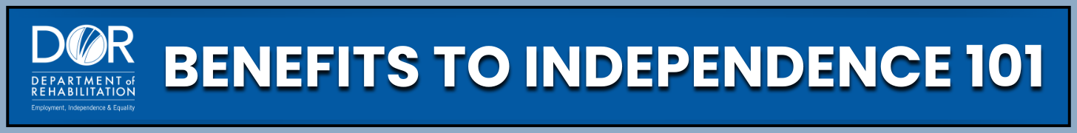
MEDICAID BUY-IN PROGRAMS FOR
SOCIAL SECURITY DISABILITY BENEFICIARIES
There are programs and supports that allow people with disabilities to maintain health coverage while working, which is especially important if you receive disability benefits. Programs like the Medicaid Buy-In program, called the Working Disabled Program (WDP) in California, can provide great support for you.
Programs and Support:
- Medi-Cal: Medicaid health coverage in California. You are automatically enrolled for this health insurance program when you receive Supplemental Security Income (SSI). It offers free or low-cost health coverage to people who qualify. Medi-Cal pays for doctor visits, dental care, eye check-ups, and more. It also covers services that keep you healthy. Learn more on the Department of Health Care Services (DHCS) website.
- WDP California’s Medicaid Buy-In program. It allows individuals with disabilities to work, earn income, and keep Medi-Cal benefits. The program includes specific income, asset, and premium guidelines. Visit the Department of Health Care Services website for up-to-date details.
- Medicaid Buy-In Programs by State: Each state operates its own Medicaid Buy-In program for workers with disabilities, with unique income and resource rules. You can find your state’s program details and eligibility guidelines on your state Medicaid agency website.
- Work Incentive Planning and Assistance (WIPA) Projects: Offer free help for people receiving disability benefits who want to work. Benefits counselors can explain how working affects your benefits. Use the Find Help tool on the Ticket to Work website to locate your local Work Incentive Planning Assistance project.
Practical Steps:
- Review the WDP (or your state’s Medicaid Buy-In) website to confirm current eligibility rules, income, and asset limits.
- Meet with a Work Incentive Planner (WIP), or WIPA project benefits counselor to discuss how working may affect your Medicaid or Medi-Cal coverage.
- Ask about spousal income and resource calculations in your state, since rules can differ.
- Track your earnings and report income changes promptly to both the Social Security Administration (SSA) and Medicaid to avoid benefit interruptions.
- Keep records of premiums or payments made through your state’s Buy-In program.
- Stay informed about updates to Medicaid Buy-In laws through your state Medicaid agency or the SSA website.
Key Takeaways:
- You can work and keep your healthcare benefits in many cases. Programs like California’s WDP are here to help.
- Medicaid Buy-In programs help workers with disabilities earn income while keeping health coverage.
- Each state has a Medicaid Buy-In program, such as California’s WDP.
- Eligibility is based on disability status, income, and resource limits, which vary by state.
- Dual eligibility (Medicare and Medi-Cal) gives you more coverage and savings.
- Always verify current rules with your state Medicaid office or a WIP.
- Support is available. Use resources like the CA Department of Rehabilitation (DOR), SSA, WIPA projects, and the Disability Benefits 101 (DB101) website for information and guidance.
You’re not alone, there are people and tools ready to help you succeed. Understanding your benefits and building a stronger future. You now have the knowledge to make smart choices about work, health coverage, and independence.
Want to learn more and stay inspired? The California Department of Rehabilitation website offers many valuable resources. One of the most powerful tools is our 'Spotlight on Social Security' YouTube channel. There, you will find webinars on topics such as SSI and Work, Social Security Disability Insurance (SSDI) and Work, and Work Incentive Planning (WIP) Services. You can also watch inspiring success stories from people who have navigated the complexities of working while on disability benefits.

