California Department of Rehabilitation
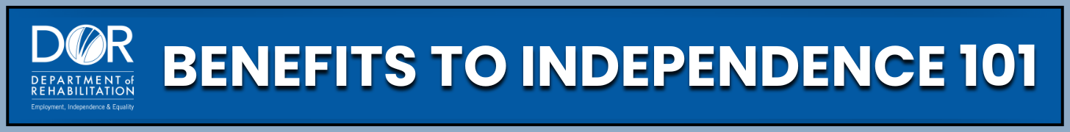
BUILDING FINANCIAL INDEPENDENCE: INCOME AND RESOURCE EXCLUSIONS FOR SUPPLEMENTAL SECURITY INCOME (SSI) BENEFICIARIES
Building financial independence while keeping your SSI benefits is possible. You can work, save, and plan for your goals without affecting your SSI eligibility. With the right strategies and support, financial independence is within reach, allowing you to move confidently toward greater stability and success.
Programs and Support:
- SSI: A monthly benefit administered by the Social Security Administration (SSA) for people with disabilities who have very low income and limited resources. For a full SSI Overview, go to the Social Security Administration website. There you can find more details about SSI Income & Resource Rules to help you remain eligible. There are income and resource exclusions to help you work and save toward your goals. These exclusions include a Plan to Achieve Self-Support (PASS), Achieving a Better Life Experience (ABLE) Accounts, Section 529 College Savings accounts, and Special Needs Trusts.
- PASS: A program that allows you to save money for a job or career goal without it counting against your SSI cash benefit or resource limit. You can save for things like school, training, or starting a business while keeping your benefits. All you need is a written plan with your goal, steps to reach it, a savings plan, and a timeline. Learn more about Cornell University’s PASS Online website. You can also visit the Social Security website to get specific contact information for PASS "cadres" of SSA employees who are experts in handling PASS applications, and find the PASS Application Form (SSA‑545).
- Achieving a Better Life Experience (ABLE) Account: A savings account for people with disabilities to pay for things like housing, school, transportation, or anything else that contributes to you having a better life experience. You can save up to $100,000 without affecting your SSI or local state benefits. You could qualify for an account if your disability began before age 46. Learn more about ABLE accounts at the ABLE National Resource Center website or for information on California’s ABLE Program, visit the CalABLE website.
- Section 529 College Savings Plans: A savings plan for education expenses that can complement an ABLE account. These tax-advantaged plans can help you save for college without affecting your SSI (in some cases). Learn more about Saving for College with 529 Plans on the College Savings Plans Network website.
- Special Needs Trusts: A legal way to hold money for someone with a disability without affecting their SSI. Special Needs Trusts can help you manage money for long-term needs. Funds in the trust are used to enhance quality of life while maintaining benefit eligibility. Learn more about Special Needs Trusts on the Disability Benefits 101 (DB101) website. You can also visit the ABLE National Resource Center (ABLE NCR) website to watch a YouTube video about ABLE Accounts and Special Needs Trusts.
Practical Steps:
- Create a PASS Plan - Think about your job or career goal and write a plan with steps, savings, and a timeline. Submit it to Social Security for approval and start saving.
- Open an ABLE Account - Visit CalABLE to learn more, watch recorded webinars, and open an account. Ready? Start saving for a better life experience! Just make sure to keep track of your spending by having all your receipts organized.
- Explore Other Tools - Look into 529 Plans if you’re saving for school or talk to a benefits counselor about Special Needs Trusts.
- Do an annual review - Rules and income limits change, so review your plan each year with a Work Incentive Planner (WIP) or an SSA representative.
Key Takeaways:
- You can save money and keep your SSI.
- SSI exclusions like PASS and ABLE accounts allow you to save for work, education, and independence without losing SSI. They are great tools to help you reach your goals.
- These programs support your independence and future planning.
- Always confirm details with SSA, a WIP, or an attorney familiar with disability benefits before making major decisions.
- Talk to a WIP or your local Department of Rehabilitation (DOR) office to get additional help.
You can use SSI exclusions to build a better future. Whether you want to work, go to school, or save for something important, tools like PASS and ABLE Accounts can help you get there, without losing your benefits.
Want to learn more and stay inspired? The Department Of Rehabilitation website offers many valuable resources. One of the most powerful tools is our Spotlight on Social Security YouTube channel. There you’ll find webinars and workshops on topics like SSI and Work, Students with Disabilities, and Work Incentive Planning (WIP) Services. You can also explore inspiring success stories from your peers. With the right information and support, you can build a future that works for you.

