California Department of Rehabilitation
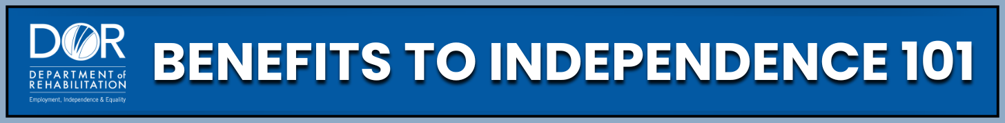
EXPEDITED REINSTATEMENT (EXR) OF
SOCIAL SECURITY DISABILITY INSURANCE (SSDI) BENEFITS
The most powerful safety net for SSDI recipients is called EXR If you have worked and your SSDI benefits stopped, but you need to get your benefits back because you can no longer work, EXR can help you get them back fast, without starting over. Understanding the information, steps, supports, and tools available to use EXR if you ever need it will allow you to focus on what is most important: you.
Programs and Support:
- Social Security Administration (SSA): Runs and oversees the SSDI program. Processes EXR requests, determines eligibility, provides provisional payments, and reinstates SSDI benefits. Visit the Social Security Administration website for more information or find your local office using the Social Security Administration Office Locator tool.
- California Department of Rehabilitation (DOR): Provides Work Incentive Planning (WIP) Services for individuals with disabilities who receive SSDI and want to understand how working affects benefits. A WIP can help explain EXR and the process for request. Visit the Department Of Rehabilitation website to learn more about Work Incentive Planning Services.
- Work Incentive Planning and Assistance (WIPA) Projects: Provide free counseling on EXR eligibility, help with requests, and support during the reinstatement process. Find your local WIPA by visiting the Ticket To Work website at www.Choosework.ssa.gov and using the Work Incentive Planning and Assistance Project Locator Tool. For a Work Incentive Planning and Assistance Project overview, you can also visit the Social Security website.
- Disability Benefits 101 (DB101) Website: Provides plain-language information explaining how Expedited Reinstatement works and when it applies, along with information about SSDI and associated work incentives. Visit the Disability Benefits 101 website for California specific information.
Practical Steps:
- Make sure your SSDI ended due to work and that your current earnings are below the Substantial Gainful Activity (SGA) level to confirm eligibility.
- Contact your local SSA office or call 1-800-772-1213 to request EXR.
- Make sure you have your documents like pay stubs and medical records ready.
- Ask about provisional benefits. If you qualify, temporary SSDI payments may begin right away while SSA reviews your EXR application.
- Keep track of your Initial Reinstatement Period (IRP). Once approved for EXR, you will receive SSDI for months you earn below the SGA level until you reach 24 months of payments.
- Check for retroactive payments. You may be eligible for up to 12 months of back payments if you qualified earlier but applied later.
Key Takeaways:
- EXR helps you restart SSDI without reapplying.
- You must meet earnings and disability rules to qualify.
- You must apply within five years of when your SSDI ends.
- You must have the same or a related disability that limits your ability to work above SGA.
- Provisional payments can begin quickly and last up to 6 months.
- The IRP gives you SSDI payments for low-earning months, up to 24 total.
- You may be eligible for retroactive payments of up to 12 months.
- Support is available through SSA, DOR, WIPA projects, and the DB101 website.
You don’t have to figure out benefits alone. There are programs and experts available to guide you, answer questions, and help you feel confident and in control of your benefit journey. Now you know how EXR can help you get back on SSDI quickly if your benefits stopped due to work. This safety net is here to support your journey toward independence and financial stability.
One of the best ways to learn more about EXR and how to use it is by exploring the resources on the California Department Of Rehabilitation website. There, you’ll find helpful tools like the 'Spotlight on Social Security' YouTube channel, which features webinars and real-life success stories. These resources are designed to help you understand your options, take action with confidence, and stay informed every step of the way.

