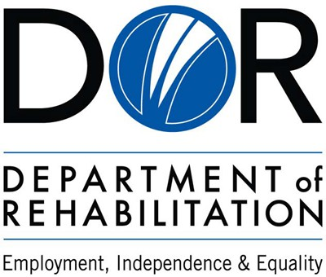

Fraud, Waste and Abuse Training for Department of Rehabilitation (DOR) Service Providers

Fraud, Waste, and Abuse (FWA)Training Who Must Participate?
- Community Rehabilitation Programs (CRPs) and Individual Service Provider (ISPs) based programs certified to provide vocational rehabilitation services to DOR consumers through a fee-for-service arrangement.
- Cooperative program (COOP) partners (state and local education agencies and local mental health agencies) who provide vocational rehabilitation services pursuant to the terms of a third-party cooperative agreement.
- Independent Living Centers (ILCs) who provide services to individuals with disabilities pursuant to the terms of the standard grant provisions.
- Older Individuals who are Blind (OIB) partner organizations providing services to visually impaired individuals, age 55 and older.
- Traumatic Brain Injury (TBI) partner organizations providing core services to DOR consumers with traumatic brain injuries, including community reintegration, supported living, vocational support, and information and referral, to promote independent living.

Fraud, Waste, and Abuse Training When Should it be Completed?
  - Community Rehabilitation Programs and Individual Service Providers must complete training at the time of application submission to become a vendorized service provider and annually thereafter.
  - Cooperative Program Partners must complete the training no later than 30 days after contract award (effective date) and annually thereafter.
  - Independent Living Centers must complete the training no later than 30 days of funding award (contract/grant effective date) and annually thereafter.
  - Older Individuals who are Blind service providers must complete the training no later than 30 days upon the subgrant award (effective date) and annually thereafter.
  - Traumatic Brain Injury providers must complete the training no later than 30 days upon contract award and annually thereafter.

By the end of this training participants will be able to:
- Understand why FWA matters
- Define FWA
- Recognize FWA Risks within DOR and its provider network
- Identify Red Flags in operations, billing and service delivery
- Understand reporting responsibilities and channels
- Apply best practices to prevent, detect and mitigate FWA

Why Are We Speaking About FWA?
  - Understanding FWA is critical to protecting program integrity and maintaining the public’s trust in government services
  - Preventing and detecting FWA is essential to protect financial resources from being used ineffectively and inappropriately
  - FWA prevention supports responsible use of public resources, and maintains the public’s trust in government services
  - Strong FWA prevention and detection practices improve accountability and compliance
  - FWA jeopardizes the success of individuals with disabilities achieving employment and independence.

These next few slides will define fraud, discuss the types of fraud and provide you with examples…

DEFINITION OF FRAUD

Fraud is any intentional act or omission by a service provider to deceive, misrepresent, or falsify information for personal gain or to obtain services, payments, or benefits that the provider is not entitled to.

Fraud includes knowingly submitting false documentation billing for services not provided, misrepresenting program information, or intentionally violating DOR requirements to secure an unauthorized advantage.
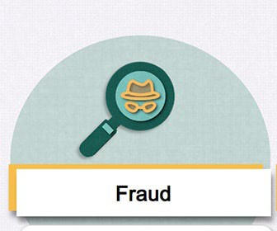

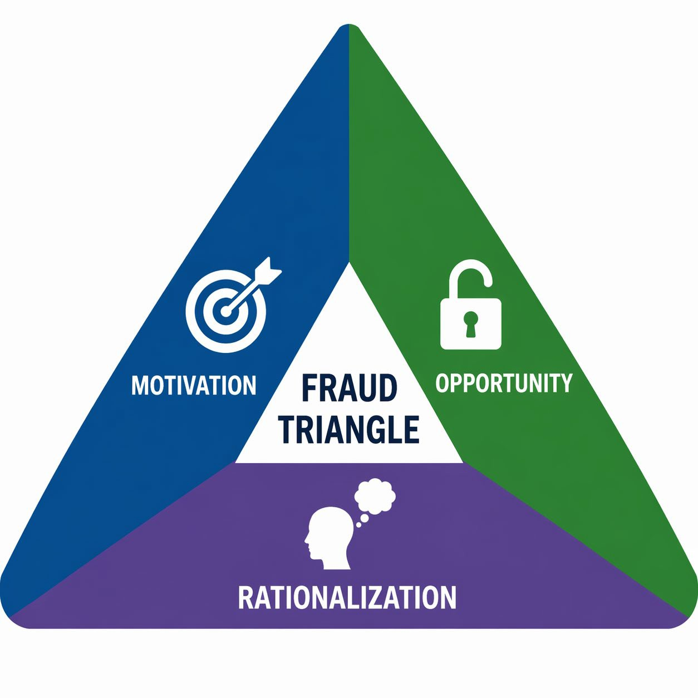
Motivation
- Debt/Greed
- Vices, addictions
- Lifestyle needs

Opportunity
- Weak or few controls
- Minimal or no oversight
- Lax rules

Rationalization
  - Everyone else is doing it
  - I intended to pay it back
  - I don’t get paid enough and deserve it


Fraud Red Flags

- No separation of duties
- Lack of internal controls
- Ignoring existing internal controls
- High turnover of personnel
- Altered or unexplained entries in records
- Inadequate or missing documentation
- Unauthorized transactions
- Transactions and financial records not reconciled


Why Red Flags Matter

Recognizing red flags is essential for:

- Protecting program integrity

- Safeguarding public funds

- Maintaining trust in government

- Supporting compliance and accountability

- Avoiding financial or legal penalties

There are two types of Fraud in service provider settings:

Financial Fraud
Financial fraud involves money, payments, billing or financial gain where someone or some entity is intentionally trying to obtain funds they are not entitled to.

Non-Financial Fraud
Non-financial fraud involves deceptive, misrepresentation, or improper actions that do not directly involve money but still violate laws, policies or contract terms.

Examples of Financial Fraud
  - Inflating service hours, units, or staffing levels on invoices
  - Billing DOR for goods or services that were never delivered
  - Misrepresenting the type, scope, or cost of services provided
  - Charging unrelated expenses to cover budget shortfalls
  - Altering or backdating documentation or falsifying financial statements to support grant/contract reimbursement claims
  - Misusing contract or grant funds intended for client services

•

Examples of Non-Financial Fraud

- Misrepresenting staff credentials, qualifications, or required certifications

- Manipulating or falsifying performance data to meet contract benchmarks

- Altering, tampering with, or creating false documentation to support service delivery

- Providing services outside of the scope of the agreement without approval

DEFINITION OF WASTE

Waste refers to the inefficient or careless use of resources such as funds, materials, time, or personnel that results in unnecessary costs or loss of value to the organization.

Waste involves the taxpayers not receiving expected services or goods in connection with any government funded activities. Waste arises from mismanagement, inappropriate actions and inadequate oversight.
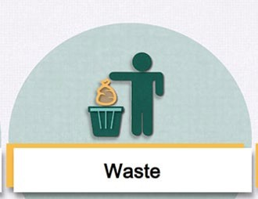

Waste Red Flags

- High or unusual volume of billed services
Providers or programs showing unnecessarily high service levels compared to peers, with no justified reason
- Sudden spikes in end of billing period
Excessive claims for operating expenses submitted right before deadlines, indicating inefficient billing practices
- Excessive meetings and redundant processes
Frequent administrative meetings that take time away from direct consumer services.
- Invoices showing identical or recurring total
Indicates poor invoice review and needless expenses

Examples of Waste
- Providing services that the consumer does not need, already received, or is covered by another program

- Skipping steps in procurement, contracting, or service delivery that leads to delays or additional corrective actions

- Ordering more materials than needed, or discarding unused items due to poor inventory management

- Paying and maintaining facilities that are unused

- Excessive meetings, redundant approvals, or processes that significantly slow down service delivery without adding value

DEFINITION OF ABUSE
Abuse involves behavior that is deficient or improper when compared with behavior that a prudent person would consider a reasonable and necessary business practice given the facts and circumstances. Abuse may include misuse of authority or position for personal gain or extravagant or excessive use to abuse one’s position or authority. Abuse can occur in financial or non-financial settings.
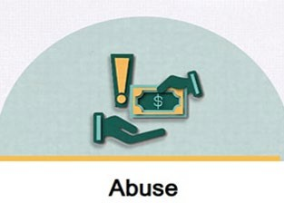

Abuse Red Flags

  - Excessive overtime approvals
Approving overtime beyond reasonable need
  - Bypassing competitive bidding
Use of sole-source or other non-competitive vendor selection methods
  - Reluctance to share information
Staff or vendors who delay or avoid providing required documentation or who resist oversight activities
  - Extravagant and high-end spending
Selecting luxury products and paying significantly more for items unnecessarily
  - Excessive employee compensation
Providing salaries that are substantially above typical market rates for comparable positions

Examples of Abuse
    - Receiving favors for awarding contracts to certain vendors

    - Using one’s position to gain a financial advantage that is not available to others

    - Misusing the official’s position for personal or family gain

    - Making vendor selections that are contrary to existing policies or are unnecessarily extravagant or expensive

These next few slides will be a few knowledge checks to test what you have learned…


Knowledge Check #1

Question: Which of the following best describes fraud in the context of DOR vendor services?

Choose the best answer:

- Accidental mistakes in billing

- Intentional deception for unjustified financial gain

- Providing services more efficiently

- Using outdated service documentation

Answer to Knowledge Check #1

Correct Answer: B. Explanation:
Fraud requires intent. It involves knowingly providing false information, misrepresenting services, or attempting to receive payment for goods or services not provided.


Knowledge Check #2

Question: Which situation is a red flag for potential waste? Choose the best answer:
- Providing services based on the individualized plan of services
- Purchasing only necessary goods for consumer services
- Offering duplicative services that do not improve consumer outcomes
- Submitting documentation on time

Answer to Knowledge Check #2

Correct Answer: C.
Explanation:
Waste occurs when resources are used inefficiently or unnecessarily. Duplicative services waste time, funds, and effort without creating additional value for the consumer.


Knowledge Check #3

Question: Which of the following is a common sign of abuse related to vendor billing?
Choose the best answer:
- Billing for services that were provided
- Undercharging for services
- Submitting corrected invoices after an error
- Repeatedly billing for the highest service level without justification

Answer to Knowledge Check #3

Correct Answer: D.
Explanation:
Abuse includes practices that result in excessive or unnecessary costs.

Why is the Prevention and Detection of Fraud/Waste/Abuse Important?
Vendors are entrusted with administering and overseeing provisions of goods and services for consumers and must do so with integrity and strict adherence to all applicable policies, laws and regulations.

By upholding these standards, we ensure resources are used efficiently and support positive outcomes for those we serve.
Remaining vigilant for potential “Red Flags” in our daily work is critical to protecting public funds and sustaining trust in our programs.

PREVENTION OF FRAUD, WASTE, AND ABUSE
Follow all DOR authorizations and service requirements:
Deliver only the services approved by DOR, never deliver services to a consumer before receiving an authorization, and maintain documents that adequately support the services provided.

Maintain compliance with all state and federal requirements:
Keep licenses, registrations, and accreditations current. Adhere to all contract terms and regulatory obligations.

Implement strong internal oversight and monitoring:
Conduct regular internal audits, verify documentation, and ensure all staff understand proper service delivery and reporting expectations.
Ensure strict consumer privacy protections:
Safeguard personal information (e.g., SSNs, birthdates, medical data, driver’s license numbers). Report any security breaches promptly through appropriate channels.

PREVENTON OF FRAUD, WASTE, AND ABUSE
Train employees on fraud prevention and ethics:
Provide ongoing training on ethical standards, program integrity measures, and appropriate billing practices to only bill for actual goods/services provided.

Maintain professional and informative interactions:
Foster transparent communication and interactions with consumers and DOR staff to reduce risk of misconduct.

Respond quickly to complaints or irregularities:
Investigate concerns immediately, suspend questionable practices, and resolve issues as quickly as possible.

Do not obstruct DOR oversight or investigations:
Fully cooperate with DOR inquiries and avoid actions that delay or hinder audits or compliance reviews.

DETECTION OF FRAUD, WASTE, AND ABUSE

Internal Monitoring & Automated Detection:
Leverage continuous monitoring tools and analytics to identify anomalies—such as duplicate claims, unusual codes, irregular billing patterns, or sudden spikes in service volume.

Periodic Internal Audits and Reviews:
Conduct both scheduled and random audits and/or reviews of case services delivery documentation, accounting records, employee payroll, and billing practices.

Strong Internal Controls:
Ensure separation of duties, maintain up-to-date policies and procedures, train staff, conduct routine reconciliations, analyze service and financial information for anomalies, and investigate deviations from normal patterns.

Anonymous Reporting Systems:
Provide confidential avenues for reporting suspected fraud, waste, or abuse, and ensure reports are promptly investigated.

These next few slides will be the remaining two knowledge checks to test what you have learned…

Knowledge Check #4

Question: Which practice helps prevent fraud, waste, and abuse? Choose the best answer:
- Submitting invoices without supporting documentation

- Avoiding internal audits to reduce administrative burden

- Allowing staff to use their own documentation templates freely

- Maintaining clear, accurate, and timely service records

Answer to Knowledge Check #4

Correct Answer: D.
Explanation:
Proper documentation is one of the strongest defenses or practices against fraud, waste, and abuse. Accurate records ensure transparency, compliance, and verification of services.

Knowledge Check #5

Question: Which practice helps detect fraud, waste, and abuse? Choose the best answer:
- Routinely reviewing documentation and verifying service delivery
- Assuming all payments are correct if the total seems reasonable
- Allowing a single individual to both authorize and pay invoices
- Submitting minimal documentation and “filling in” details later

Answer to Knowledge Check #5

Correct Answer: A.
Explanation:
Regular, consistent review of records makes it easier to identify errors inconsistencies, or unusual patterns that may indicate or detect fraud, waste, or abuse.

What Should a DOR Vendor Do when Fraud, Waste, or Abuse is suspected

  - Immediately document any questionable activity
  - Secure relevant records and evidence
  - Interview staff suspected of FWA as well as their supervisor and any other relevant parties to gather information about the circumstances that surround the FWA
  - Assess the duration of the FWA and the potential monetary impact
  - Implement immediate corrective actions to prevent future occurrence

What Happens Once Fraud, Waste, or Abuse is Discovered?
Disputed Invoices:
Invoices that are intentionally inaccurate, unsupported, or unauthorized, will be disputed by DOR. Payment will be withheld pending verification

Requested Reimbursement of Overpayments:
When DOR determines that a vendor received more funds than warranted such as billing for unprovided or unnecessary services, the vendor is required to reimburse the overpayment

Suspension of Services:
DOR may suspend a vendor’s authorization or certification, effectively halting their ability to provide services and receive reimbursement

Termination of CRP Certification:
Serious or repeated FWA violations can lead to termination of a CRP’s certification and vendorization/ contract or grant

Who to contact when reporting FWA related to the use of DOR funding in the provision of goods and services

Report the suspected FWA to your local DOR district management team

Report the suspected FWA to DOR Audits Services at Audit.Info@dor.ca.gov

Now that you have completed the FWA training, you should be able to:

- Understand risks. Understand the specific fraud, waste, and abuse exposures within your duties and daily workflows

- Promote awareness. Communicate red flags and best practices to colleagues. Increased awareness strengthens prevention and early detection

- Question the unusual. Question, verify, and follow up on activities, documents, or situations that appear inconsistent or outside normal procedures

- Implement controls. Implement strong controls to protect records, funds, and resources



Thank you for participating in today’s FWA training!

Your commitment to understanding these requirements helps protect program integrity, safeguard public resources, and ensure quality services for the
individuals we serve.

Requirements for Maintaining Your Certificate of Completion

- Please ensure you retain your Certificate of Completion as official evidence that you have successfully finished the FWA training

- Participants must keep a copy of the certificate on file for no less than three (3) years from the date of completion

- Certifications must be made available upon DOR request during audits, monitoring activities, or site reviews and serves as verification of compliance with DOR training requirements

Fraud, Waste and Abuse Certificate of Completion

This certificate is hereby granted to:

Employee Name:

Employee Job Title:

Date of Completion:

This certifies that the above individual has successfully completed the training and demonstrates an understanding of Fraud, Waste and Abuse risks, as well as prevention strategies and detection techniques.

