STATE OF CALIFORNIA
DEPARTMENT OF REHABILITATION

INDEPENDENT LIVING AND ASSISTIVE TECHNOLOGY SECTION

TRAUMATIC BRAIN INJURY PROGRAM

REQUEST FOR APPLICATIONS
RFA IL-24-06-01

INDEPENDENT LIVING AND ASSISTIVE TECHNOLOGY SECTION
TRAUMATIC BRAIN INJURY PROGRAM
REQUEST FOR APPLICATIONS (RFA) IL-24-06-01
TABLE OF CONTENTS

1. AUTHORITY 5
2. BACKGROUND 5
3. KEY ACTION DATES 6
A. Submitting Questions 6
B. Bidder’s Conference 6
C. Application Package Due 7
D. Application Evaluation 7
E. Notice of Intent to Award 7
4. PURPOSE AND OVERVIEW OF THIS RFA 8
5. ELIGIBILITY TO APPLY 8
6. DESCRIPTIONS OF SERVICES AND OBLIGATIONS 9
7. SUBMITTAL OF APPLICATIONS 12
A. Accessibility 12
B. Submission Information 13
I. Option 1: Applications may be submitted electronically by email 13
II. Option 2: Mailed Submissions 13
8. APPLICATION REQUIREMENTS 14
A. General Requirements 15
B. Organization of Application and Required Documents 15
9. REVIEW PROCESS AND CRITERIA 17
A. Disposition of Applications 17
B. Administrative Review 17
C. Evaluation 18
D. Notice of Intent to Award 19
E. Applicant Appeals 19
F. Execution and Performance 21
10. ADDITIONAL PROVISIONS 21
A. Insurance 21
I. Proof of Insurance 21
II. Duration of Coverage 22
III. DOR’s Right of Enforcement 22
IV. Acceptable Insurers 22
V. Endorsement and Waiver of Subrogation 22
VI. Enforcement of Agreement Provisions (non-estoppel) 23
VII. Requirements Not Limiting 23
VIII. Coverage Requirements 23
IX. Notice of Cancellation 24
X. Additional Insured Status 24
XI. Self-Insured Retentions 24
XII. Timely Notice of Claims 24
XIII. Subcontractors 24
B. Debarment, suspension, and Non-procurement 24
C. Prohibition on Tax Delinquency 25
11. PROGRAM NARRATIVE 25
A. Section 1: Organizational Information (15 Points) 25
I. Organizational Experience (5 Points) 26
II. Organizational Resources (10 Points) 26
B. Section 2: Summary of Program Activities, Work Plan and Timeline, Planned Program Outcomes, and Evaluation (65 Points) 26
I. Summary of Program Activities (10 Points) 26
II. Work Plan and Timeline (25 Points) 27
III. Planned Program Outcomes (20 Points) 27
IV. Evaluation Measures (10 Points) 28
C. Section 3: Budget and Staffing Plan (20 Points) 28
I. Proposed Budget and Budget Narrative (15 Points) 29
II. Proposed Staffing Plan (5 Points) 29
ATTACHMENT 1: Required Document Checklist 30
ATTACHMENT 2: Cover Sheet and Assurances 32
ATTACHMENT 3: Sample of Secretary of State Organization’s Annual Corporate Report 35
ATTACHMENT 4: Sample Entity Status Letter from CA Franchise Tax Board 36
ATTACHMENT 5: Sample Non-Profit Status Letter from the IRS 37
ATTACHMENT 6: Sample of Proof of Insurance Coverage 38
ATTACHMENT 7: Evaluation and Scoring 39
ATTACHMENT 8: Sample of Budget Narrative 54
ATTACHMENT 9: TBI Service Budget Spreadsheet 56

AUTHORITY
Under the authority of the California Welfare and Institutions Code (WIC) section 4357.1, the California Department of Rehabilitation (DOR) is issuing this Request for Applications (RFA) for the award of the Traumatic Brain Injury (TBI) Program for services detailed in this RFA.
The grants resulting from this RFA are statutorily authorized and shall be interpreted in accordance with the laws and regulations of the State of California.

BACKGROUND
TBI is caused by a sudden jolt, blow, or penetrating injury to the head that disrupts the typical function of the brain. Falls and motor vehicle crashes are the primary causes of injuries, with sports, recreational, work-related, and war-related injuries also being contributing factors. A TBI can happen to anyone, at any age, at any time.
The injury may result in problems with thinking, memory, emotions, behavior, language, physical mobility, and sensory abilities that affect how a person is able to live and work independently.
The DOR is working to expand current TBI resources to establish a network of services and supports that will improve the quality of life for persons with TBI, their families, and caregivers.
The DOR, through its Independent Living and Assistive Technology Section (ILATS), announces the availability of state grant funds as authorized under WIC sections 4353-4358.5. This RFA is made available to qualified service providers for the purpose of carrying out the programs and services needed to support individuals with TBI and their families.
The term of this grant will be December 1, 2024, or upon approval (whichever is later) through June 30, 2027. At the DOR’s discretion one or more grants may be extended for up two (2) additional, one (1) year extensions under the same terms and conditions. The determination to extend a grant will be considered on a case-by-case basis. This program is funded through an annual General Fund appropriation of $1,500,000.00 to be divided across up to five (5) grants, with a limit of one grant per awardee. If fewer than five (5) grants are awarded, funding may be distributed across awarded grants. Applicants must select a county as their primary geographical service area for in-person services, and DOR will not award more than one grant per county except for Los Angeles County, which will be awarded up to two grants.
Fifty-one of California’s 58 counties are eligible for funding with the following counties not eligible for funding as a primary county with this solicitation:
- Nevada
- Orange
- Stanislaus
- Sacramento
- San Bernardino
- Santa Barbara
- Ventura

KEY ACTION DATES
Action | Responsibility | Date
RFA available to prospective applicants | DOR | June 21, 2024
Deadline to submit written questions | Applicants | July 10, 2024  by 5:00 p.m.
Bidders’ Conference | DOR, Applicants | July 16, 2024  at 3:00 p.m.
Addendum (questions and answers) posted to DOR website | DOR | July 18, 2024
Application package due | Applicants | July 23, 2024  by 3:00 p.m.
Application screening and evaluation | Administrative Screening | July 24, 2024 –  July 26, 2024
 | Evaluation Panel & Technical Review | July 26, 2024 –  August 16, 2024
 | Executive Review & Approval | August 19, 2024 –  August 23, 2024
Notice of Intent to Award | DOR | August 28, 2024
Last date to file appeal | Applicants | September 27, 2024
Last date to respond to appeals | DOR, Applicants | October 28, 2024
Anticipated Grant period begins | DOR, Applicants | December 1, 2024

Submitting Questions
All questions regarding the RFA must be submitted in writing to grants@dor.ca.gov by the date and time listed above. All questions submitted should use the subject line: RFA IL-24-06-1 Traumatic Brain Injury Grant.

Bidder’s Conference
    - A Bidders’ Conference will be held to address questions submitted to the DOR and to provide additional clarity, if required. Additional questions will also be addressed at this time. Attendance at the Bidders’ Conference is highly encouraged but NOT mandatory.
    - All questions and answers discussed during the Bidders’ Conference will be posted on the DOR’s website in the form of an addendum.
    - The Bidders’ Conference will take place through video conference:

Bidders’ Conference
Date: July 16, 2024
Time: 3:00 p.m. Pacific Time
Register in advance for this meeting: https://dor-ca-gov.zoom.us/meeting/register/tZYkce-gqDMvH9QWABrUYQT-WXjNF_haqVDx
If disability-related accommodations are required for your participation in the Bidders’ Conference, please contact Tanya Thee at tanya.thee@dor.ca.gov no less than 3 business days before the meeting. After that deadline the DOR will make every effort to meet accessibility needs but cannot guarantee to do so.

Application Package Due
Application packages are due to the DOR no later than 3:00 p.m. Pacific Time on July 23, 2024. Application packages received after this deadline will be disqualified.

Application Evaluation
The screening and evaluation of applications will be performed by a qualified, knowledgeable Evaluation Panel.

Notice of Intent to Award
A Notice of Intent to Award will be posted to the DOR website for 30 days. Following the proposed award period, the DOR will send the successful applicants a grant package for review and signature with a date by which to respond. If the grant has not been signed within the time specified, the DOR reserves the right to finalize a grant with the next most qualified applicant or redistribute funds to the remaining awardees, without undertaking a new procurement process.

PURPOSE AND OVERVIEW OF THIS RFA
The following provides a general overview of information related to the subject of this RFA.
The RFA seeks experienced and qualified non-profit organizations to provide directly, or by arrangement, all the core services as identified in Welfare and Institutions Code section 4357 and as outlined in the RFA.
The DOR may award up to five (5) grant awards, with no more than one award per county except in Los Angeles County, where up to two awards will be made. Awards will be made to the highest scored application in each primary county identified by each applicant, and in Los Angeles County, to the two highest scored applications. Applicants must specify the primary county that they are proposing to serve where they have a physical location for in-person services.
Fifty-one of California’s 58 counties are eligible for funding with the following counties not eligible for funding as a primary county with this solicitation:
- Nevada
- Orange
- Stanislaus
- Sacramento
- San Bernadino
- Santa Barbara
- Ventura
The term of this grant will be December 1, 2024, or upon approval (whichever date is later) through June 30, 2027. At the DOR’s discretion, one or more grants may be extended for up to an additional two (2), one (1) year extensions under the same terms and conditions, not to extend past June 30, 2029. The determination to extend a grant will be considered on a case-by-case basis.
The purpose of this RFA is to award up to five (5) grants to the most successful applicants to provide the services delineated in this RFA. The total annual funding amount of $1,500,000.00 will be divided across up to five (5) grants, with a limit of one grant per awardee each State fiscal year until the end of the grant period as follows:
December 1, 2024, to June 30, 2025, funding is $875,000.
July 1, 2025, to June 30, 2026, funding is $1,500,000.
July 1, 2026, to June 30, 2027, funding is $1,500,000.
If fewer than five (5) grants are awarded, funding may be distributed across awarded grants. The DOR will not award more than one grant per county except for Los Angeles County, which will be awarded up to two grants.

ELIGIBILITY TO APPLY
  - Organizations must have experience serving individuals with disabilities, including individuals with TBI.
Organizations must have a physical location for in-person services in the primary county they are proposing to serve.
  - Organizations cannot propose to serve the following primary counties: Nevada, Orange, Stanislaus, Sacramento, San Bernadino, Santa Barbara, and Ventura counties.
  - Organizations must provide in-person services. Virtual services in the primary county, region, or statewide are encouraged but not required.
  - Applicants must currently be a 501(c)(3) non-profit organization.

DESCRIPTIONS OF SERVICES AND OBLIGATIONS
Grantees must provide the services and meet the requirements described in WIC section 4357.
  - Service providers must identify the needs of consumers and deliver services designed to meet those needs.
  - Service providers must match not less than 20 percent of the amount granted, except for funds used for mentoring. The required match may be cash or in-kind contributions, or a combination of both, from the awardee or any cooperating agency. In-kind contributions may include, but shall not be limited to, staff and volunteer services.
  - Service providers must provide at least 51 percent of their services under the grant to individuals who are Medi-Cal eligible or who have no other identified third-party funding source.
  - Service providers must provide, directly or by arrangement, a coordinated service model to include the following (the model must be designed and modified with advice from consumers and their families, and must be accessible to the population in need, considering transportation and linguistic and cultural factors):
    - Supported Living Services: Supported Living Services are a range of appropriate supervision, support, and training services designed to maximize independence and skills for activities of daily living.
    - Community Reintegration Services: Community Reintegration Services are designed to develop, maintain, increase, or maximize independent functioning with the goal of living in the community and participating in community life. These services may include, but are not limited to, providing, or arranging for access to, housing, transportation, medical care, rehabilitative therapies, day programs, chemical dependency recovery programs, personal assistance, and education.
    - Vocational Supportive Services: Vocational Supportive Services are a method of providing vocational rehabilitation and related services that may include prevocational and educational services to individuals who are unserved or underserved by existing vocational rehabilitation services.
The following four characteristics distinguish “vocational supportive services” from traditional methods of providing vocational rehabilitation and day activity services:
      - Service recipients appear to lack the potential for unassisted, competitive employment.
      - Ongoing training, supervision, and support services must be provided.
      - The opportunity is designed to provide the same benefits that other persons receive from work, including an adequate income level, quality of working life, security, and mobility.
      - There is flexibility in the provision of support which is necessary to enable the person to function effectively at the worksite.
    - Enhanced Information and Assistance: Enhanced Information and Assistance provides broad assistance, as compared with Community Navigation, in identifying, accessing, utilizing, and coordinating all services needed by individuals with TBI, their families, and caregivers. This service provides comprehensive resource information, follow-up, and referrals through “warm hand-off” to service delivery systems to ensure individuals with TBI have streamlined access to eligible services.
    - Community Navigation: Community Navigation services promote the utilization of cross-system services by providing information and guidance to consumers and their families to braid available resources, including mental health counseling, support groups, financial support, accessing community events/services/activities, support for activities of daily living, medical treatments and services, assistive technologies, and transportation. These services are particularly needed for individuals with more severe TBIs to navigate complex healthcare, independent living, substance use, mental health, justice, and homeless services. Navigation is personalized to provide additional support to individuals with cognitive or behavioral issues that might prevent TBI survivors from connecting with other service delivery systems and to support retention of services.
    - Person-centered Case Coordination: Person-centered Case Coordination is a systematic approach that ensures the consumer’s needs and preferences are met across the continuum of care, and that the communication and information sharing between the consumer, the family, and the service providers are effective and timely. Case coordinators work with the individuals and their support teams to develop and implement person-centered plans that align with the consumers’ goals and values to directly address unmet needs. Case coordination is often used for consumers with multiple or co-occurring and complex health, disability, and social needs. Case coordination can be particularly important to individuals with TBI to mitigate any memory or behavioral issues that might prevent individuals from maintaining relationships with the service delivery system. Case Coordination services can be tailored to the individual’s needs related to cognitive, emotional, behavioral, and social challenges caused by brain injury. Case Coordination becomes the basis for delivery of services.
    - Public and Professional Education: Public and Professional Education builds the capacity of other service delivery systems by raising awareness and educating about TBI including understanding signs and symptoms, early identification of persons with brain injury, how to provide prompt referrals of individuals with TBI to appropriate services, and how services delivery systems can improve to better meet the needs of individuals with TBI. Professional education included education and training for health care, rehabilitation, homeless response system, justice system, and other community support professionals about the needs of TBI survivors and their families. Public education includes educational forums and training to families and individuals regarding TBI signs, symptoms, recovery, and self-advocacy. Public and Professional Education also includes creating culturally competent resources, education, and outreach to organizations that intersect with populations with a higher prevalence of TBI, such as people experiencing domestic violence, homelessness, or justice involvement.
  - Service providers must develop and utilize an individual service plan which will allow consumers to move from intensive medical rehabilitation or highly structured living arrangements to increased levels of independence and employment. The goals and priorities of each consumer must be an integral part of the individual’s service plan.
  - Service providers must seek all third-party reimbursements for which consumers are eligible and must utilize all services otherwise available at no cost to consumers, including vocational rehabilitation services provided by the department. However, grantees may utilize grant dollars for the purchase of non-reimbursed services or services otherwise unavailable to consumers.
  - Service providers must endeavor to serve a population that is broadly representative, regarding race and ethnicity, of the TBI population in their primary county, undertaking outreach activities as needed to achieve this goal.
  - Service providers must maintain a broad network of relationships with local and geographically underserved groups of brain injury survivors and families of survivors, as well as local providers of health, social, and vocational services to individuals with traumatic brain injury and their families. The awardees must work cooperatively with these groups and providers to improve and develop needed services and to promote a well-coordinated service system, taking a leadership role as necessary.
  - Service providers must furnish uniform data to the department pursuant to WIC Section 4355(a) as necessary to monitor and evaluate the program.
  - Service providers wishing to continue to participate in the program must comply with any additional eligibility requirements established by the Department pursuant to WIC section 4355.

SUBMITTAL OF APPLICATIONS
To be considered for funding, applications must comply with the instructions and criteria given.

Accessibility
Workplan sections 1-3, which are used for scoring, must be in accessible formats. Further information on making documents accessible is available at the following website: California Department of Rehabilitation – Resources for Creating Accessible Content. This requirement applies to all workplans submitted in either printed or electronic formats. Workplans submitted in a non-accessible format will be considered incomplete and disqualified.

Submission Information

Option 1: Applications may be submitted electronically by email

Electronic submissions must be received by grants@dor.ca.gov before the date and time specified above. Electronic submissions must contain all documents and attachments listed in this RFA to be considered responsive. All documents must be in a printable and searchable format and may not be password protected. All electronic submissions should use the subject line: RFA IL-24-06-01 Traumatic Brain Injury Grant Application. Applications submitted by email will not be opened until the deadline has passed.

Option 2: Mailed Submissions
      - One original and one copy of the application must be mailed in a sealed envelope and be received by DOR before the date and time the application is due.
      - The original application must be marked "ORIGINAL." All documents contained in the original application package must have original signatures and must be signed by a person who is authorized to bind the proposing organization. The second application set may be a photocopy of the original package.
      - The application envelope must be plainly marked with the RFA number and title, the applicant organization’s name, and "DO NOT OPEN," as shown in the following example:
Department of Rehabilitation
RFA IL-24-06-01
Traumatic Brain Injury Program
Applicant Organization’s Name
DO NOT OPEN

Mail applications (U.S. Postal Service Deliveries, UPS, Express Mail, or Federal Express) to the following address:
Department of Rehabilitation
RFA IL-24-06-01
Contracts and Procurement
721 Capitol Mall, 6th Floor
Sacramento, CA 95814
DO NOT OPEN
      - Applications not submitted in a sealed envelope and marked as indicated above will be disqualified.
    - Additionally, an electronic copy of the application must be emailed to grants@dor.ca.gov before the date and time the application is due. Electronic applications must contain all documents and attachments listed herein to be considered responsive. All documents must be in a printable format and may not be password protected. All electronic applications should use the subject line: RFA IL-24-06-01 Traumatic Brain Injury Grant Application. The electronic copy of the applications submitted by email will not be opened until the deadline has passed. Application packages delivered by fax will not be accepted.
    - Applications containing modifications to the terms of this RFA, or that contain inaccurate or missing information will be grounds for application disqualification.
    - Late Submittals:
Applications received after the specified date and time are considered late and will not be accepted. Any application received after the specified time will not be considered or reviewed by the DOR.

APPLICATION REQUIREMENTS
The following summarizes the content and organization of the application package. Omissions, inaccuracies, or misstatements may be sufficient cause for rejection of an application.

General Requirements
    - Applications must be typewritten, and if submitted by mail, must be manually signed. Forms and certifications may be completed in ink, though providing typewritten forms and certifications is preferred. All documents contained in a mailed submission must have original signatures and must be signed by a person who is authorized to bind the applicant organization. Electronic submissions may contain manually signed and scanned documents or certified electronic signatures furnished by an individual authorized to bind the applicant organization.
    - Documents must be prepared in a single-spaced type, 14-point Arial font, on 8½” x 11” sheets with 1” margins. Under this RFA, a page is defined as a single side of an 8 ½” x 11” sheet.
    - Pages must be numbered to show the page numbers and total number of pages in the response; (e.g., Page 1 of 22, Page 2 of 22, etc.). Pages must be numbered at the bottom of the page.

Organization of Application and Required Documents
    - Table of Contents
The table of contents must contain a list of all sections of the application with corresponding page numbers.
    - Required Document Checklist
The Required Document Checklist details all documents that must be included for an application to be considered responsive. Applications submitted without a completed Required Document Checklist will be considered incomplete and disqualified.
    - Cover Sheet and Assurances
Applications must contain Attachment 2, Cover Sheet and Assurances, which must be signed by an official authorized to bind the applicant contractually, and provide the names, titles, addresses, telephone numbers, and email addresses of individuals authorized to negotiate and contractually bind the applicant.
By signing the Cover Sheet and Assurances, the applicant affirms the following:
      - The application is complete and accurate.
      - The applicant, its principals, and/or subcontractors are not presently debarred, suspended, proposed for debarment, declared ineligible, or voluntarily excluded from participation in this transaction by any federal department or agency.
      - The applicant, its principals, and/or subcontractors are not presently on either list: Franchise Tax Board (Delinquent Taxpayers), or the California Department of Tax and Fee Administration (CDTFA Sales & Use Tax Delinquencies).
    - The applicant must also include the following:
      - Copy of organization's articles of incorporation.
      - Copy of organization’s bylaws.
      - Copy of organization’s annual corporate report, filed with the California Secretary of State for all organizations who have completed one (1) year of fiscal operation, which can be found at https://businesssearch.sos.ca.gov/.
      - Copy of an “entity status” letter issued by the California Franchise Tax Board indicating non-profit status.
      - Copy of non-profit status letter from the Internal Revenue Service.
      - Licensing and Certification (if applicable).
      - Insurance and Bonding
        - Commercial General Liability Insurance.
        - Workers’ Compensation Insurance.
        - Professional Liability Insurance (if applicable).
        - Surety bonding for individual practitioners (if applicable).
        - Dishonesty bonding for organizations and group practices (if applicable).
    - Program Narrative
The program narrative must be written in a narrative format and should be a clear and comprehensive document detailing an applicant’s ability to provide the services requested in this RFA.
The program narrative will become the Scope of Work for the grant, if awarded.
The program narrative consists of three sections: Section 1: Organizational Information, Section 2: Summary of Program Activities, Work Plan and Timeline, Planned Program Outcomes, and Evaluation, and Section 3: Budget and Staffing. Applicants are encouraged to submit the program narrative divided into these three specific sections.
Sections 1 and 2 of the program narrative must not exceed 22 pages, combined.

REVIEW PROCESS AND CRITERIA

Disposition of Applications
All written correspondence, exhibits, photographs, reports, printed material, tapes, electronic discs, and other graphic and visual aids submitted to the DOR during this process, including as part of a response to this RFA, are the property of the DOR and are subject to the Open Government Laws. Collectively, the California Public Records Act (Government Code sections 7920.000, et seq.), and the Bagley-Keene Open Meeting Act (Gov. Code section 11120 et seq.), comprise the Open Government Laws.

Administrative Review
    - The Administrative Review is completed to ensure that applications conform to all RFA requirements. This review is completed on a pass/fail basis.
    - Applications received by the deadline will be opened, reviewed, and evaluated for completeness with the contents of each application compared to the Required Document Checklist. Applications missing required items, including the Required Document Checklist, will be considered incomplete and disqualified.

Evaluation
    - Evaluation of applications must be completed by the DOR’s Evaluation Panel, which must comprise qualified individuals who are knowledgeable about the services requested.
    - Evaluations must be completed in accordance with the scoring criteria contained within this RFA.
    - The DOR may award up to five (5) grants under this RFA; however, the DOR reserves the right to reject all applications and is under no obligation to enter a grant because of this request.
    - An application must receive a minimum score of 60 points to be considered for funding.
    - In the event of a tie, when all factors are considered equal, a coin toss will be used to determine which of the tied applicants receives the award. The applicants involved will be given an opportunity to attend the coin toss either in person or via teleconference. The coin toss will be witnessed by at least three persons.
Prior to the coin being tossed, the applicant who submitted their grant application package by email to the DOR first will call “heads” or “tails,” indicating which side of the coin that party is choosing. The other party will be assigned the opposite side. During the coin toss, the coin will be thrown in the air such that it rotates edge-over-edge several times, and the coin will be allowed to land on the ground or any other surface without being caught. When the coin comes to rest, the toss is complete and the party who called correctly or was assigned the upper side of the coin will be declared the winner.
If the coin lands on its side, against an object, or becomes stuck in such a manner that the coin rests upon its edge, the coin will be re-flipped.
Should multiple applicants be tied for award, one coin will be tossed for each applicant, with each choosing “heads” or “tails” for their own coin, until only one applicant remains. If all applicants miscall a toss, and there is no apparent winner, the round will be re-tossed.

Notice of Intent to Award
    - Upon completion of the review and evaluations of the applications, the DOR may award up to one grant to the highest scored applicant in each county that received qualified applicants, except for in Los Angeles County where DOR may award up to two grants to the highest scored applicants for up to five (5) grants total.
    - Upon identification of proposed awardees, a Notice of Intent to Award will be posted to the DOR website prior to the award of a grant.
    - Following the 30-day proposed award period, in the absence of an appeal, the DOR will send the successful applicants grant packages for review and signatures with a date by which the grant packages must be returned.
    - If the grant has not been signed within the time specified, the DOR reserves the right to finalize a grant with the next most qualified applicant or redistribute funds to the remaining awardees, without undertaking a new procurement process.

Applicant Appeals
The California Code of Regulations, Title 9 Section 7334(d) provides for appeal rights for awards. Any applicant for a grant who is dissatisfied with the decision of the DOR relative to an application for or discontinuation of grant funding may request a review by the DOR. The request must be submitted to the DOR within 30 days of the date of the notification of action. The request for review must be in writing and must:
    - Clearly identify all issues in dispute,
    - Contain a full statement of the potential grantee’s position with respect to each issue, and
    - Contain pertinent facts and reasons in support of the potential grantee’s position and the action requested.
The written request must be submitted to the DOR within 30 days of the date of the Notice of Intent to Award via email to Grants@dor.ca.gov. DOR Contracts and Procurement staff will acknowledge receipt via email. The Grant Review Committee will be appointed by the Chief Deputy Director and will consist of up to three DOR employees, selected at the Chief Deputy Director's discretion. The Grant Review Committee will:
      - Send a notification letter to the appellant, program staff, and any intended grantee whose grant award could be affected by the appeal. The letter will include the following:
        - The names, titles, and qualifications of the individuals on the Grant Review Committee.
        - The method for communicating with the Grant Review Committee (e.g., submission by email only, appointing a single contact person, requiring that parties copy each other on all communications with the Grant Review Committee).
        - Notice that intended grantees may also respond to the appeal in writing to the Grant Review Committee.
        - The deadline by which information will be submitted to the Grant Review Committee in relation to the appeal.
        - The information and documents on which the Grant Review Committee will base its decision, including the RFA and any documents submitted for review.
        - The date on which the Grant Review Committee’s decision will be issued.
        - A copy of the appeal submitted.
        - A statement notifying all parties that the decision of the Grant Review Committee is final under California Code of Regulations, title 9, section 7334(d)(3).
      - Review the appeal, any responses to the appeal by DOR Program and affected applicants, and the RFA. Depending on the issues raised in the appeal, the Grant Review Committee may also review the Grant Solicitation Manual applications of relevant parties, evaluator bios, resumes, scoresheets, scoring guidelines, and other documents related to the RFA, the documents and evidence presented, and documents related to the RFA as needed. The Grant Review Committee’s decision is limited to the issues raised and documents presented in the appeal.
      - Make its decision, after reviewing the appeal, response, and related information. The Grant Review Committee may take actions that could include upholding the grant award in the Notice of Intent to award, deciding that applications should be re-scored by a new evaluation panel, or re-scoring the applications themselves. The new score given by the new evaluation panel may be appealed. If the Grant Review Committee re-scores the applications themselves, the new scores will be the Grant Review Committee’s final decision and may not be appealed.
      - Notify the appellant, in writing, of the decision of the committee within 30 days of the date of the potential grantee’s appeal request is received by DOR. The Grant Review Committee will document the reasoning behind its decision. The Grant Review Committee will notify in writing all parties affected by its decision. The decision of the Grant Review Committee is final.

Execution and Performance
No grant between the DOR and a successful applicant is in effect until the grant is signed by the successful applicant and the DOR.
Upon execution, the Grantee must start providing the services under its grant within 30 calendar days, or on the express date mutually agreed upon by the DOR and the Grantee. Should a Grantee fail to start work within this timeframe, DOR reserves the right to terminate the grant. Notice of termination will be provided to the Grantee after the start work period and allow for the Grantee to have five business days to start work. Failure to start work will result in the termination of the grant.

ADDITIONAL PROVISIONS
The following requirements must be made part of any grant awarded because of this RFA, and it is the sole responsibility of the Grantee to ensure full compliance to these requirements throughout the term of their grant.

Insurance

Proof of Insurance
The Grantee must provide certificates of insurance to the DOR as evidence of the insurance coverage required, along with all specified endorsements required by the DOR. All insurance policies, certificates, and endorsements must be approved by the DOR prior to commencement of work. Current certification of insurance must always be kept on file with the DOR during the term of the Grant. The DOR reserves the right to require complete, certified copies of all required insurance policies, at any time.

Duration of Coverage
The Grantee must procure and maintain, for the duration of the Grant, insurance against claims for injuries to persons or damage to property, which may arise from or in connection with the performance of the work hereunder by the Grantee, its agents, representatives, employees, or subcontractors/subconsultants. The Grantee agrees to maintain all applicable insurance, for a period of no less than three years after completion of the work.

DOR’s Right of Enforcement
In the that any policy of insurance required under this Grant does not comply with these specifications or is canceled and not replaced, the DOR has the right, but not the duty, to obtain the insurance it deems necessary and any premium paid by the DOR will be promptly reimbursed by the Grantee or the DOR will withhold amounts sufficient to pay premium from the Grantee’s payments. In the alternative, the DOR may cancel this Grant.

Acceptable Insurers
All insurance companies must carry a rating acceptable to the Office of Risk and Insurance Management. If the Contractor is self-insured for a portion or all its insurance, review of financial information including a letter of credit may be required.

Endorsement and Waiver of Subrogation
Any required endorsements requested by the State must be physically attached to all requested certificates of insurance and not substituted by referring to such coverage on the certificate of insurance. The workers’ compensation policy must contain a waiver of subrogation in favor of the State. Endorsements and Waiver of subrogation will be required if awarded a grant.

Enforcement of Agreement Provisions (non-estoppel)
The Grantee acknowledges and agrees that any actual or alleged failure on the part of the DOR to inform the Grantee of non-compliance with any requirement under this Grant, does not impose any additional obligations on the DOR and does not waive any rights of the DOR hereunder.

Requirements Not Limiting
Requirements of specific coverage features or limits contained in this section are not intended as a limitation on coverage, limits, or other requirements, or a waiver of any coverage normally provided by any insurance. Specific reference to a given coverage feature is for purposes of clarification only as it pertains to a given issue and is not intended by any party or insured to be all inclusive, or to the exclusion of other coverage, or a waiver of any type. All insurance coverage and limits provided by the Grantee and available or applicable to this Grant are intended to apply to the full extent of the policies.
Nothing contained in the Grant limits the application of such insurance coverage.

Coverage Requirements
Commercial General Liability – Grantee shall maintain general liability on an occurrence form with limits not less than $1,000,000 per occurrence for bodily injury and property damage liability combined with a $2,000,000 annual policy aggregate. The policy shall include coverage for liabilities arising out of premises, operations, subcontractors and/or subconsultants, independent contractors, products, completed operations, personal & advertising injury, and liability assumed under the Grant. This insurance shall apply separately to each insured against whom claim is made or suit is brought subject to the Grantee’s limit of liability.
Workers’ Compensation and Employers Liability – Grantee shall maintain statutory worker’s compensation and employer’s liability coverage for all its employees who will be engaged in the performance of the grant. Employer’s liability limits of $1,000,000 are required.

Professional Liability (if applicable) – Grantee shall maintain Professional Liability at $1,000,000 per occurrence and $2,000,000 aggregate covering any damages caused by a negligent error, act, or omission. The policy’s retroactive date must be displayed on the certificate of insurance and must be before the date this grant is executed.

Notice of Cancellation
The Grantee agrees to oblige its insurance agent or broker and insurers to provide to the DOR a minimum of 30 days’ notice of cancellation (except for nonpayment, for which 10 days’ notice is required), material change in coverage, or non-renewal of coverage for each required coverage.

Additional Insured Status
The general liability and auto liability policies must provide or be endorsed to provide the DOR and its officers, officials, employees, and agents with additional insured status. This provision must also apply to any excess liability policies.

Self-Insured Retentions
Any self-insured retentions must be declared to DOR.

Timely Notice of Claims
The Grantee must give the DOR prompt and timely notice of claims made or suits instituted that arise out of, or result from, the Grantee’s performance, and that involve, or may involve, coverage under any of the required liability policies.

Subcontractors
To the extent that the Grantee engages the services of subcontractors and/or subconsultants, the Grantee agrees to require the same insurance as required of the Grantee, except as to limits. The limits of insurance for subcontractors and subconsultants must be no less than $1 million each occurrence and in coverage on insurance for which a limit is specified above.

Debarment, suspension, and Non-procurement
This RFA and subsequent grants are covered transactions for purposes of title 2 Code of Federal Regulations (C.F.R.) Part 1200. As such, the Grantees are required to comply with applicable provisions of Executive Orders Nos. 12549 and 12689; and “Debarment and Suspension,” Title 31 of the United States Code (U.S.C.) section 6101 note; which adopt and supplement the provisions of U.S. Office of Management and Budget (U.S. OMB) “Guidelines to Agencies on Government-wide Debarment and Suspension (Non-procurement),” found at title 2 C.F.R. Part 180.
The Applicant’s signature on the Cover Sheet and Assurances must also constitute a certification under penalty of perjury under the laws of the State of California that the Applicant or any person associated therewith in the capacity of owner, partner, director, officer, or manager:
    - Is not currently under suspension, debarment, voluntary exclusion, or determination of ineligibility by any federal agency.
    - Has not had one or more public transactions (federal, state, and local) terminated within the preceding three years for cause or default.
    - Has not been convicted within the preceding three years of any of the offenses listed in title 2 C.F.R. section 180.800(a) or had a civil judgment rendered against it for one of those offenses within that period; and,
    - Is not presently indicted for or otherwise criminally or civilly charged by a government entity (federal, state, or local) with commission of any of the offenses listed in title 2 C.F.R. section 180.800.
Should the Grantee become excluded or disqualified as defined in this section during the life of the Grant, the Grantee must immediately inform the DOR of this exclusion or disqualification.

Prohibition on Tax Delinquency
Any agreement that a state agency enters into is void if the grant is between a state agency and a grantee, or subcontractor, whose name appears on either list of the 500 largest tax delinquencies pursuant to Section 7063 or 19195 of the Revenue and Taxation Code. (Public Contract Code section 10295.4). In accordance with Public Contract Code section 10295.4, agencies are required to cancel agreements with entities that appear on either list.

PROGRAM NARRATIVE

Section 1: Organizational Information (15 Points)
The DOR intends to award grants to applicants with organizational experience and plans that are appropriate for the TBI Program Grant.

Organizational Experience (5 Points)
Provide a description of the organization including history, vision and mission, services provided, and primary county. Include the primary county in which the organization is proposing to provide TBI services. Include diversity of the proposed primary county including racial, ethnic, socioeconomic, language, and geographically underserved communities.

Organizational Resources (10 Points)
Describe the organization’s resources, capabilities, experience, and organizational partners in the community including:
      - Experience working with individuals with TBI.
      - Resources and ability to provide services and activities in the primary county.
      - Collaborative partnerships with private and public entities to coordinate services for individuals with TBI, family members, and caregivers to access services and supports they need.
      - How this RFA increases the ability of the organization to provide TBI services.
      - How the organization will meet the 20 percent match requirement and what funding sources will be used.

Section 2: Summary of Program Activities, Work Plan and Timeline, Planned Program Outcomes, and Evaluation (65 Points)
The DOR is seeking applicants who will utilize innovative approaches to provide TBI services both in-person and online. Comprehensive and well-qualified Work Plans and Timelines will focus on a person-centered service delivery model.

Summary of Program Activities (10 Points)
Provide a summary of outcome-based goals and major objectives for providing services as outlined in this RFA. Identify the unmet needs for individuals with TBI, family members, and caregivers, and how the services provided will address them. Include a brief description of the methodology for providing person-centered services.

Work Plan and Timeline (25 Points)
Include a Work Plan with Timeline(s) with specific and measurable goals, objectives, and activities through June 30, 2027, that are ambitious, achievable, and innovative to meet the needs of individuals with TBI, family members, and caregivers. Work Plan and Timeline should include how the organization will:
      - Provide supported living, community reintegration, vocational supportive services, enhanced information and assistance, community navigation, person-centered case coordination, and public and professional education services. Include the proposed number of services provided and proposed number of unduplicated individuals served.
      - Provide services in-person and virtually.
      - Engage with community partners for collaboration and coordination to streamline access to services for individuals with TBI, family members, and caregivers including health care, long-term services and supports, homeless response system, justice system, domestic violence, and other community support systems for whole person services.
      - Conduct outreach, communicate, and provide services to a broad range of individuals including those from diverse racial, ethnic, sexual orientation, gender identity, socioeconomic, and geographically underserved communities.
      - Conduct outreach and identify and enroll participants who are Medi-Cal eligible or have no other identified third-party funding sources.
      - Develop and disseminate accessible, inclusive, and multilingual TBI information and resource materials.
      - Develop educational and training materials for professionals, individuals with TBI, family members, caregivers, and the general public to increase the awareness of TBI.

Planned Program Outcomes (20 Points)
Clearly identify the outcomes that will result from the strategies implemented for the TBI program.
      - Include a summary of the outcomes that will result from the organization’s proposed goals, objectives, and strategies for individuals with TBI, family members and caregivers, professionals, and the community.
      - Include a summary of the expected number of unduplicated individuals with TBI to be served and the number of professionals and family members to be educated.
      - Describe how the organization will utilize any evidence-based models and best practices to provide services and track outcomes.
      - Describe expected measurable outcomes for individuals with TBI in major life areas after receiving services. Major life activities may include housing and home integration, social integration, leisure and recreation, self-care, independent living, transportation, employment, managing money and finances, motor functioning, justice involvement, mental health, and cognitive functioning.

Evaluation Measures (10 Points)
Describe resources, methods, techniques, and tools that will be used to monitor and evaluate progress towards goals and objectives, including:
      - Identification of key stakeholders and staff involved in evaluation activities and whether external evaluations will be used.
      - How the organization will monitor and track program activities and effectiveness.
      - How program reports, products, and grant outcomes will be used to identify “lessons learned” – both positive and negative – to develop best practices for improving and innovating services.

Section 3: Budget and Staffing Plan (20 Points)
Provide a proposed Budget using Attachment 9, for the annual amounts listed below, that aligns with the Attachment 8 Program Narrative, Work Plan, and Timeline and has a logical purpose in support of the intended outcomes described therein. The proposed budget will be incorporated into the final grant, if awarded.
December 1, 2024 to June 30, 2025, up to $175,000.
July 1, 2025 to June 30, 2026, up to $300,000.
July 1, 2026 to June 30, 2027, up to $300,000.
The budget should include planned expenditures, made available through this grant, by year and line item in spreadsheet and in narrative format including, but not limited to, the following categories.

Proposed Budget and Budget Narrative (15 Points)
      - Attachment 8 TBI Budget narrative - Complete the Budget Narrative using Attachment 8.
      - Attachment 9 TBI Budget - Complete the Attachment 9 Budget spreadsheet for each of the 3-year timeframes.

Proposed Staffing Plan (5 Points)
- Describe each of the personnel positions charged to the grant and how it is aligned with the Work Plan and program goals, objectives, strategies, activities, and outcomes. Include how staffing plan is diverse and inclusive and seeks to maintain a multilingual staff.
- Provide resumes for key personnel (Executive Director and/or Program Manager/s) that demonstrate leadership experience and qualifications for supporting program goals, objectives, strategies, activities, and outcomes.
- Provide duty statements for all positions funded under this proposal that demonstrate qualifications needed to support program goals, objectives, strategies, activities, and outcomes.

ATTACHMENT 1: Required Document Checklist
Page 1
A complete application package must consist of the items identified below. Complete this checklist to confirm the items are included in your application. Place a check mark or “X” next to each item that you are submitting to the DOR. For your application to be responsive, all required documents listed below must be returned with bid. This checklist must also be returned with your bid package.
Table of Contents (with all sections of the application with corresponding page numbers)
Required Attachment Check List (Attachment 1)
Cover Sheet and Assurances (Attachment 2) Page 1 signed by an authorized representative
Articles of Incorporation
Organization’s Bylaws
Organization’s Annual Corporate Report, as filed with the CA Secretary of State (see Attachment 3 for sample report)

Entity status letter from the CA Franchise Tax Board (see Attachment 4 for sample letter)
Nonprofit status letter from the Internal Revenue Service (see Attachment 5 for sample letter)
Licensing and Certification (if applicable)

ATTACHMENT 1: Required Document Checklist
Page 2

Proof of Insurance coverage for General Liability, Worker’s Compensation and, if applicable, Professional Liability (see Attachment 6 for sample certificate(s)
Program Narrative
Section 1: Organization Information
- Organizational Experience
- Organizational Resources
Section 2: Summary of Program Activities, Work Plan and Timeline, Planned Program Outcomes, and Evaluation
- Summary of Program Activities
- Work Plan and Timeline
- Planned Program Outcomes
- Evaluation Measures
Sections 1 & 2: maximum 22 pages
Section 3: Budget and Staffing Plan
- Proposed Budget and Budget Narrative
  - Budget Narrative (Attachment 8)
  - Budget Spreadsheet (Attachment 9)
- Proposed Staffing Plan
  - Description of personnel positions
  - Key personnel resumes
  - Duty statements for all positions funded

ATTACHMENT 2: Cover Sheet and Assurances
Page 1
Applicant (Organizations): _______________________________________________
Primary County to be Served (select one):

☐ Alameda
☐ Alpine
☐ Amador
☐ Butte
☐ Calaveras
☐ Colusa
☐ Contra Costa
☐ Del Norte
☐ El Dorado
☐ Fresno
☐ Glenn
☐ Humboldt
☐ Imperial
☐ Inyo
☐ Kern
☐ Kings
☐ Lake
☐ Lassen
☐ Los Angeles
☐ Madera
☐ Marin
☐ Mariposa
☐ Mendocino
☐ Merced
☐ Modoc
☐ Mono
☐ Monterey
☐ Napa
☐ Placer
☐ Plumas
☐ Riverside
☐ San Benito
☐ San Diego
☐ San Francisco
☐ San Joaquin
☐ San Luis Obispo
☐ San Mateo
☐ Santa Clara
☐ Santa Cruz
☐ Shasta
☐ Sierra
☐ Siskiyou
☐ Solano
☐ Sonoma
☐ Sutter
☐ Tehama
☐ Trinity
☐ Tulare
☐ Tuolumne
☐ Yolo
☐ Yuba

ATTACHMENT 2: Cover Sheet and Assurances
Page 2
Other Geographical Areas to be Served (if applicable): _________________________
_____________________________________________________________________
Mailing Address: _______________________________________________________
City: ____________________________ State: _____________ Zip Code: _________
Tax ID: ______________________________________________________________
Project Director: _______________________________________________________
Phone: ___________________ Email: _____________________________________
Grant Administrator: ____________________________________________________
Phone: ___________________ Email: _____________________________________
Contact Person for Application: ___________________________________________
Phone: ___________________ Email: _____________________________________
The applicant certifies that, to the best of their knowledge and belief, the data and information in this application is true and correct.
Name: ___________________________________________ Date: ______________

Signature: ___________________________________________________________
Page 1 of this Attachment must be completed and signed by the applicant, and one copy of the below-listed required documentation must be returned with the application as outlined in SECTION 7. APPLICATION REQUIREMENTS.

ATTACHMENT 2: Cover Sheet and Assurances
Page 3
- Corporate:
  - Copy of organization’s articles of incorporation.
  - Copy of organization’s bylaws.
  - Copy of organization’s annual corporate report, as filed with the California Secretary of State for all organizations who have completed one (1) year of fiscal operation.
- Financial Status:
  - Provide Entity Status letter from the California Franchise Tax Board indicating nonprofit status.
  - Provide Nonprofit status letter from the Internal Revenue Service.
- Licensing and Certification (if applicable):
  - If your organization operates a licensed health facility or facilities, attach a current copy of the certificate(s).
  - Statement that licensing requirements have been met or are in process.
  - The organization agrees to hire, employ, and sub-contract with only licensed and/or certified personnel for the provision of all services that require such licensure and/or certification.
- Compliance with Federal and State Regulations:
By signing the Cover Sheet and Assurances, the applicant agrees to comply with all federal and State legal requirements, including Department of Rehabilitation policies and regulations, which apply to the services being provided.
- Proof if Insurance and Bonding:
As part of your grant agreement with the Department of Rehabilitation, you are required to carry insurance coverage. An application can be rejected if, after review of the documents submitted under this section, verification of insurance is missing.
ATTACHMENT 2: Cover Sheet and Assurances
Page 4
You must submit applicable:
  - Commercial General Liability Insurance
  - Workers’ Compensation Insurance
  - Professional liability insurance, if applicable
  - Surety bonding for individual practitioners, if applicable
  - Dishonesty bonding for organizations and group practices, if applicable
Debarment, Suspension, and Non-procurement
  - Is not currently under suspension, debarment, voluntary exclusion, or determination of ineligibility by any federal agency.
  - Has not had one or more public transactions (federal, state, and local) terminated within the preceding three years for cause or default.
  - Has not been convicted withing the preceding three year of any of the offenses listed in Title 2 C.F.R. section 180.800(a) or had a civil judgement rendered against it for one of those offenses within that time period; and,
  - Is not presently indicted for or otherwise criminally or civilly charged by a government entity (federal, state, or local) with commission of any of the offenses listed in Title 2 C.F.R. section 180.800.
Should the Grantee become excluded or disqualified as defined in this section during the life of the Grant, the Grantee must immediately inform the DOR of this exclusion or disqualification.

ATTACHMENT 3: Sample of Secretary of State Organization’s Annual Corporate Report

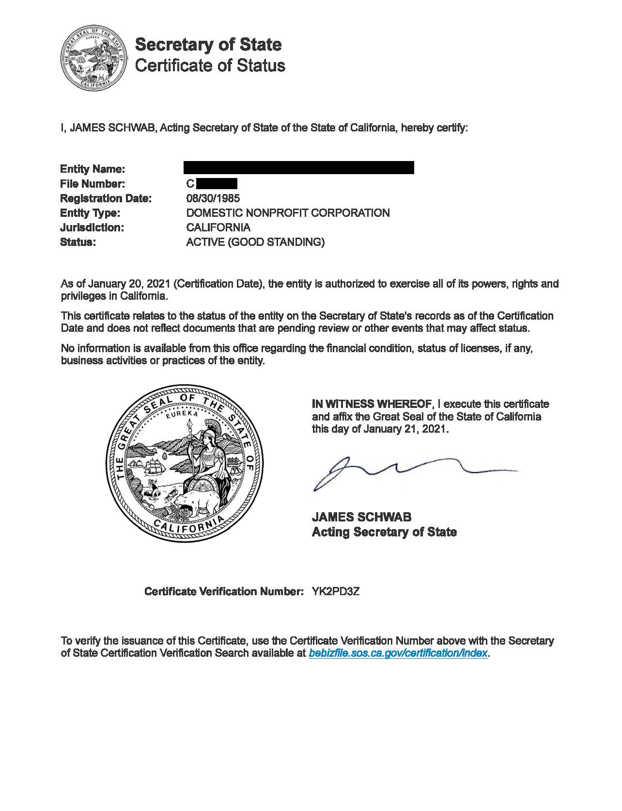

ATTACHMENT 4: Sample Entity Status Letter from CA Franchise Tax Board

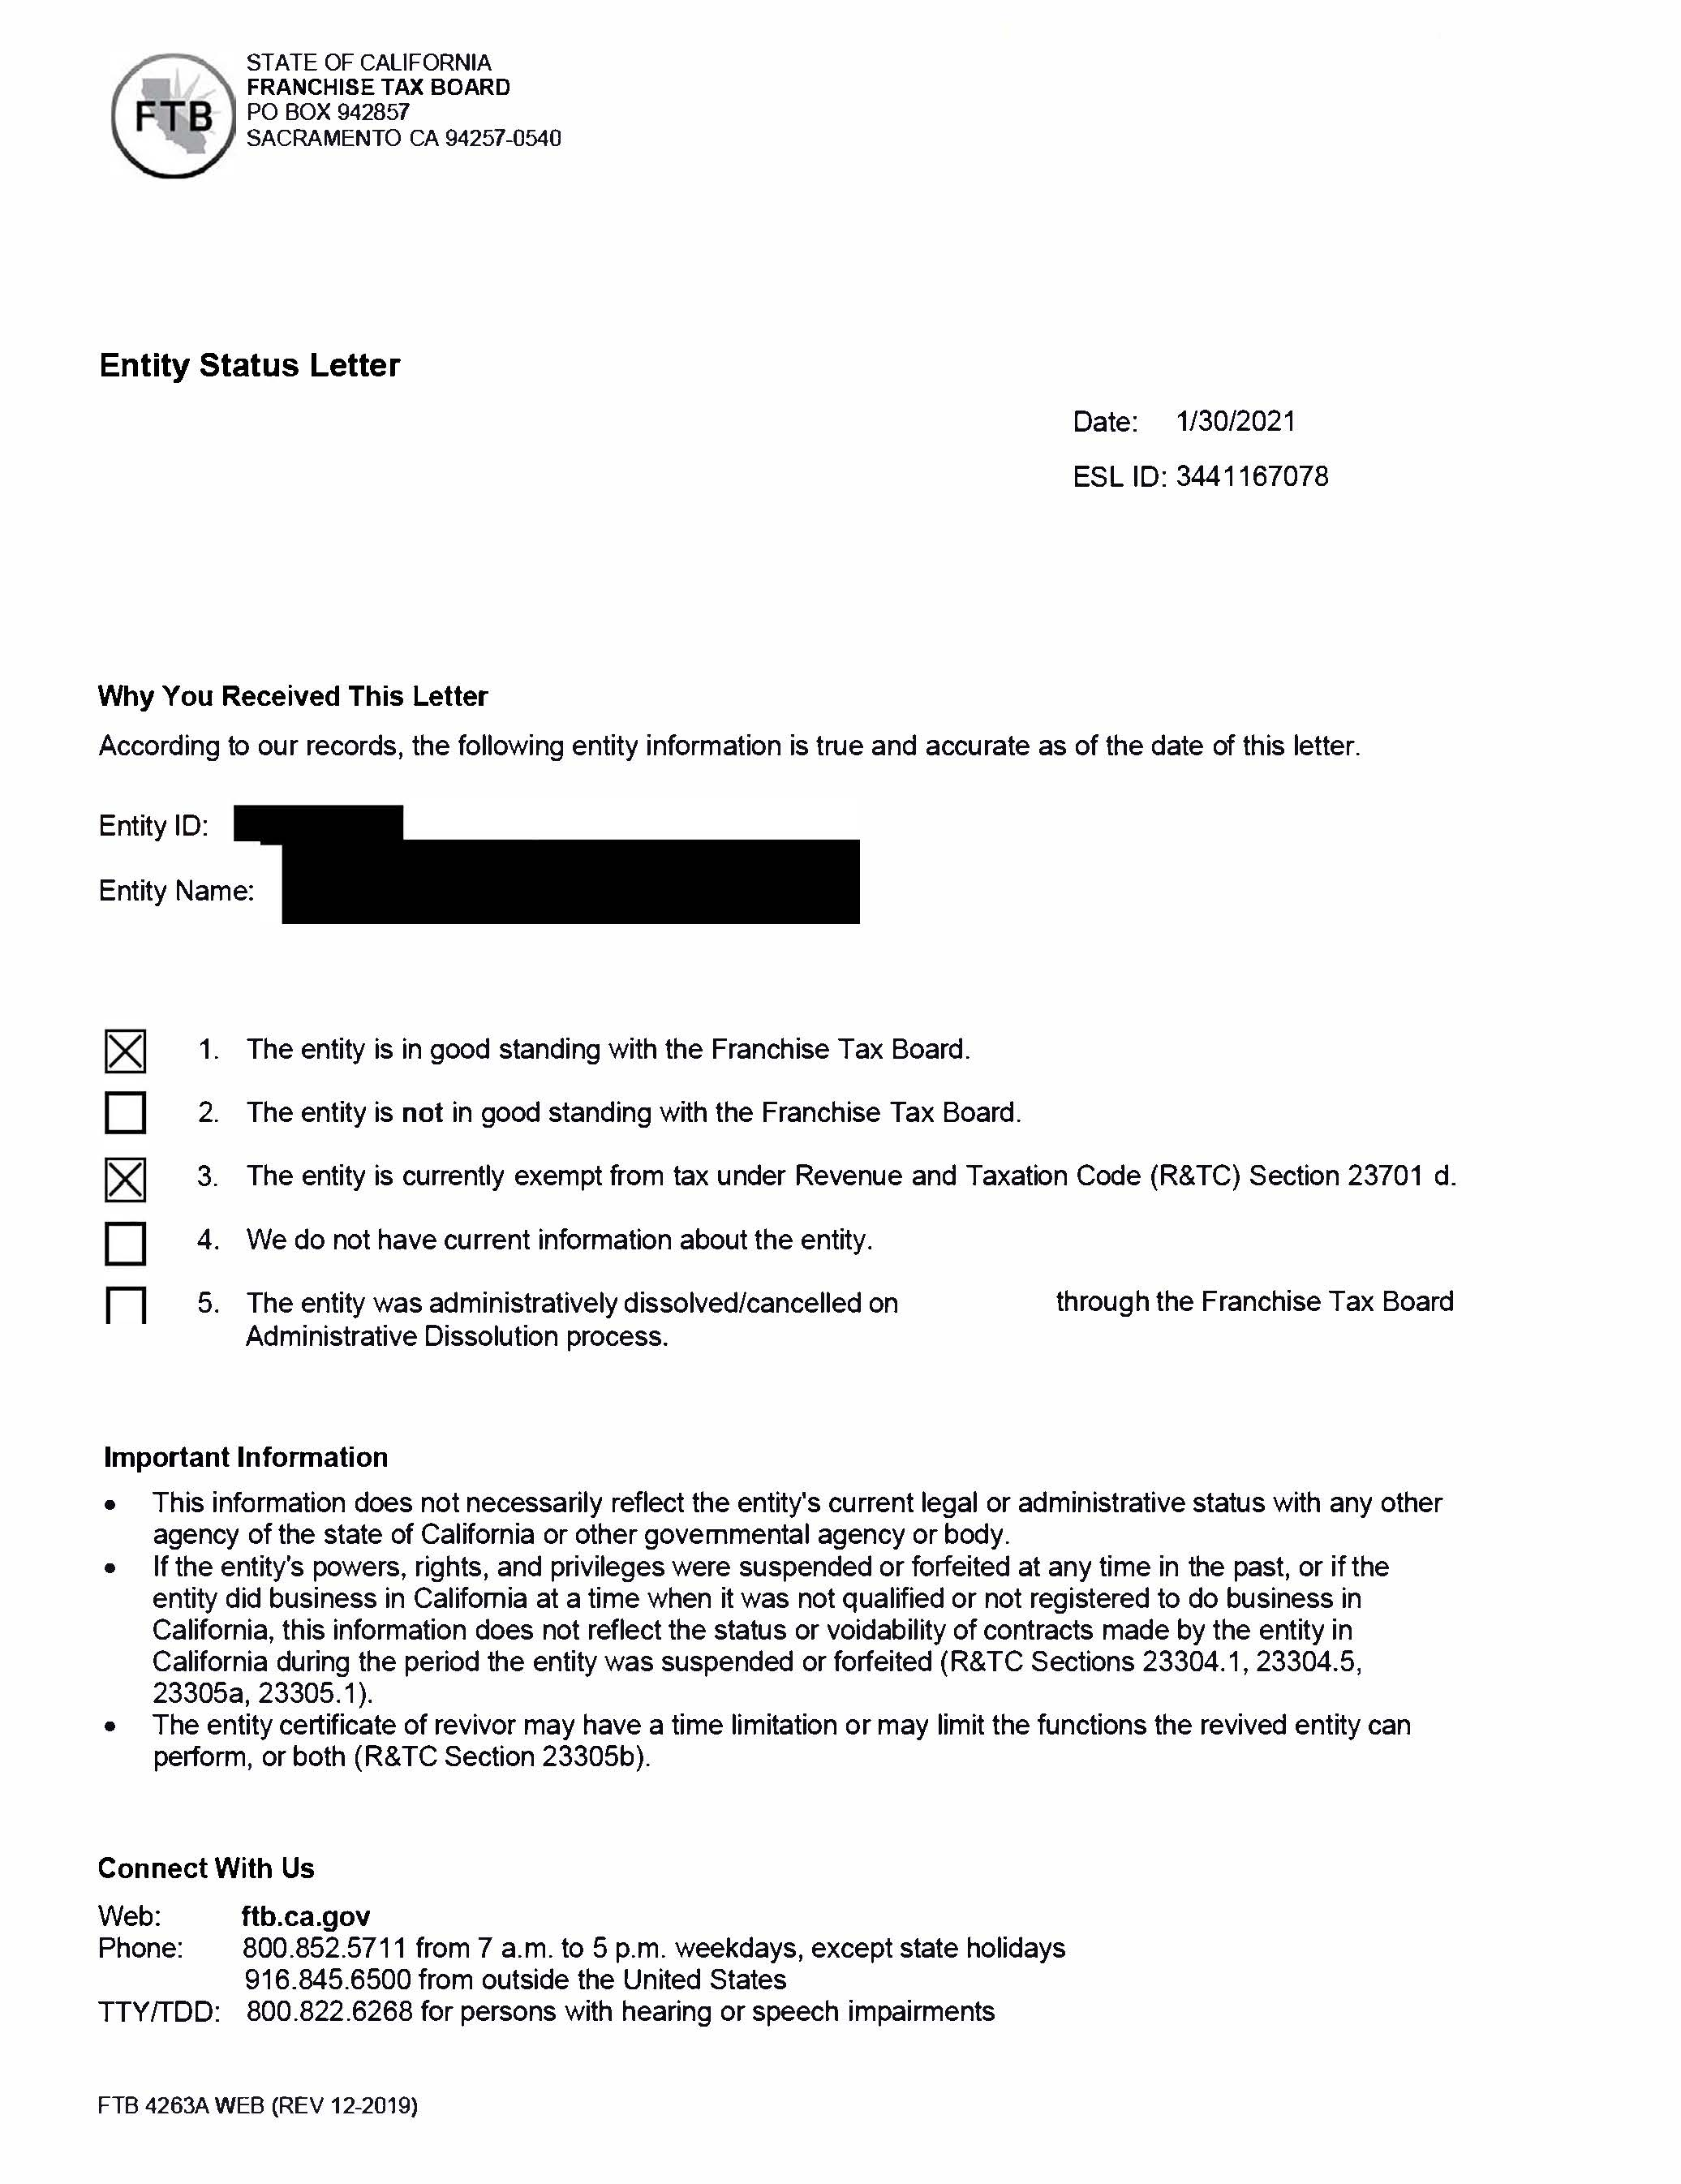

ATTACHMENT 5: Sample Non-Profit Status Letter from the IRS

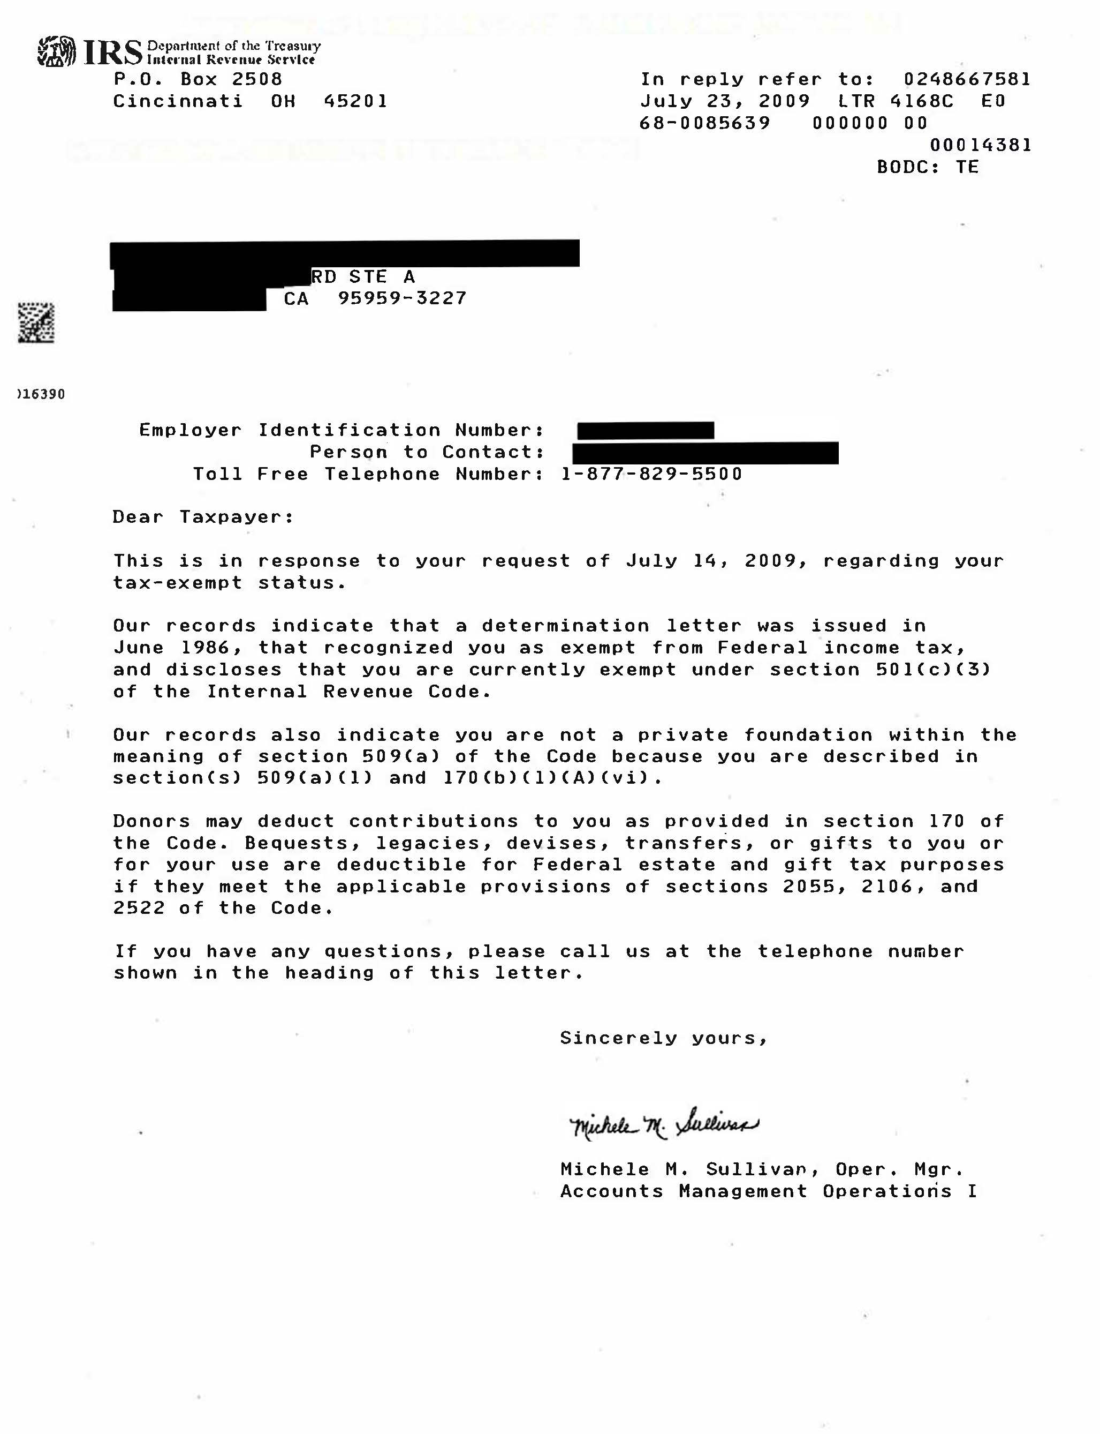

ATTACHMENT 6: Sample of Proof of Insurance Coverage

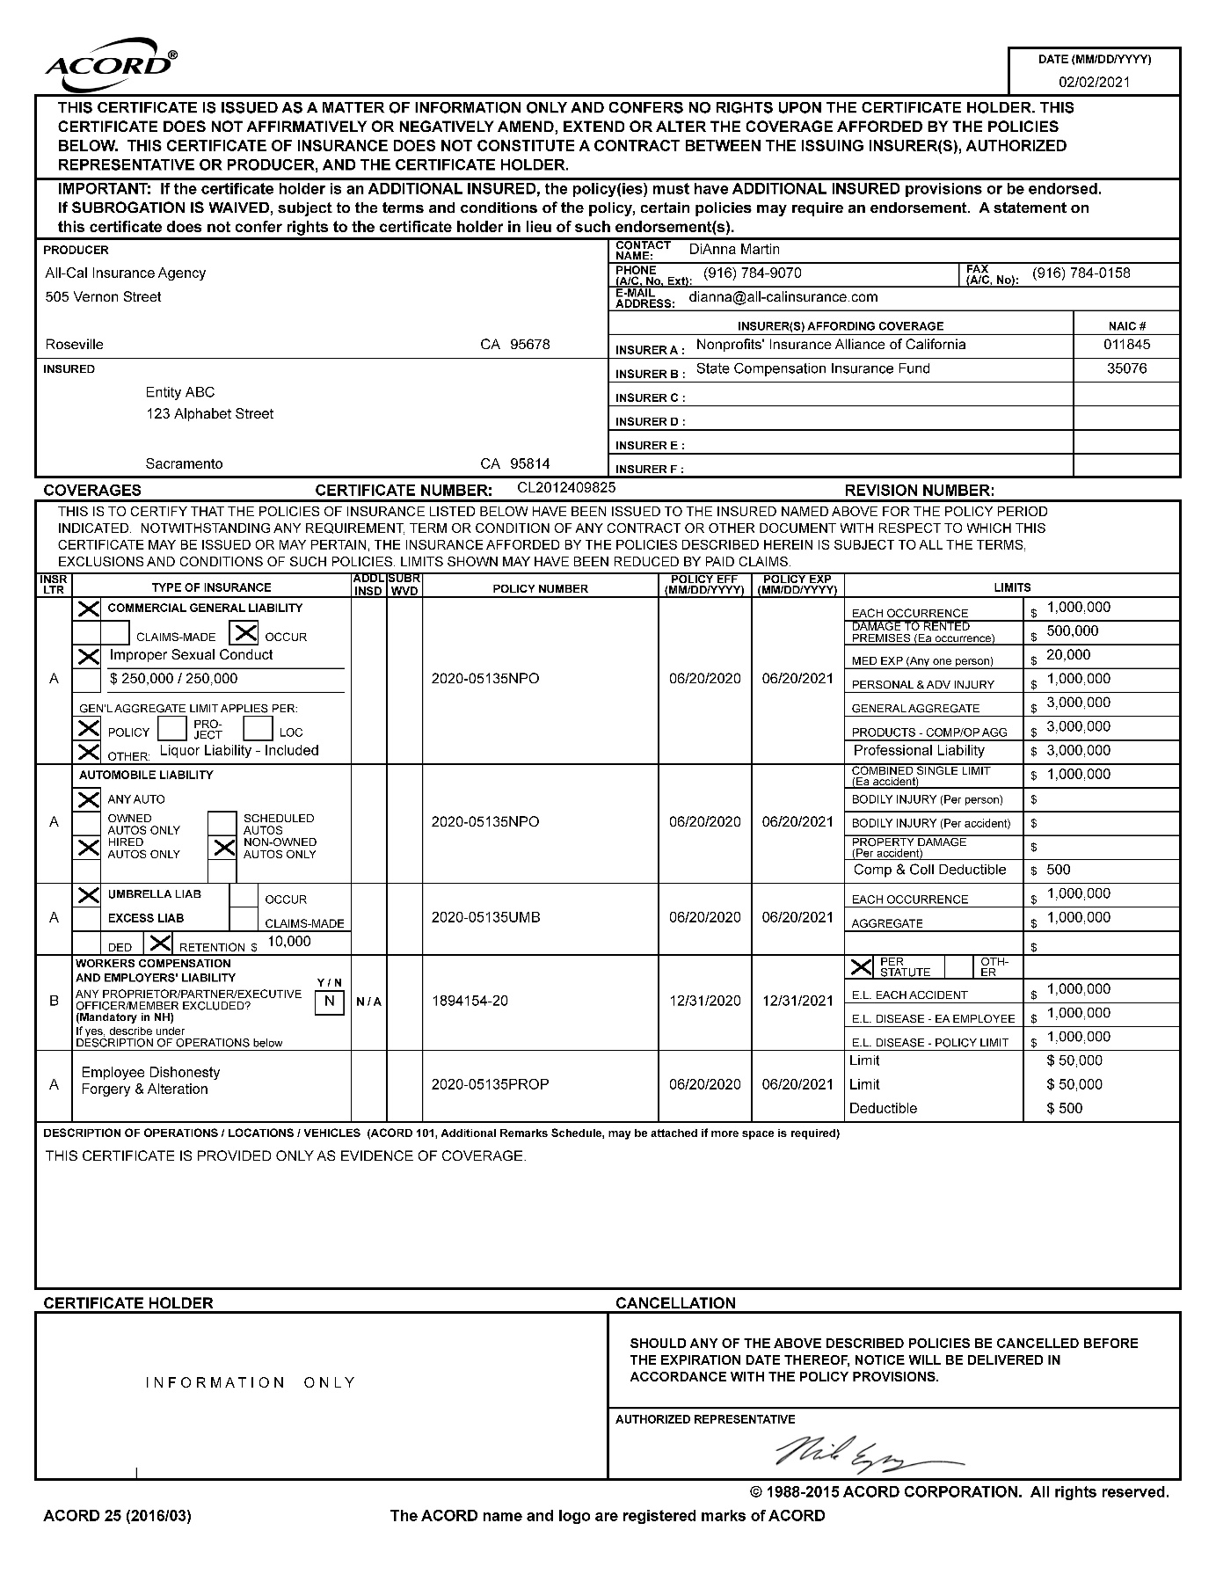

ATTACHMENT 7: Evaluation and Scoring
The following benchmark materials will be provided to the evaluators. Applications can receive up to 100 points possible. Each section and its elements are outlined in the table below. Scoring criteria can be found on the following page.
# | Response | Element Possible Score | Actual Score
Organizational Information (15 Points)
1 | Organization Experience | 5
2 | Organization Resources | 10
Summary of Program Activities, Work Plan and Timeline, Planned Program Outcomes, and Evaluation (65 Points)
1 | Summary of Program Activities | 10
2 | Work Plan and Timeline | 25
3 | Planned Program Outcomes | 20
4 | Evaluation Measures | 10
Budget and Staffing (20 Points)
1 | Proposed Budget | 15
2 | Proposed Staffing Plan | 5
Total Possible Score |  | 100

Section 1: Organizational Information: Organization Experience and Resources
Item 1 | Well Qualified (5 points) | Qualified (3 to 4 points) | Not Qualified (0 to 2 points)
Organization Experience | - Specifically, logically, and clearly articulates the organization’s history, vision, mission, services, and primary county.  - Specifically identifies the primary county where the organization has a physical location to provide services. Also includes a clear description of any in-person or virtual services planned.  - Specifically, logically, and clearly describes the racial, ethnic, socioeconomic, language, and geographic diversity of the proposed primary county. | - Broadly articulates the organization’s history, vision, mission, services, and primary county but lacks specific details.  - Identifies the primary county that the organization will serve. Also includes a broad description of any in-person or virtual services planned.  - Broadly describes the racial, ethnic, socioeconomic, language, and geographic diversity of the proposed primary county. | - Lacks sufficient description of the organization’s history, vision, mission, services, and primary county.  - Does not identify the primary county that the organization will serve or describe in-person or virtual services planned.  - Lacks sufficient description of the racial, ethnic, socioeconomic, language, and geographic diversity of the proposed primary county.
Organization Experience ____/5 Points
Required Notes:
Item 2 | Well Qualified (8 to 10 points) | Qualified (6 to 7 points) | Not Qualified (0 to 5 points)
Organization Resources | - Specifically, logically, and clearly describes specific experience working with individuals with TBI.  - Specifically, logically, and clearly articulates a connection between the organization’s resources and its ability to provide services and activities in the primary county.  - Specifically, logically, and clearly articulates collaborative partnerships with private and public entities to coordinate services for individuals with TBI, family members, and caregivers to access services and supports they need.  - Thoroughly describes, in a clear and logical manner, how this RFA will increase the ability of the organization to provide TBI services.  - Clearly and specifically describes an achievable plan to obtain the 20 percent match with specific funding sources identified. | - Broadly describes experience working with individuals with disabilities but not specific experience working with individuals with TBI.  - Broadly articulates a connection between the organization’s resources and its ability to provide services and activities in the primary county.  - Broadly articulates collaborative partnerships with private and public entities to coordinate services for individuals with TBI, family members, and caregivers to access services and supports they need but lacks specifics.  - Broadly describes how this RFA will increase the ability of the organization to provide TBI services.  - Describes a plan to obtain the 20 percent match with general funding sources identified but lacks specifics | - Lacks sufficient description of experience working with individuals with TBI or disabilities.  - Lacks sufficient description of the organization’s resources and ability to provide services and activities in primary county.  - Lacks sufficient description of meaningful collaborative partnerships with private and public entities to coordinate services for individuals with TBI, family members, and caregivers to access services and supports they need.  - Lacks sufficient description of how this RFA will increase the ability of the organization to provide TBI services.  - Lacks a sufficient plan to obtain the 20 percent match with general funding sources identified.
Organizational Resources ____/10 Points
Required Notes:
Organization Experience ____/5 Points
Organizational Resources ____/10 Points
TOTAL Organizational Information ____/15 Points
Section 2: Summary of Program Activities, Work Plan and Timeline, Planned Program Outcomes, and Evaluation
Item 1 | Well Qualified (8 to 10 points) | Qualified (6 to 7 points) | Not Qualified (0 to 5 points)
Summary of Program Activities | - Clear and concise summary of outcome-based goals and major objectives.  - Clearly identifies the unmet needs for individuals with TBI, family members, and caregivers, and how the services provided will address them.  - Thoroughly described, and clearly and logically aligned with the methodology for providing person-centered services. | - General overview of program goals and objectives  - Broadly identifies the unmet needs for individuals with TBI, family members, and caregivers, and how the services provided will address them.  - Described and generally aligned with the methodology for providing person-centered services. | - Lacks overview of program goals and objectives  - Lacks sufficient description the unmet needs for individuals with TBI, family members, and caregivers, and how the services provided will address them.  - Lacks sufficient description of how services are aligned with the methodology for providing person-centered services.
Summary of Program Activities ____/10 Points
Required Notes:
Item 2 | Well Qualified (20 to 25 points) | Qualified (13 to 19 points) | Not Qualified (0 to 12 points)
Work Plan and Timeline | - Thoroughly, clearly and logically describes measurable goals, objectives, and activities and timelines for all TBI services (supported living, community reintegration, vocational supportive services, enhanced information and assistance, community navigation, person-centered case coordination, and public and professional education).  - Specific and tangible activities and practices that speak to innovative approaches to meet the needs of consumers in-person and virtually.  - Goals and objectives are measurable and include clear and logical description of coordination and collaboration with multiple organizations such as health care, long-term services and supports, homeless response system, justice system, domestic violence, or other community services and support systems.  - Goals and objectives are measurable and include clear and logical description of how the organization will conduct outreach, communicate, and provide services to a broad range of individuals including those from diverse racial, ethnic, socioeconomic, gender identity, sexual orientation, and geographically underserved communities.  - Goals and objectives are measurable and include clear and logical description of how the organization will conduct outreach, identify, and enroll participants who are Medi-Cal eligible or have no other third-party funding sources.  - Goals and objectives are measurable and include clear and logical description of how the organization will develop and disseminate accessible, inclusive, and multilingual TBI information and resource materials.  - Goals and objectives are measurable and include clear and logical description of how the organization will develop educational and training materials for professionals, individuals with TBI, family members, caregivers, and the general public to increase the awareness of TBI. | - Generally describes measurable goals, objectives, and activities and timelines for all TBI services (supported living, community reintegration, vocational supportive services, enhanced information and assistance, community navigation, person-centered case coordination, and public and professional education).  - Activities and practices generally utilize innovative approaches to meet the needs of consumers in-person and virtually.  - Goals and objectives are measurable but include only a general description of coordination and collaboration with health care, long-term services and supports, homeless response system, justice system, domestic violence, or other community services and support systems.  - Goals and objectives are measurable but include only a general description of how the organization will conduct outreach, communicate, and provide services to a broad range of individuals including those from diverse racial, ethnic, socioeconomic, gender identity, sexual orientation, and geographically underserved communities.  - Goals and objectives are measurable but include only a general description of how the organization will conduct outreach, identify, and enroll participants who are Medi-Cal eligible or have no other third-party funding sources.  - Goals and objectives are measurable but include only a general description of how the organization will develop and disseminate accessible, inclusive, and multilingual TBI information and resource materials.  - Goals and objectives are measurable but include only a general description of how the organization will develop educational and training materials for professionals, individuals with TBI, family members, caregivers, and the general public to increase the awareness of TBI. | - Lacks measurable goals, objectives, and activities and timelines for TBI services.  - Activities and practices do not utilize innovative approaches to meet the needs of consumers in- person and virtually.  - Lacks measurable goals and objectives that include coordination and collaboration with health care, long-term services and supports, homeless response system, justice system, domestic violence, or other community services and support systems.  - Lacks measurable goals and objectives that include how the organization will conduct outreach, communicate, and provide services to a broad range of individuals including those from diverse racial, ethnic, socioeconomic, gender identity, sexual orientation, and geographically underserved communities.  - Lacks measurable goals and objectives that include how the organization will conduct outreach, identify, and enroll participants who are Medi-Cal eligible or have no other third-party funding sources.  - Lacks measurable goals and objectives that include how the organization will develop and disseminate accessible, inclusive, and multilingual TBI information and resource materials.  - Lacks measurable goals and objectives that include how the organization will develop educational and training materials for professionals, individuals with TBI, family members, caregivers, and the general public to increase the awareness of TBI.
Work Plan and Timeline ____/25 Points
Required Notes:
Item 3 | Well Qualified (16 to 20 points) | Qualified (11 to 15 points) | Not Qualified (0 to 10 points)
Planned Program Outcomes | - Clear, logical, and concise summary of the outcomes that will result from the organization’s proposed goals, objectives, and strategies for individuals with TBI, family members, and caregivers, professionals, and the community.  - Clear, logical, and specific summary of the expected number of unduplicated individuals with TBI to be served and number of professionals and family members to be educated.  - Clearly and logically identified evidence-based models and best practices to provide services and track outcomes.  - Clearly and logically describes expected measurable outcomes for individuals with TBI in major life areas because of receiving services. Major life activities may include housing and home integration, social integration, leisure and recreation, self-care, independent living, transportation, employment, managing money and finances, motor functioning, justice involvement, mental health, and cognitive functioning. | - General overview of the outcomes that will result from the organization’s proposed goals, objectives, and strategies for individuals with TBI, family members and caregivers, professionals, and the community.  - General overview of the expected number of unduplicated individuals with TBI to be served and number of professionals and family members educated.  - General description of evidence-based models and best practices to provide services and track outcomes.  - General description of expected outcomes for individuals with TBI in major life areas because of receiving services. Major life activities may include housing and home integration, social integration, leisure and recreation, self-care, independent living, transportation, employment, managing money and finances, motor functioning, justice involvement, mental health, and cognitive functioning. | - Lacks outcomes that will result from the organization’s proposed goals, objectives, and strategies for individuals with TBI, family members and caregivers, professionals, and the community.  - Lacks information on number of unduplicated individuals with TBI to be served and number of professionals and family members educated.  - Lacks evidence-based models and best practices to provide services and track outcomes.  - Lacks outcomes for individuals with TBI in major life areas because of receiving services. Major life activities may include housing and home integration, social integration, leisure and recreation, self-care, independent living, transportation, employment, managing money and finances, motor functioning, justice involvement, mental health, and cognitive functioning.
Planned Program Outcomes ____/20 Points
Required Notes:
Item 4 | Well Qualified (8 to 10 points) | Qualified (6 to 7 points) | Not Qualified (0 to 5 points)
Evaluation Measures | - Clear, logical and specific identification of the organization’s key stakeholders and staff involved in evaluation activities and if external evaluations will be used, includes a description of how the evaluations will benefit the TBI program.  - Clear, logical, and concise summary of how the organization will do continuous quality improvement and will monitor and track program activities and effectiveness, including the frequency of such monitoring.  - Clear, logical, and concise summary of how the program reports, products, and grant outcomes will be used to identify “lessons learned” – both positive and negative – to develop best practices for improving and innovating services. | - General identification of the organization’s key stakeholders and staff involved in evaluation activities and if external evaluations will be used.  - General summary of how the Organization will do continuous quality improvement and will monitor and track program activities and effectiveness.  - General summary of how the program reports, products, and grant outcomes will be used to identify “lessons learned” to develop best practices for improving and innovating services. | - Lacks how the organization will do continuous quality improvement and will monitor and track program activities and effectiveness.  - Lacks identification of the organization’s key stakeholders and staff involved in evaluation activities and if external evaluations will be used.  - Lacks information of how the program reports, products, and grant outcomes will be used to identify “lessons learned” to develop best practices for improving and innovating services.
Evaluation Measures ____/10 Points
Required Notes:
Summary of Program Activities _____/10 Points
Work Plan and Timeline ____/25 Points
Planned Program Outcomes ____/20 Points
Evaluation Measures ____/10 Points
TOTAL Summary of Program Activities, Work Plan and Timeline, Planned Program Outcomes, and Evaluation ____/65 Points
Section 3: Budget and Staffing
Item 1 | Well Qualified (12 to 15 points) | Qualified (8 to 11 points) | Not Qualified (0 to 7 points)
Proposed Budget | - Budget clearly and logically aligns with the program narrative including the Work Plan and Timeline.  - Budget matches the identified annual amounts of:  - December 1, 2024 to June 30, 2025, a budget up to $175,000.  - July 1, 2025 to June 30, 2026, a budget up to $300,000.  - July 1, 2026 to June 30, 2027, a budget up to $300,000.  - Clear, logical, and specific (by line item) budget that includes all proposed personnel charged to the grant, includes position title, full-time salary, benefits, and full-time equivalent charged to the grant and (if applicable) operating expenses needed to support the program.  - Clear, logical, and specific indirect cost rate, how it was determined, and lists administrative and general expenses that are included. If the organization uses a cost allocation plan, includes a clear and logical description of how general administrative expenses are allocated to the grant. | - Budget generally aligns with the program narrative including the Work Plan and Timeline.  - Budget matches the identified annual amounts of:  - December 1, 2024 to June 30, 2025, a budget up to $175,000.  - July 1, 2025 to June 30, 2026, a budget up to $300,000.  - July 1, 2026 to June 30, 2027, a budget up to $300,000.  - Specific budget that includes all proposed personnel charged to the grant, includes position title, full-time salary, benefits, and full-time equivalent charged to the grant and (if applicable) operating expenses needed to support the program.  - General (or a range) indirect cost rate, but lacks specifics on how it was determined, and lists administrative and general expenses that are included. If the organization uses a cost allocation plan, includes a general description of how general administrative expenses are allocated to the grant. | - Lacks sufficient alignment with the program narrative including the Work Plan and Timeline.  - Budget does not match the identified annual amounts of:  - December 1, 2024 to June 30, 2025, a budget up to $175,000.  - July 1, 2025 to June 30, 2026, a budget up to $300,000.  - July 1, 2026 to June 30, 2027, a budget up to $300,000.  - Lacks a specific budget and does not include all proposed personnel charged to the grant, position titles, full-time salary, benefits, and full-time equivalent charged to the grant and (if applicable) operating expenses needed to support the program.  - Lacks an indirect cost rate or does not describe the general administrative expenses that are allocated to the grant.
Proposed Budget ____/15 Points
Required Notes:
Item 2 | Well Qualified (5 points) | Qualified (3 to 4 points) | Not Qualified (0 to 2 points)
Staffing Plan | - Clear, logical, and specific summary of how each of the personnel positions charged to the grant is aligned with the Work Plan and program goals, objectives, strategies, activities, and outcomes. Includes specific details on how the staffing plan is diverse and inclusive and seeks to maintain a multilingual staff.  - Resumes are included for key personnel (Executive Director and/or Program Manager/s) that demonstrate at least three years of leadership experience and qualifications for supporting program goals, objectives, strategies, activities, and outcomes.  - Duty statements are included for all positions funded under this proposal that demonstrate qualifications needed to support program goals, objectives, strategies, activities, and outcomes. | - General summary of how each of the personnel positions charged to the grant is aligned with the Work Plan and program goals, objectives, strategies, activities, and outcomes but lacks details on how the staffing plan is diverse and inclusive and seeks to maintain a multilingual staff.  - Resumes are included for key personnel (Executive Director and/or Program Manager/s) that demonstrate at least one but less than three years' experience and qualifications for supporting program goals, objectives, strategies, activities, and outcomes.  - Duty statements are included for all positions funded under this proposal but fail to demonstrate adequate qualifications needed to support program goals, objectives, strategies, activities, and outcomes. | - Lacks a summary of how each of the personnel positions charged to the grant is aligned with the Work Plan and program goals, objectives, strategies, activities, and outcomes.  - Lacks resumes for key personnel demonstrate with more than one year experience and qualifications for supporting program goals, objectives, strategies, activities, and outcomes.  - Duty statements are not included for all positions funded under this proposal.
Staffing Plan ____/5 Points
Required Notes:
Proposed Budget ____/15 Points
Staffing Plan ____/5 Points
TOTAL Budget and Staffing ____/20 Points

ATTACHMENT 8: Sample of Budget Narrative

(PROGRAM NAME)
TBI BUDGET NARRATIVE

BENEFITS

BENEFIT PERCENTAGE REQUIREMENTS
For the
[SERVICE BUDGET/CERTIFIED EXPENDITURE] NARRATIVE

[In the narrative, list the benefit cost rate or range and itemize all benefits being claimed in calculating the percentage rate. The Contractor must include a breakdown of the percent of each benefit being claimed. Include only actual percentages, Do not include estimates. (See sample below.)]

Sample language for Benefit Costs:
BENEFITS: Benefits are calculated at a range of 21% – 53%. Blueberry College provides PERS (10%) or STRS (10%) depending on the classification, Social security (6.2%), MediCare (1.45%), health insurance portion (6%), unemployment (6%), retirement (5%) and worker’s compensation (3%).

[NOTE: Items already included in the Indirect Cost cannot be used to calculate benefit costs.]

Benefits Narrative:

PERSONNEL
Include all proposed personnel charged to the grant to support program goals, objectives, strategies, and activities. Include personnel positions by title, full-time salary, benefits, and full-time equivalent (FTE) charged to the grant as stated in the budget spreadsheet (Attachment 9).

[Position Title 1]:

[Position Title 2]:

[Add or remove additional positions as necessary]

OPERATING EXPENSES
Include operating expenses needed to support program goals, objectives, strategies, and activities. Operating expenses may include rent, communications, utilities, office supplies, travel, equipment, and other operational expenses. It might also include direct expenses for program activities such as transportation for consumers, education and outreach, and any subcontracted services. Do not include expenditures being reimbursed through indirect costs (see below).

For each operating expense include the following in the space below:

- A list of what specific costs are included in the category. For example, do the communication costs include internet access, telephone access, etc.?
- How the costs will be allocated to the Agreement. For example, charging a staff person’s communication costs to the Agreement based upon the actual amount of time spent working on the Agreement during the prior month.

[Operating Expense 1]:

[Operating Expense 2]:

[Add or remove additional positions as necessary]

INDIRECT COST
Include the organization indirect cost rate, how it was determined, and list administrative and general expenses are included (insurance, audits, administrative staff, office supplies, etc.). If the organization uses a cost allocation plan instead of an indirect cost rate, include a clear description of how general administrative expenses are allocated to the grant.

[Indirect Cost Rate and how determined]:

[List of general expenses included in Indirect Cost Rate]:

ATTACHMENT 9: TBI Service Budget Spreadsheet
Grantee Name and Address |  | Budget Period |  |  | Budget Period |  |  | Budget Period
 |  | December 1, 2024 - June 30, 2025  $175,000.00 |  |  | July 1, 2025 - June 30, 2026  $300,000.00 |  |  | July 1, 2026 - June 30, 2027  $300,000.00
Line No. | PERSONNEL-Position Title & Time Base | Annual Salary Per FTE | Annual FTE | Amount Budgeted | Annual Salary Per FTE | Annual FTE | Amount Budgeted | Annual Salary Per FTE | Annual FTE | Amount Budgeted
 | Administrative Personnel
1
2
3
4
5
6 | Admin Subtotal
7 | Direct Service Personnel
8
9
10
11
12 | Personnel Subtotal
13 | OPERATING EXPENSES
14
15
16
17
18
19
20
21
22 | Operating Subtotal
23 | Personnel and Operating Subtotal
24 | Indirect Rate Percentage
25 | Indirect Cost
27 | TOTAL (rounded to nearest dollar)

