STATE OF CALIFORNIA

DEPARTMENT OF REHABILITATION (DOR)
Independent Living and Community Access Division (ILCAD)

REQUEST FOR APPLICATION (RFA)

Voice Options Program (VOP)
RFA # G26-VOP-01
Program Year: 2026 - 2029

Table of Contents

Authority 4
Background 5
Purpose 5
Description of Services 5
Program Regions 8
Minimum Qualifications 9
Key Action Dates 10
Table 1: Key Action Dates 10
Application 11
Table 2: Sample Proposed Budget 12
Application Submission Requirements 14
Required Format for Application 14
Application Review Process and Scoring Criteria 14
Award Funding Formula 16
Table 3: Award Funding Tier based on Final Score 17
Regional Weight Formula 17
Award Notification 18
Appeal Rights 18
Disposition of Applications 20
Agreement Execution and Performance 20
Performance Actions 21
Attachment C: List of Regions to be served 22
Attachment D: Required Documents Checklist and Assurances 23
ATTACHMENT 2: Cover Sheet and Assurances 25
Figure 1: Sample of Secretary of State Organization’s Annual Corporate Report 28
Figure 2: Sample Entity Status Letter from CA Franchise Tax Board 29
Figure 3: Sample Non-Profit Status Letter from the IRS 30
Figure 4: Sample of Proof of Insurance Coverage 31
Terms and Conditions 32
Exhibit A 32
Exhibit B 35
Exhibit C 38

Authority
California Connect, also called the Deaf and Disabled Telecommunications Program (DDTP), provides communication access for Californians with hearing, vision, cognitive, mobility, and speech-related disabilities. The program of the California Public Utilities Commission (CPUC) includes accessible communication equipment and devices, relay service, and Augmentative and Alternative Communication (AAC) devices.
In 1979, the California Legislature enacted Public Utilities (PU) Code Section 2881. PU Code Section 2881 required the CPUC to create a program that provides telecommunication access to individuals with functional limitations of hearing, vision, movement, manipulation, speech, and interpretation of information. The California Legislature later expanded PU Code Section 2881 to include providing a dual-party relay system, specialized telecommunications equipment to other disability groups, and assistance for speech generating devices. The program, which has since been named the Deaf and Disabled Telecommunications Program (DDTP), is governed by the following mandates:
- PU Code Section 2881(a), which authorizes the provision of Teletypewriters (TTYs) to deaf or hard-of-hearing individuals;
- Public Utilities Code Section 2881(b), which uses third-party intervention to connect telephone consumers who are deaf, hard of hearing, or have difficulty speaking with other parties;
- Public Utilities Code Section 2881(c), which authorizes the provision of other specialized telecommunications equipment to consumers with hearing, vision, mobility, speech, or cognitive disabilities; and
- Public Utilities Code Sections 2881(d) and 2881(e)(1), which authorizes the provision of speech generating devices with DDTP as the provider of last resort and adds speech language pathologists as a DDTP certifying agent.
The Department of Rehabilitation (DOR) is California’s designated state agency for vocational rehabilitation services per the Rehabilitation Act of 1973 (29 U.S.C. § 701 et seq.) and Welfare and Institutions Code § 19000 et seq., and for assistive technology services per the Assistive Technology Act of 1998 (29 U.S.C. § 3001 et seq.). DOR partners statewide with independent living centers, schools, colleges, and community programs to support Californians with disabilities in achieving employment, independence, and equality.

Background
The Voice Options Program (VOP) administered by DOR offers eligible Californians with verified speech or language disabilities access to speech‑generating devices (SGDs) and speech‑generating applications to increase independent communication. Providers support individuals through education, demonstrations, short‑term loan devices (STLs), training, and issuance of long‑term loan devices (LTLs). The program aims to complete at least 1,260 LTLs statewide annually and ensure equitable device distribution across 10 CPUC‑identified regions, including underserved areas.

Purpose
Through this Request for Application (RFA), DOR seeks qualified organizations to deliver assistive technology services under the VOP. Selected Providers will serve individuals of all ages who have difficulty speaking or cannot speak. This is a formal application process. Applicants must submit a complete, accessible application packet as outlined in this RFA to be considered for award.

Description of Services
Selected Providers shall provide services in the following categories:
- Individual Identification & Eligibility
  - Identify individuals of all ages with a speech or language disability who have difficulty speaking or cannot speak.
  - Verify eligibility via referral/recommendation from an approved clinician or specialist.
- Demonstrations, STLs, and Training
  - Maintain demonstration SGDs preloaded with seven (7) VOP applications:
    - GoTalk NOW Plus
    - LAMP Words for Life
    - Predictable (available for Android devices)
    - Proloquo2Go
    - Proloquo4Text
    - TouchChat HD w/ WordPower
    - TD Snap
  - Provide STL devices for a duration of 2–14 calendar days with the seven apps to allow individuals to use for a trial period and select the most suitable app.
  - Conduct education and training on the SGD’s accessibility features and application use.
  - DOR reserves the right to add additional approved SGDs and speech-generating applications, as approved by CPUC.
- LTL Issuance
  - Provide LTL devices of new iPads, new Android, or other CPUC-approved SGDs with one VOP application selected by the individual to support independent communication.
- Apple and Google App Store Account & Gift Codes
  - Maintain an Apple and/or Google App Store account to purchase redeemable gift codes for approved VOP apps (one per LTL device).
  - Submit gift code receipts with invoices for reimbursement.
- Documentation & Records
  - Complete an LTL device Application and individual served survey for each issued device. DOR staff will provide applications and surveys.
  - Retain financial and program records, including equipment purchase receipts, for seven (7) years after the grant period.
- Outreach & Referral
  - Conduct outreach and make referrals as appropriate to the California Connect and Voice Options programs.
Allowable Personnel & Travel Costs include:
- Staff time for demonstrations and STL devices, training, LTL devices processing, equipment acquisition, setup, technical support, reporting, outreach, referral, and survey facilitation.
- Reasonable travel expenses for demonstrations, education, and training.
  - Travel expenses must not exceed CalHR excluded employee rates: http://www.calhr.ca.gov/employees/pages/travel-reimbursements.aspx
Allowable Non-Personnel Costs include:
- Purchase of a new Apple iPad (generation 11 or later), new Android tablet, or other CPUC approved SGD with ≥128 GB storage.
  - Refurbished SGDs may be considered case-by-case.
- Protective SGD equipment: cases, screen protectors, mounts as appropriate.
- One VOP speech-generating application of the individual’s choice from the following list:
  - GoTalk NOW Plus
  - LAMP Words for Life
  - Predictable (available for Android devices)
  - Proloquo2Go
  - Proloquo4Text
  - TouchChat HD w/ WordPower
  - TD Snap
  - Other speech-generating application as approved by the CPUC.
- SGD warranty and accessories needed to accommodate the individual’s specific disability.
- Shipping costs not to exceed $100 per SGD.

Program Regions
Applicants must specify one or more program regions to serve with application materials submitted. Program Regions with higher populations of individuals with disabilities will be considered for more than one awarded provider. Applicants can be awarded to serve more than one region. Also, DOR reserves the right to award one entity per region to ensure geographic coverage of providers statewide. The VOP aims to distribute approximately 105 devices per month (1,260 per year) across the following 10 regions:
- Region 1 – Superior California: Butte, Colusa, El Dorado, Glenn, Lassen, Modoc, Nevada, Placer, Plumas, Sacramento, Shasta, Sierra, Siskiyou, Sutter, Tehama, Yolo, Yuba
- Region 2 – North Coast: Del Norte, Humboldt, Lake, Mendocino, Napa, Sonoma, Trinity
- Region 3 – San Francisco Bay Area: Alameda, Contra Costa, Marin, San Francisco, San Mateo, Santa Clara
- Region 4 – Northern San Joaquin Valley: Alpine, Amador, Calaveras, Madera, Mariposa, Merced, Mono, San Joaquin, Stanislaus, Tuolumne
- Region 5 – Central Coast: Monterey, San Benito, San Luis Obispo, Santa Barbara, Santa Cruz, Ventura
- Region 6 – Southern San Joaquin Valley: Fresno, Inyo, Kern, Kings, Tulare
- Region 7 – Inland Empire: Riverside, San Bernardino
- Region 8 – Los Angeles County: Los Angeles
- Region 9 – Orange County: Orange
- Region 10 – San Diego–Imperial: Imperial, San Diego

Minimum Qualifications
Nonprofit and community-based organizations with a 501(c)(3) status with the IRS and demonstrated experience in assistive technology services, including experience serving people with disabilities of all ages.

Key Action Dates

Table 1: Key Action Dates
Event | Responsible Party | Due Dates
RFA available to potential applicants | DOR | February 19, 2026
Deadline to submit written questions | Applicant(s) | February 27, 2026 by 11:59 pm
Applicant Conference Call | DOR and Applicant(s) | March 4, 2026 from 1:00 – 2:00 pm  Zoom Registration
Addendum “Questions and Answers” posted to the DOR website | DOR | March 9, 2026
Application Submission | Applicant(s) | March 18, 2026 by 11:59 pm
Application Screening and Evaluation | DOR | March 19 – April 3, 2026
Notice of Intent to Award posted to the DOR website | DOR | Tentatively  April 10, 2026
Last date to file appeal | Applicant(s) | May 11, 2026
Grant Effective Date | All | July 1, 2026, or upon DOR approval, whichever date is later

Application
Applicants shall provide responses in each category within application materials submitted. Application narrative for Organizational Experience and Capacity and Work Plan should not be more than 10 pages total combined, 14pt Arial font, single-spaced in Microsoft Word format.
The Proposed Budget(s) and Narrative(s) should not be more than 5 pages total, 14pt Arial font, single-spaced in Microsoft Word format. For applicants applying to serve more than one region, a proposed budget and narrative is required for each region. To be clear, this portion may consist of up to 50 pages (ten total regions, times 5 pages each region.)
A. Organizational Experience and Capacity
- Describe the organization’s ability to implement the VOP, including experience serving individuals with disabilities and those with speech/language disabilities.
- Describe the organization’s understanding of the selected program region(s) demographics to be served, including population statistics of individuals with disabilities.
- Provide examples of prior experience working with healthcare professionals, approved specialists, licensed physicians, or speech therapists.
- Provide quantitative and qualitative examples of performance metrics, including numbers and demographics of individuals served, total number of device demonstrations, total number of short-term and long-term device loans, breadth of outreach activities, individual success and impact stories.
- Provide job descriptions and roles for key personnel who will provide VOP services during the grant period, including Include: position title, time allocation (full-time or part-time), duties (demonstrations and STL devices, training, equipment management, LTL processing, reporting, outreach), minimum qualifications and relevant experience.
- If applying to serve more than one region, describe the organization’s capacity to serve multiple regions.
B. Proposed Work Plan
- Provide a detailed work plan with specific, measurable, achievable, and time-bound (SMART) goals, objectives, and activities for implementing the VOP.
- Provide a detailed Outreach Plan to promote California Connect and Voice Options programs to eligible individuals of all ages in the proposed region(s).
- Provide specific processes for tracking and monitoring VOP equipment loaned for STL devices and issued for LTL devices.
- Provide a Reporting plan to ensure programmatic data are shared timely with DOR.
C. Proposed Budget and Narrative
Applicants can apply for up to $250,000 per fiscal year over the three-year grant term. The grand total costs per fiscal year cannot exceed $250,000.

Table 2: Sample Proposed Budget
Expense | Total Year 1 | Total Year 2 | Total Year 3
Personnel | $_____ | $_______ | $________
Travel | $_____ | $_______ | $________
Outreach Activities | $_____ | $_______ | $________
Equipment | $_____ | $_______ | $________
Applications (Apple and/or Google) | $_____ | $_______ | $________
Grand Totals | $_____ (cannot exceed $250,000) | $_______ (cannot exceed $250,000) | $________ (cannot exceed $250,000)

Budget Proposal Narrative Components:
- Personnel: Costs for staff who will perform eligible activities (demonstrations, equipment acquisition & setup, LTL processing, technical support, reporting). If multiple staff support an LTL device, specify hours and rates per person and show totals.
- Travel: Include estimated transportation costs (mileage/fuel, tolls, parking, airfare/rental if applicable). Ensure compliance with CalHR rates for excluded employees.
CalHR travel: http://www.calhr.ca.gov/employees/pages/travel-reimbursements.aspx
- Outreach Activities: Costs for developing and implementing outreach plan to promote program to eligible individuals of all ages in the proposed region(s).
- Equipment: Costs for purchasing and providing STL devices and LTL devices of new iPads, new Android, or other CPUC approved SGDs with one VOP application selected by the individual to support independent communication, including protective equipment, accessories, and warranties (as applicable).
- Applications: Costs for maintaining Apple and/or Google App Store account to purchase redeemable gift codes for approved VOP apps (one per LTL device).

Application Submission Requirements
To be considered, applicants must submit a complete, accessible application packet by Wednesday, March 18, 2026 at 11:59 p.m. (Pacific) (review DOR Guidance for Creating Accessible Content: https://www.dor.ca.gov/Home/HowToCreateAccessibleContent).
Submit electronically via email to: Grants@dor.ca.gov
Subject line: RFA # G26-VOP-01 – Voice Options Program Application – [Organization Name]

Required Format for Application
- Attachment A: Application/Work Plan (no more than 10 pages total, 14pt Arial font, single-spaced in Microsoft Word format)
- Attachment B: Proposed Budget and Narrative (no more than 5 pages total for each region, 14pt Arial font, single-spaced in Microsoft Word format)
- Attachment C: List of Regions to be served
- Attachment D: Required Documents Checklist and Assurances and includes additional Attachments 1-6

Application Review Process and Scoring Criteria
Submitted applications will be screened for an administrative check of pass or fail for all required application documents prior to scoring. Submitted applications failing the administrative check will not be scored or considered for award.
The Evaluation Committee will review each application for completeness and conformance to requirements, and score using the rubric below. DOR will determine the number and geographic distribution of awards to meet statewide service goals.
Applications will be evaluated against the following 100 points rubric. Applications must score a minimum of 75 points to be considered for award. DOR shall break ties by awarding the grant to the application with the highest score in the ‘Organizational Experience & Capacity’ category with the highest points possible. If those scores are the same, DOR shall break the tie by awarding the grant to the application with the highest score in the ‘Proposed Work Plan’ category with the second highest points possible, and so on to break the tie. If there is still no apparent winner, a coin toss shall be performed.
- Administrative and Accessibility Review (Pass or Fail)
  - All required attachments submitted (Attachments A, B, C, Checklist and Assurances).
  - Conformance to page limits, font, and format requirements.
  - Application submitted by deadline.
  - Accessible document format compliant with DOR accessibility standards.
  - Applicant meets minimum eligibility (501(c)(3))
- Organizational Experience & Capacity (50 points)
  - Demonstrated experience serving individuals with disabilities, particularly speech/language disabilities.
  - Demonstrated collaboration with healthcare professionals and approved specialists.
  - Demonstrated performance metrics and successful outcomes for individuals served by organization.
  - Demonstrated staffing capacity, including relevant qualifications and experience to provide VOP services.
  - Demonstrated infrastructure and expertise in training and technical demonstrations.
  - Demonstrated capacity to serve multiple regions.
- Proposed Work Plan (40 points)
  - Detailed work plan with specific, measurable, achievable, and time-bound (SMART) goals, objectives, and activities for implementing the Voice Options Program (VOP).
  - Detailed outreach strategy to reach eligible individuals of all ages in selected regions.
  - Specific processes identified for equipment tracking/monitoring of STL devices and LTL devices.
  - Detailed reporting plan to ensure programmatic data are shared timely with DOR.
- Cost Proposal & Narrative (10 points)
  - Narrative’s alignment with allowable costs.
  - Feasibility of costs to support work plan goals, objectives, and activities.
  - Feasibility of costs to support identified program region(s).

Award Funding Formula
Each eligible application will be assigned a Funding Tier based on its final score as outlined in Table 3. Only applications that meet both conditions below advance to award consideration and calculation:
- Passed Administrative & Accessibility Review (Pass/Fail).
- Scored a minimum of 75 points overall.
Applications scoring below 75 are not eligible for funding, regardless of requested amount.

Table 3: Award Funding Tier based on Final Score
Final Score (Points) | Funding Tier | % of Maximum Award
90–100 | Tier 1 (Excellent) | 100% of max
85–89 | Tier 2 (Very Strong) | 90% of max
80–84 | Tier 3 (Strong) | 80% of max
75–79 | Tier 4 (Acceptable) | 70% of max

If an applicant is awarded multiple regions, the award may be adjusted using a Regional Weight Factor, subject to funding availability.

Regional Weight Formula
- 1 region: 1.00
- 2 regions: 1.15
- 3+ regions: 1.25 (cap)
Award adjustments must not exceed $250,000 per fiscal year per awarded region.
DOR retains discretion to reduce individual awards proportionally if total preliminary awards exceed available funds; and adjust awards to:
  - Ensure coverage in underserved regions.
  - Avoid over-concentration in a single region.
  - Meet statewide equity and access goals.

Award Notification
DOR will post award notifications on its ‘Intent to Award’ webpage. DOR will issue up to 20 total awards. DOR will make up to $3,150,000 available per fiscal year, for a total of $9,450,000 over the three-year grant term, subject to funding availability. Comments or concerns regarding proposed awards must be submitted via email to Grants@dor.ca.gov.

Appeal Rights
The California Code of Regulations, Title 9 Section 7334(d) provides for appeal rights for awards. Any applicant for a grant who is dissatisfied with the decision of the DOR relative to an application for or discontinuation of grant funding may request a review by the DOR. The request for review must be in writing and must:
- Clearly identify all issues in dispute,
- Contain a full statement of the potential grantee’s position with respect to each issue, and
- Contain pertinent facts and reasons in support of the potential grantee’s position and the action requested.
The written request must be submitted to the DOR within 30 days of the date of the Notice of Intent to Award via email to contractsinfo@dor.ca.gov. DOR Contracts and Procurement staff will acknowledge receipt via email.
The Grant Review Committee will be appointed by the Chief Deputy Director and will consist of up to three DOR employees, selected at the Chief Deputy Director's discretion. The Grant Review Committee will:
- Send a notification letter to the appellant, program staff, and any intended grantee whose grant award could be affected by the appeal. The letter will include the following:
  - The names, titles and qualifications of the individuals on the Grant Review Committee;
  - The method for communicating with the Grant Review Committee (e.g., submission by email only, appointing a single contact person, requiring that parties copy each other on all communication with the Grant Review Committee);
  - Notice that intended grantees may also respond to the appeal in writing to the Grant Review Committee;
  - The deadline by which information will be submitted to the Grant Review Committee in relation to the appeal;
  - The information and documents on which the Grant Review Committee will base its decision, including the RFA and any documents submitted for review;
  - The date on which the Grant Review Committee’s decision will be issued;
  - A copy of the appeal submitted;
  - A statement notifying all parties that the decision of the Grant Review Committee is final under California Code of Regulations, title 9, section 7334(d)(3).
- Review the appeal, any responses to the appeal by DOR Program and affected applicants, and the RFA. Depending on the issues raised in the appeal, the Grant Review Committee may also review the Grant Solicitation Manual, applications of relevant parties, evaluator bios, resumes, scoresheets, scoring guidelines, the documents and evidence presented, and documents related to the RFA as needed. The Grant Review Committee’s decision is limited to the issues raised and documents presented in the appeal.
- After reviewing the appeal, response and related information, the Grant Review Committee will make its decision. The Grant Review Committee may take actions that could include upholding the grant award in the Notice of Intent to award, making a determination that applications should be re-scored by a new evaluation panel, or rescoring the applications themselves. The new score resulting from the new evaluation panel may be appealed. If the Grant Review Committee rescores the applications themselves, the new scores will be the Grant Review Committee’s final decision and may not be appealed.
- The Grant Review Committee will notify the appellant, in writing, of the decision of the committee within 30 days of the date of the potential grantee’s appeal request is received by DOR. The Grant Review Committee will document the reasoning behind its decision. The Grant Review Committee will notify all affected parties of its decision in writing. The decision of the Grant Review Committee is final.

Disposition of Applications
All written correspondence, exhibits, photographs, reports, printed material, tapes, electronic disks, and other graphic and visual aids submitted to the DOR during this process, including as part of a response to this RFA are, the property of the DOR and are subject to the Open Government Laws. Collectively, the California Public Records Act (Government Code sections 6250, et seq.), the Bagley-Keene Open Meeting Act (Gov. Code section 11120 et seq.), and the Freedom of Information Act (FOIA) (5 U.S.C. section 552, as amended by Public Law No. 104-231, 110 Stat. 3048) comprise the Open Government Laws.

Agreement Execution and Performance
The expected grant start date is July 1, 2026, or upon DOR approval, whichever date is later, through June 30, 2029.
DOR may, in its discretion, extend the term of the grant, in whole or in part, through one or more written amendments to support continuity of services, subject to funding availability, Grantee performance, and applicable approvals under the State Contracting Manual and law.

Performance Actions
Grantees must complete the following performance actions:
- Records Retention: Maintain all program and financial records, including equipment purchase receipts, for seven (7) years post-grant period.
- Pre-Approval: Obtain written DOR approval prior to incurring reimbursable obligations.
- Invoicing: Submit timely invoices with required documentation.
- Eligibility Verification: Ensure an approved clinician/specialist/agency verifies disability for each individual served, in accordance with Public Utilities Code section 2881. In addition, must ensure an application is completed, as required by CPUC.
- Device Management: Demonstration devices must remain in provider’s possession and be used solely for demonstrations/STL devices.
- Monthly Reporting: Submit monthly activity reports showing counts of device demonstrations, STL devices, LTL devices, and outreach efforts; including completing and distributing DOR provided survey for each individual issued VOP funded equipment. Must also submit completed LTL Applications.

Attachment C: List of Regions to be served
Select the region(s) and county(ies) your organization will serve (check all that apply). DOR reserves the right to award one entity per region.
- ☐ Region 1 – Superior California: Butte, Colusa, El Dorado, Glenn, Lassen, Modoc, Nevada, Placer, Plumas, Sacramento, Shasta, Sierra, Siskiyou, Sutter, Tehama, Yolo, Yuba
- ☐ Region 2 – North Coast: Del Norte, Humboldt, Lake, Mendocino, Napa, Sonoma, Trinity
- ☐ Region 3 – San Francisco Bay Area: Alameda, Contra Costa, Marin, San Francisco, San Mateo, Santa Clara
- ☐ Region 4 – Northern San Joaquin Valley: Alpine, Amador, Calaveras, Madera, Mariposa, Merced, Mono, San Joaquin, Stanislaus, Tuolumne
- ☐ Region 5 – Central Coast: Monterey, San Benito, San Luis Obispo, Santa Barbara, Santa Cruz, Ventura
- ☐ Region 6 – Southern San Joaquin Valley: Fresno, Inyo, Kern, Kings, Tulare
- ☐ Region 7 – Inland Empire: Riverside, San Bernardino
- ☐ Region 8 – Los Angeles County: Los Angeles
- ☐ Region 9 – Orange County: Orange
- ☐ Region 10 – San Diego–Imperial: Imperial, San Diego

Attachment D: Required Documents Checklist and Assurances
A complete application package must consist of the items identified below. Complete this checklist to confirm the items are included in your application. Place a check mark or “X” next to each item that is being submitted to DOR. For your application to be responsive, all required documents listed below must be returned with application. This checklist must also be returned with your application package.
Checkmark | Required Document
 | Table of Contents (with all sections of the application with corresponding page numbers)
 | Required Attachment Check List (Attachment 1)
 | Cover Sheet and Assurances (Attachment 2) Page 1 signed by an authorized representative
 | Articles of Incorporation
 | Organization’s Annual Corporate Report, as filed with the CA Secretary of State (review Attachment 3 for sample report)
 | Entity status letter from the CA Franchise Tax Board (review Attachment 4 for sample letter)
 | Nonprofit status letter from the Internal Revenue Service (review Attachment 5 for sample letter)
 | Proof of Insurance coverage for General Liability, Worker’s Compensation and, if applicable, Professional Liability (review Attachment 6 for sample certificate)
 | Payee Data Record Form (STD. 204) (form can be found in the California Statewide Forms Directory)
Application Narrative Sections 1 and 2 (maximum of 10 pages) (Attachment A):
Section 1. Organizational Experience and Capacity
Section 2. Proposed Work Plan

Budget and Budget Narrative (maximum of 5 pages for each region) (Attachment B):
- Proposed Budget and Budget Narrative
  - Budget for Region (s) to Serve
  - Budget Narrative for Region (s) to Serve

List of Region(s) to be served (Attachment C):
- Select the region(s) and county(ies) your organization will serve (check all that apply). DOR reserves the right to award one entity per region.

ATTACHMENT 2: Cover Sheet and Assurances
Page 1
Applicant (Organization): _______________________________________________
Physical Address: ______________________________________________________
Mailing Address: _______________________________________________________
City: ____________________________ State: _____________ Zip Code: _________
Tax ID: ______________________________________________________________
Project Director: _______________________________________________________
Phone: ___________________ Email: _____________________________________
Grant Administrator: ____________________________________________________
Phone: ___________________ Email: _____________________________________
Contact Person for Application: ___________________________________________
Phone: ___________________ Email: _____________________________________
The applicant certifies that, to the best of their knowledge and belief, the data and information in this application is true and correct.
Name: ___________________________________________ Date: ______________
Signature: ___________________________________________________________
Page 1 of this Attachment must be completed and signed by the applicant, and one copy of the below-listed required documentation must be returned with the application as outlined in ‘Required Format for Application’ section of the Request for Application (RFA) G26-VOP-01.
ATTACHMENT 2: Cover Sheet and Assurances
Page 2
- Corporate:
  - Copy of organization’s articles of incorporation.
  - Copy of organization’s bylaws.
  - Copy of organization’s annual corporate report, as filed with the California Secretary of State for all organizations who have completed one (1) year of fiscal operation.
- Financial Status:
  - Provide Entity Status letter from the California Franchise Tax Board indicating nonprofit status.
  - Provide Nonprofit status letter from the Internal Revenue Service.
- Licensing and Certification (if applicable):
  - If your organization operates a licensed health facility or facilities, attach a current copy of the certificate(s).
  - Statement that licensing requirements have been met or are in process.
  - The organization agrees to hire, employ, and sub-contract with only licensed and/or certified personnel for the provision of all services that require such licensure and/or certification.
- Compliance with Federal and State Regulations:
By signing the Cover Sheet and Assurances, the applicant agrees to comply with all federal and State legal requirements, including Department of Rehabilitation policies and regulations, which apply to the services being provided.
- Proof of Insurance:
As part of your grant agreement with the Department of Rehabilitation, you are required to carry insurance coverage. An application can be rejected if, after review of the documents submitted under this section, verification of insurance is missing.

ATTACHMENT 2: Cover Sheet and Assurances
Page 3
You must submit applicable:
  - Commercial General Liability Insurance
  - Workers’ Compensation Insurance
  - Professional liability insurance, if applicable
Debarment, Suspension, and Non-procurement
- Is not currently under suspension, debarment, voluntary exclusion, or determination of ineligibility by any federal agency.
- Has not had one or more public transactions (federal, state, and local) terminated within the preceding three years for cause or default.
- Has not been convicted withing the preceding three year of any of the offenses listed in Title 2 C.F.R. section 180.800(a) or had a civil judgement rendered against it for one of those offenses within that time period; and,
- Is not presently indicted for or otherwise criminally or civilly charged by a government entity (federal, state, or local) with commission of any of the offenses listed in Title 2 C.F.R. section 180.800.
Should the Grantee become excluded or disqualified as defined in this section during the life of the Grant, the Grantee must immediately inform the DOR of this exclusion or disqualification.

Figure 1: Sample of Secretary of State Organization’s Annual Corporate Report

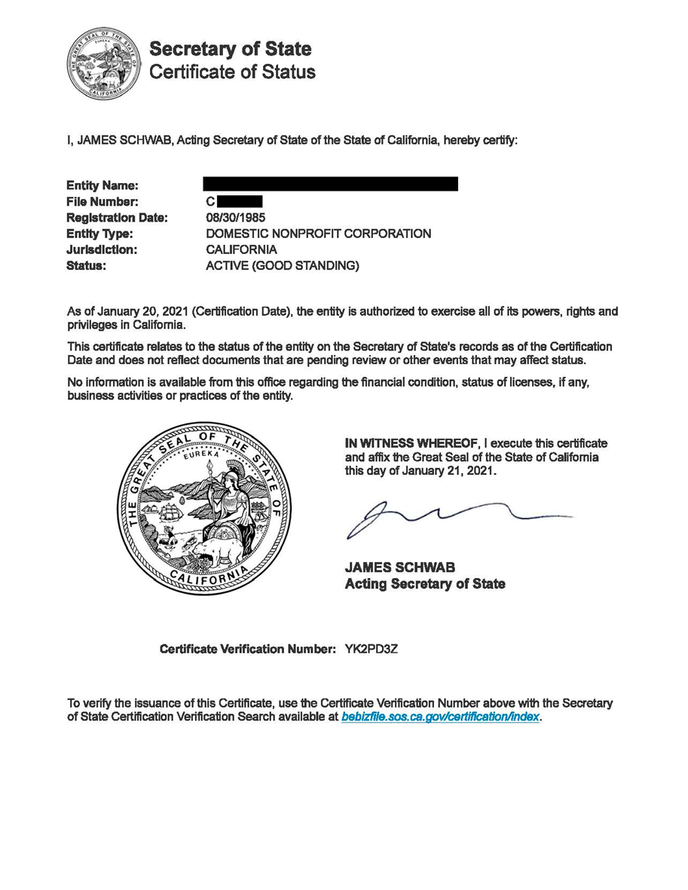

Figure 2: Sample Entity Status Letter from CA Franchise Tax Board

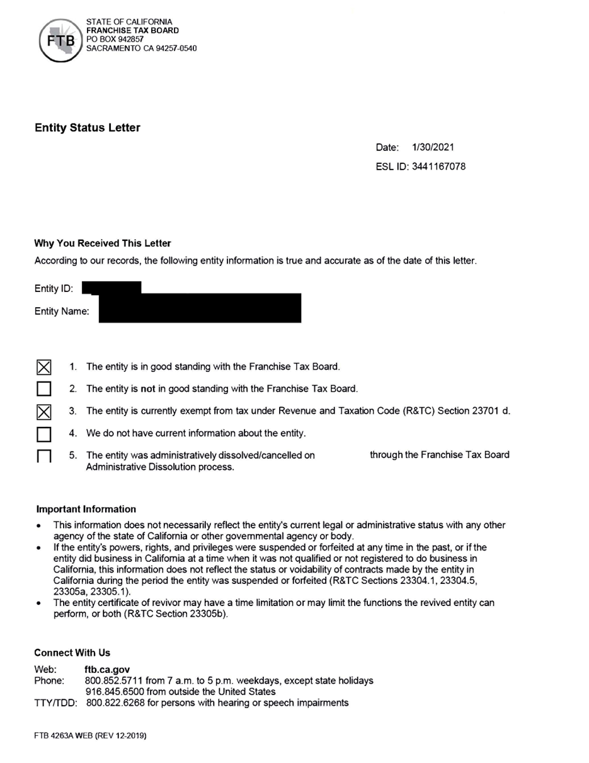

Figure 3: Sample Non-Profit Status Letter from the IRS
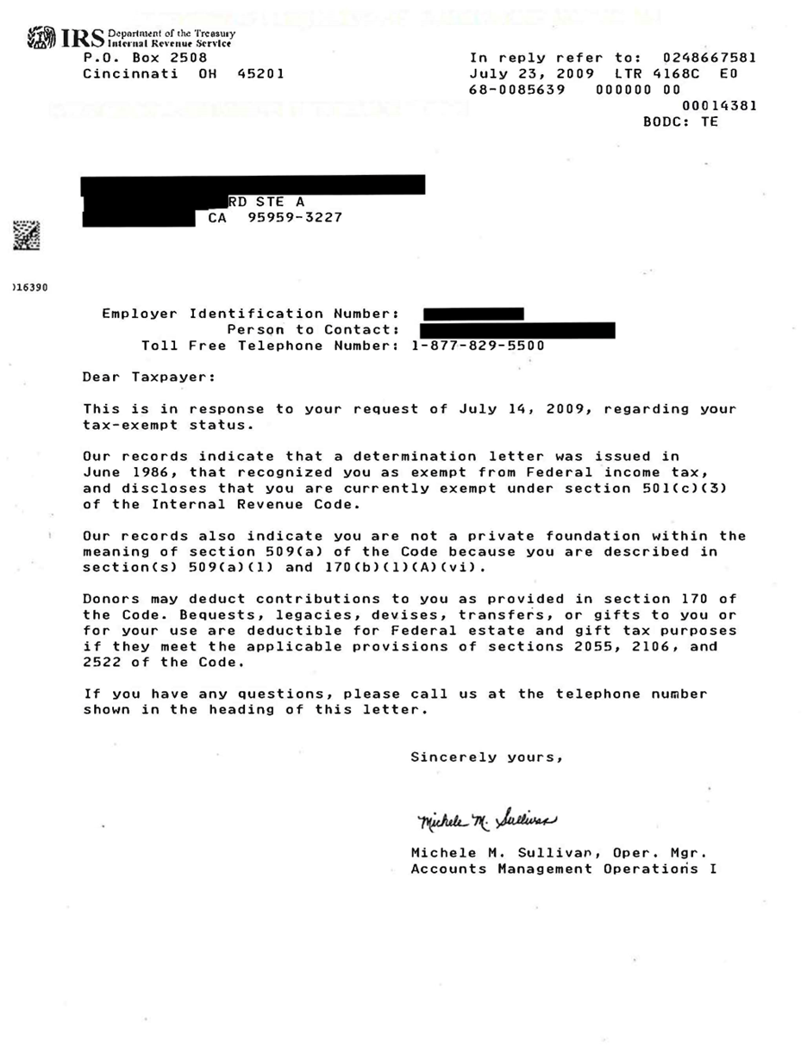

Figure 4: Sample of Proof of Insurance Coverage

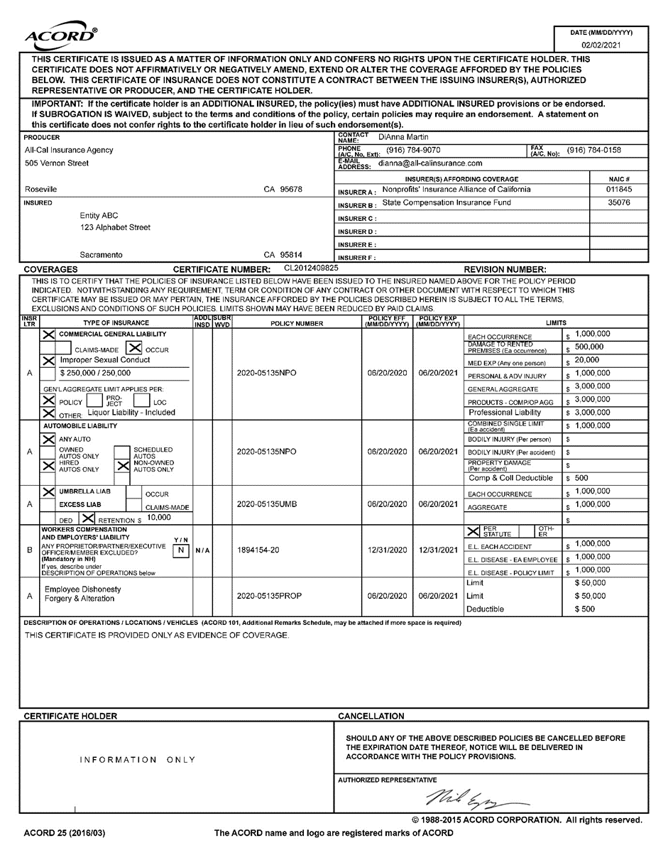

Terms and Conditions

Exhibit A
SCOPE OF WORK
- This Grant Agreement is entered between <<Grantee Name>> and the Department of Rehabilitation (DOR).
- The purpose of this Grant Agreement is to provide eligible Californians of all ages with verified speech or language disabilities access to speech-generating devices (SGDs) and speech-generating applications to increase independent communication. Grantee is to support individuals through education, demonstrations, short-term loan devices (STLs), training, and issuance of long-term loan devices (LTLs).
- The California Public Utilities Commission (CPUC), as part of its Deaf and Disabled Telecommunications Program (DDTP), provides funding for Supplemental Telecommunications Equipment (STE) pursuant to California Public Utilities Code section 2881.4(a)(4)(B).
The DOR, as the designated state unit in California for the provision of vocational rehabilitation services pursuant to the Rehabilitation Act of 1973, as amended, (29 U.S.C. § 701 et seq.) and Welfare and Institutions Code section 19000 et seq., provides vocational rehabilitation services to approximately 110,000 Californians with disabilities annually through its 80 offices throughout the state. Further, the DOR is the designated state unit in California for the provision of assistive technology services authorized by the Assistive Technology Act of 1998, as amended, (29 U.S.C. § 3001, et seq.). As the designated state unit, the DOR partners with independent living centers, schools, colleges, community resource programs, and others to serve Californians with disabilities to achieve employment, independence, and equality.
Grantee is required to comply with applicable provisions of the Public Utilities Code, namely section 2881 and related rulemaking by the CPUC.
- Services shall be provided during the term of <<start date>> or upon final approval from DOR whichever date occurs later, through <<end date>>.
- The services shall be performed at <<Grant program to add the location where services will be provided>>
- The project representatives during the term of this Grant Agreement will be:
Grantor  Department of Rehabilitation | Grantee  <<Grantee Name>>
Name: <<DOR staff person responsible for the program>> | Name:
Phone: | Phone:
Email: | Email
Direct all inquiries to:
Grantor  Department of Rehabilitation | Grantee  <<Grantee Name>>
Section: | Section/Unit: N/A
Point of Contact: <<DOR Grant Manager>> | Point of Contact:
Phone: | Phone:
Email: | Email:
Either party may change any portion of the above contact information by providing thirty (30) days written notice of the change to the other party. No amendment of this Grant Agreement is required to make such a change.
- Service to be performed:
  - Individual Identification & Eligibility
    - Identify individuals of all ages with a speech or language disability who have difficulty speaking or cannot speak.
    - Verify eligibility via referral/recommendation from an approved clinician or specialist.
  - Demonstrations, STLs, and Training
    - Maintain demonstration SGDs preloaded with seven (7) VOP applications:
      - GoTalk NOW Plus
      - LAMP Words for Life
      - Predictable (available for Android devices)
      - Proloquo2Go
      - Proloquo4Text
      - TouchChat HD w/ WordPower
      - TD Snap
    - Provide STL devices for a duration of 2–14 calendar days with the seven apps to allow individuals to use for a trial period and select the most suitable app.
    - Conduct education and training on the SGD’s accessibility features and application use.
    - DOR reserves the right to add additional approved SGDs and speech-generating applications, as approved by CPUC.
  - LTL Issuance
    - Provide LTL devices of new iPads, new Android, or other CPUC-approved SGDs with one VOP application selected by the individual to support independent communication.
  - Apple and Google App Store Account & Gift Codes
    - Maintain an Apple and/or Google App Store account to purchase redeemable gift codes for approved VOP apps (one per LTL device).
    - Submit gift code receipts with invoices for reimbursement.
  - Documentation & Records
    - Complete an LTL device Application and individual served survey for each issued device. DOR staff will provide applications and surveys.
    - Retain financial and program records, including equipment purchase receipts, for seven (7) years after the grant period.
  - Outreach & Referral
    - Conduct outreach and make referrals as appropriate to the California Connect and Voice Options programs.

Exhibit B
BUDGET DETAIL AND PAYMENT PROVISIONS
- The Department of Rehabilitation (DOR) shall have no obligation to disburse any funds under this Grant Agreement unless and until all conditions herein are satisfied. The grant award amount is <<Grant program to add funding amount>>. This Grant Agreement provides the Grantee access to funding strictly on a reimbursement basis subject to the following conditions:
- Reimbursement shall not exceed <<Grant program to add dollar amount>>;
- Any disbursement is contingent upon the following:
  - Availability of funds;
  - Satisfactory performance by the Grantee in accordance with this Grant Agreement; and
  - Written authorization by the DOR Grant Manager prior to payment.
No obligation shall arise unless all conditions are met and funds are appropriated and available.
- Reimbursement and Billing
  - All authorized expenditures shall be reimbursed in arrears upon receipt of complete invoices, including required documentation.
  - Invoices shall be submitted to DOR no later than 60 calendar days after the date of service (or date goods received). Invoices that are submitted more than one year late will be disputed pursuant to Government Code Section 911.2. All invoices are to be submitted electronically to VoiceOptions@dor.ca.gov.
  - Grantees that provide incomplete invoices will be notified via email to resubmit a corrected invoice. The corrected invoice will need to be recompiled into one new document.
  - Grantees will receive a “Notice of Dispute” for any billing that requires correction prior to being processed by DOR.
  - Invoices must be submitted on the invoice form provided by DOR and contain the following information:
- Invoice number (H number) supplied by DOR in Funding Request Approval email
- Original signature of a person authorized to request payment on the signature authorization form
- Grant agreement number
- Itemization of expenses including purchase amounts
Invoices should be accompanied by the following:
- Approved Funding Request form reflecting the assigned invoice number (H number)
- Receipts for each non-personnel expense reflecting the date of the purchase
- Fiscal documentation to all expenses incurred during the invoicing period
  - The Grantee shall retain backup documentation for audit purposes available to DOR upon request. The Grantee shall include appropriate provisions in any sub agreement to secure adequate backup documentation to verify all subgrantee services and expenses invoiced for payment under this Grant Agreement.
- Restricted Uses of Voice Options Program Funding
- Shipping expenses cannot exceed $100 per long-term iPad loan provided to a consumer.
- Indirect costs are ineligible for reimbursement.
- Program funding may not generally be used for consumers who have already received a device through the Voice Options Program. If a consumer received a Voice Options iPad prior to literacy and has outgrown the speech-generating application they obtained, they may qualify to receive a more suitable speech-generating application.
- Prepayment for services that will be fulfilled following the end of the funding period are ineligible for reimbursement. If only a portion of the service delivery period for an eligible program expense occurs during the funding period, the reimbursement will be pro-rated to cover the funding period portion.
- A consumer receiving Voice Options Program equipment must have a speech or language disability and be referred by a licensed physician and surgeon, audiologist, licensed speech-language pathologist, physician assistant, nurse practitioner, or a qualified state or federal agency, pursuant to Public Utilities Code section 2881.
- Travel will be reimbursed at actual costs not to exceed the California Department of Human Resources (CalHR) designated rates for excluded employees.
- No payments shall be made directly to a consumer.
- Reduction or Depletion of Grant Funds:
Grant funds may be reduced or depleted prior to the end of the funding period. If this occurs, this grant will be considered invalid and have no further force or effect. Grantees shall not be obligated to perform any provisions of this grant. Grantees will be notified immediately, in writing, when funding is depleted.
- Budget Contingency Clause
It is mutually agree that this grant shall be of no further force and effect if the Budget Act of the current year and/or any subsequent years, if applicable, covered under this grant does not appropriate sufficient funds. In this event, the State shall have no liability to pay any funds whatsoever to the Grantee or to furnish any other considerations under this Grant Agreement and the Grantee shall not be obligated to perform any provision of this Grant Agreement.
- Prior Approval of Expenditures
Prior to the obligation or expenditure of funds, the Grantee must complete a funding request and submit it to DOR for approval. DOR must approve all funding requests in writing prior to any obligation or expenditure of funds. Goods or services provided without prior authorization from DOR are not eligible for reimbursement.

Exhibit C
TERMS AND CONDITIONS
- Reporting Requirements
The Grantee will comply with the service and reporting requirements established by DOR. On a monthly basis, the Grantee will provide the following:
- Completed LTL Application
- Completed survey, provided by DOR, for each consumer that is issued Voice Option Program equipment
- Activity reports showing counts of device demonstrations, STL devices, LTL devices, and outreach efforts
- Any additional reporting deemed necessary for DOR
- Consumer Identification
All consumer information that is submitted to the DOR, should be deidentified. This means that NO employee of the State should be capable of identifying a consumer based off the information submitted. To achieve this, all paperwork should utilize unique identifiers for consumers when submitting encumbrance requests and invoices to DOR. A Unique Identifier is provided by the Grantee to aide in identifying the consumer and in keeping the consumer’s personal information confidential. If any of the invoices submitted to DOR contain any consumer information they will be returned to the provider unapproved until correction has been made.
- State Indemnification
The Grantee agrees to indemnify, defend and save harmless the State, its officers, agents and employees from any and all claims and losses accruing or resulting to any and all Grantees, subgrantees, material people, laborers and any other person, firm or corporation furnishing or supplying work, services, materials or supplies in connection with the performance of this grant and from any and all claims and losses accruing or resulting to any person, firm or corporation who may be injured or damaged by the Grantee in the performance of this grant.
- Nondiscrimination Clause
During the performance of this grant agreement, Grantee and its subgrantees shall not deny the grant’s benefits to any person on the basis of race, religious creed, color, national origin, ancestry, physical disability, mental disability, medical condition, genetic information, marital status, sex, gender, gender identity, gender expression, age, sexual orientation, or military and veteran status, pursuant to Government Code Sections 11135-11139.5, nor shall they unlawfully discriminate, harass, or allow harassment, against any employee or applicant for employment because of sex, race, color, ancestry, religious creed, national origin, disability (including HIV and AIDS), medical condition, age, marital status, sexual orientation, gender identity, denial of family and medical care leave and denial of pregnancy disability leave. Grantees and subgrantees shall insure that the evaluation and treatment of their employees and applicants for employment are free from such discrimination and harassment. Grantee and subgrantees shall comply with the provisions of the Fair Employment and Housing Act (Government Code, Section 12900 et seq.) and the applicable regulations promulgated thereunder (California Code of Regulations, Title 2, Section 7285.0 et seq.). The applicable regulations of the Fair Employment and Housing Commission implementing Government Code, Section 12990 (a-f), set forth in Chapter 5 of Division 4 of Title 2 of the California Code of Regulations, are incorporated into this grant agreement by reference and made a part hereof as if set forth in full. Grantee and its subgrantees shall give written notice of their obligations under this clause to labor organizations with which they have a collective bargaining or other agreement. Grantee shall permit access by representatives of the Department of Fair Employment and Housing and the awarding state agency upon reasonable notice at any time during the normal business hours, but in no case less than 24 hours’ notice, to such of its books, records, accounts, and all other sources of information and its facilities as said Department or Agency shall require to ascertain compliance with this clause.
The Grantee shall include the nondiscrimination and compliance provisions of this clause in its written materials distributed to consumers and employees upon first engagement.
- Termination
The State reserves the right to terminate this Agreement upon thirty (30) days prior written notice to Grantee. The State may terminate this grant and be relieved of any payments should the Grantee fail to perform the requirements of this grant at the time and in the manner herein provided.
In the event of such termination the State may proceed with the work in any manner deemed proper by the State. All costs to the State shall be deducted from any sum due the Grantee under this grant and the balance, if any, shall be paid to the Grantee upon demand.
- Notification
All notices, required by either party, shall be in writing, sent by email
- Audit and Review Requirements
- The State shall reserve the right to conduct inspections, reviews, and/or audits of the Grantee to determine whether the services provided, and the expenditures invoiced by the Grantee were in compliance with this grant and other applicable federal or state statutes and regulations.
- Grantee agrees that Department of Rehabilitation, State Controller’s Office, Department of General Services, Bureau of State Audits, California Public Utilities Commission, or their designated representatives shall have the right to review and to copy any records and supporting documentation pertaining to the performance of the grant, including but not limited to: accounting records, consumer service records, records and evaluations of individuals referred to the program, and other supporting documentation that may be relevant to the audit or investigation.
- Grantee agrees to allow access to such records during normal business hours and to allow interviews of any employees who might reasonably have information related to such records.
- Grantee agrees to maintain all financial and program-related records, for seven years after the grant funding period.
- Americans With Disabilities Act (ADA)
By signing this Agreement, Grantee (Grantee) agrees to comply with the Americans with Disabilities Act (ADA) of 1990, 42 U.S.C. Section 12101 et seq., Section 504 of the Rehabilitation Act of 1973, 29 U.S.C. Section 794, and Government Code Section 11135 et seq., which prohibit discrimination on the basis of disability, as well as the regulations which implement these statutes. Grantee specifically understands and agrees that by entering into this agreement it is obligated to comply with Title II of the ADA where the obligations imposed by Title II are more stringent than the Grantee’s obligations otherwise would be under Title I or Title III of the ADA.
- Drug-Free Workplace
By signing this Agreement, the Grantee hereby certifies, under penalty of perjury under the laws of the State of California, that the Grantee will comply with the requirements of the Drug-Free Workplace Act of 1990 (Government Code Section 8350 et seq.), and will provide a drug-free workplace by taking the following actions, as required by 41 U.S.C. § 701 et seq.:
- Publish a statement notifying employees that unlawful manufacture, distribution, dispensation, possession, or use of a controlled substance is prohibited in the Grantee’s workplace and specifying actions to be taken against employees for violation of such prohibition.
- Establishing an ongoing drug-free awareness program to inform employees about:
- The dangers of drug abuse in the workplace.
- The Grantee’s policy of maintaining a drug-free workplace.
- Any available drug counseling, rehabilitation, and employee assistance programs; and
- The penalties that may be imposed upon employees for drug abuse violations occurring in the workplace.
- Making it a requirement that each employee to be engaged in the performance of the grant be given a copy of the statement required by paragraph (a), above.
- Notifying the employee in the statement required by paragraph (a), that as a condition of employment under the grant, the employee will:
  - Abide by the terms of the statement; and
  - Notify the employer in writing of his or her conviction for a violation of a criminal drug statute occurring in the workplace no later than five calendar days after such conviction.
- Notifying the agency in writing, within ten calendar days after receiving notice under paragraph (d)(ii) from an employee or otherwise receiving actual notice of such conviction. Employers of convicted employees must provide notice, including position title, to every grant officer or other designee, on whose grant activity the convicted employee was working, unless the granting agency has designated a central point for the receipt of such notices. Notice shall include the identification number(s) of each affected grant.
- Taking one of the following actions, within 30 calendar days of receiving notice under paragraph (d)(ii), with respect to any employee who is so convicted:
- Taking appropriate personnel action against such an employee, up to and including termination, consistent with the requirements of the Rehabilitation Act of 1973, as amended; or
- Requiring such employee to participate satisfactorily in a drug abuse assistance or rehabilitation program approved for such purposes by a Federal, State, or local health, law enforcement, or other appropriate agency;
- Making a good faith effort to continue to maintain a drug-free workplace through implementation of paragraphs (one through six).
Failure to comply with these requirements may result in suspension of payments under the grant agreement or termination of the grant agreement or both and the Grantee may be ineligible for award of any future state contracts if the department determines that any of the following has occurred: (1) the Grantee has made false certification, or (2) violates the certification by failing to carry out the requirements as noted above.
- Assurances
The Grantee ensures the following:
        - Materials (including web pages, PowerPoint, brochures) developed under the grant agreement will acknowledge the Department of Rehabilitation. Materials should include the DOR logo. Electronic resources (e.g., webpages) must be accessible with 508 compliances.
        - In other activities (e.g., demonstrations, reutilization, public awareness activities [presentations, expos, press releases], and training), the Grantee will identify itself as a part of the California Department of Rehabilitation Voice Options Program.
        - Funding received by the Grantee will be used to supplement, not supplant, amounts available from other sources for technology-related assistance (e.g. the Grantee will not use funding received to provide direct services to consumers for which alternate funding is available through Vocational Rehabilitation, Medical Assistance, Special Education, or other public sources).
        - The Grantee’s services and programs are available to persons of all ages, regardless of nature or degree of disability.
        - The Grantee will ensure appropriate eligibility verification regarding disability is completed by an approved clinician/specialist/agency for each individual served, in accordance with Public Utilities Code section 2881. In addition, the Grantee will ensure an application is completed, as required by CPUC.
        - The Grantee will ensure appropriate device management, including that demonstration devices remain in Grantee’s possession and be used solely for demonstrations/STL devices.
        - The Grantee is housed in a building free from architectural and communication barriers. The Grantee has a working text telephone (TTY) and/or videophone on site.
        - The Grantee will provide reasonable accommodations to meet the needs of individuals with disabilities seeking services of the Grantee. Upon request, all materials will be available in a timely fashion in alternative formats (including braille, accessible electronic text, etc.)
        - The Grantee will comply with any otherwise applicable provisions of the Americans with Disabilities Act.
        - The Grantee will comply with Section 508 of the Rehabilitation Act (access to electronic information technology). This includes the assurance of accessibility of the Grantee’s website.
        - Grantee’s employees and the officers of its governing body shall avoid any actual or potential conflicts of interest, and no offer or employee who exercises any functions or responsibilities in connection with this Agreement shall have any personal financial interest or benefit which either directly or indirectly arises from this Agreement.
Grantee shall establish safeguards to prohibit its employees or its officers from using their positions for a purpose which could result in private gain or which gives the appearance of being motivated for private gain for themselves or others, particularly those with whom they have family, business, or other ties.
- Debarment, Suspension, Ineligibility and Voluntary Exclusion
Federal and State agencies shall not award assistance to Grantees that are debarred or suspended, or otherwise excluded from or ineligible for participation in federal assistance programs under Executive Order 12549. By signing the Agreement, Grantee certifies that neither it nor its principals or sub grantees are presently debarred, suspended, proposed for debarment, declared ineligible, or voluntarily excluded from participation in this transaction by any federal department or agency.
- Prohibition On Tax Delinquency
Any Agreement that a state agency enters into after July 1, 2012, is void if the grant is between a state agency and a Grantee, or subcontractor, whose name appears on either list of the 500 largest tax delinquencies pursuant to Section 7063 or 19195 of the Revenue and Taxation Code. In accordance with Public Contract Code section 10295.4, agencies are required to cancel Agreements with entities that appear on either list.
Franchise Tax Board - 500 Largest Tax Delinquencies
California Department of Tax and Fee Administration - 500 Largest Tax Delinquencies
- Darfur Contracting Act
By agreeing to this grant, pursuant to Public Contract Code section 10478, the vendor does not currently nor has within the previous three years had business activities or other operations outside of the United States and certifies that it is not a “scrutinized” company as defined in Public Contract Code section 10476.
- Insurance
- Coverage Term - Coverage, specified below, needs to be in force for the complete term of the Grant Agreement. If insurance expires during the term of the grant, the State must receive a new certificate at least 10 days prior to the expiration of this insurance. Any new insurance must still comply with the original terms of the grant.
- Policy Cancellation or Termination and Notice of Non-Renewal - Insurance policies shall contain a provision stating coverage will not be cancelled without 30 days prior written notice to the State. In the event Grantee fails to keep in effect at all times the specified insurance coverage, the State may, in addition to any other remedies it may have, terminate this Grant upon the occurrence of such event, subject to the provisions of this Grant.
- Deductible - Grantee is responsible for any deductible or self-insured retention contained within their insurance program.
- Primary Clause - Any required insurance contained in this grant shall be primary, and not excess or contributory, to any other insurance carried by the State.
- Insurance Carrier Required Rating - All insurance companies must carry a rating acceptable to the Department of General Services Office of Risk and Insurance Management. If the Grantor is self-insured for a portion or all of its insurance, review of financial information including a letter of credit may be required.
- Endorsements - Any required endorsements requested by the State must be physically attached to all requested certificates of insurance and not substituted by referring to such coverage on the certificate of insurance.
- Inadequate Insurance - Inadequate or lack of insurance does not negate the Grantee’s obligations under the grant.
- Insurance Requirements
  - Commercial General Liability
The Grantee shall maintain general liability on an occurrence form with limits not less than $1,000,000 per occurrence for bodily injury and property damage liability combined with a $2,000,000 annual policy aggregate. The policy shall include coverage for liabilities arising out of premises, operations, independent contractors, products, completed operations, personal & advertising injury, and liability assumed under an insured Agreement. This insurance shall apply separately to each insured against whom claim is made or suit is brought subject to the Grantee’s limit of liability. The policy must include:
The State of California, its officers, agents, employees, and servants as additional insured, but only with respect to work performed under the Agreement.
Endorsements must be physically attached to all requested certificates of insurance and not substituted by referring to such coverage on the certificate of insurance. The endorsement must be acceptable to the DGS Office of Risk and Insurance Management.
  - Automobile Liability (If Applicable)
For consumers being provided transportation, the Grantee shall maintain motor vehicle liability with limits not less than $1,000,000 combined single limit per accident. Such insurance shall cover liability arising out of a motor vehicle including owned, hired, and non-owned motor vehicles to include the following additional insurance coverage below.
  - For non-profit organizations
Automobile Liability insurance must include Any-Auto, Hired-Autos, Non-Owned Autos, and any other auto used in performing services under the Agreement. For seating capacity of up to 15 people (includes driver) the certificate of insurance shall state a limit of liability of not less than $1,000,000 per occurrence for bodily injury and property damage liability combined. For seating capacity for 16 passengers or more the certificate of insurance shall state a limit of liability of not less than $5,000,000 per occurrence for bodily injury and property damage liability combined.
The same additional insured designation and endorsement required for general liability is to be provided for this coverage.
  - Workers Compensation and Employers Liability
Grantee shall maintain statutory worker’s compensation and employer’s liability coverage for all its employees who will be engaged in the performance of the Agreement. Employer’s liability limits of $1,000,000 are required.
The workers’ compensation policy shall contain a waiver of subrogation in favor of the State. The waiver of subrogation endorsement shall be provided.
- Confidentiality
- Grantee agrees that any report or material created during the performance of the grant agreement will not be released to any source except as required by this agreement or otherwise authorized by DOR.
- The Grantee shall implement appropriate measures designed to ensure the confidentiality and security of all data and information designated confidential by DOR, protect against any anticipated hazards or threats to the integrity or security of such information, protect against unauthorized access or disclosure of information, and prevent any other action that could result in substantial harm to DOR or an individual identified within the data.
- The Grantee agrees that any information obtained in the performance of the grant agreement is confidential and shall not be published or open to public inspection in any manner, except as authorized by DOR. Permission to disclose information on one occasion or public hearing relating to this grant shall not authorize the Grantee to disclose further such information or disseminate the same or similar information on any other occasion.
- The Grantee shall not issue any news release or public relations item of any nature whatsoever regarding work performed or to be performed under this grant without prior review of the contents thereof by the DOR and receipt of the DOR’s written permission.
- The Grantee shall not comment publicly to the press or any other media regarding this grant or DOR’s actions on the same, except to the DOR’s staff, Grantee’s own personnel, including subcontractors, affiliates, and vendors, involved in the performance of this grant, at public hearings, or in response to questions from a Legislative Committee.
- Grantee agrees to maintain the confidentiality of any information concerning any consumers that the Grantee may obtain in the performance of the grant agreement and specifically agrees to comply with the provisions applicable to such information as set forth in 34 Code of Federal Regulations, Section 361.38, title 9, California Code of Regulations, Section 7140 et seq., and the Information Practices Act of 1977 (California Civil Code Section 1798 et seq.).
- Grantee agrees to report any security breach or information security incident involving consumers’ personal information to the DOR’s Grant Manager and the DOR’s Information Security Officer. The DOR’s Information Security Officer can be contacted via e-mail at isoinfo@dor.ca.gov.
- Security breaches or information security incidents that shall be reported include, but are not limited to:
  - Inappropriate use or unauthorized disclosure of consumers’ personal information by the Grantee or the Subcontractor’s assignees. Disclosure methods include, but are not limited to, electronic, paper, and verbal.
  - Unauthorized access to consumers’ personal information. Information can be held in medium that includes, but is not limited to, electronic and paper
  - Loss or theft of information technology (IT) equipment, electronic devices/media, paper media, or data containing DOR consumers’ personal information. IT equipment and electronic devices/media include, but are not limited to, computers (e.g., laptop and desktop, netbooks, tablets), smartphones, cell phones, CDs, DVDs, USB flash drives, servers, printers, peripherals, assistive technology devices (e.g., note takers, videophones), and copiers. Data can be held in medium that includes, but is not limited to, electronic and paper.
- Grantee agrees to provide annual security and privacy training for all individuals who have access to personal, confidential, or sensitive information relating to the performance of this agreement.
- Grantee agrees to obtain and maintain acknowledgements from all individuals to evidence their understanding of the consequences of violating California privacy laws and the Grantee’s information privacy and security policies.
- For Grantee that do not have a security program that includes annual security and privacy training, a self-training manual is available on the DOR website at the following link: Security and Privacy Training
- Additional training and awareness tools are available at the California Office of Information Security (OIS) website and the California Privacy Protection Agency (CPPA) website.
- Competitive Bidding Requirement for Goods and Contracting Services
  - Grantee shall comply with applicable laws and regulations regarding securing competitive bids and undertaking negotiations in Grantee agreements with other entities for acquisition of goods and services with funds provided by the State or Federal government under this Agreement.
  - The Grantee shall seek prior approval for any purchase of goods or contracting services exceeding $5,000 or more. A minimum of two competitive quotations is required for any purchase order or subcontract agreement for services of $5,000 or more. An adequate written justification on how cost reasonableness was determined in absence of bidding may also be submitted to the grant administrator for prior approval.
  - Documentation of fair and reasonable pricing maybe used in lieu of quotes for purchases under $10,000.
  - Grantees must maintain a copy of the narrative description of the procurement system guidelines, rules or regulations that will be used to make purchases under this Agreement for auditing purposes. The State reserves the right to request a copy of these documents and to inspect the purchasing practices from the Grantee at any time.
  - The Grantee must maintain supporting documentation of all paid vendor/grantee invoices, documents, bids, and other information used in vendor/grantee selection, for inspection for all purchases expended through this grant agreement for auditing purposes.
- Software
Grantee certifies that it has appropriate systems and controls in place to ensure that State funds will not be used in the performance of this grant for the acquisition, operation, or maintenance of computer software in violation of copyright laws.
- Return of Inappropriate Use of Funds
By signing this document, the Grantee certifies that in the event of funds used inappropriately, funds must be returned to the DOR.
- Fraud Awareness
The Grantee/subgrantee has their employees or any individuals performing activities related to this grant shall review the "Fraud Awareness Overview" no later than 30 days upon contract award. The Fraud Awareness Overview maybe viewed at the following internet site: DOR-Fraud Awareness for DOR Contractors and Grantees PowerPoint
- National Voter Registration Act
By signing this grant Agreement, Grantee agrees to implement the provisions of the National Voter Registration Act (42 USC Section 1973gg), in accordance with the State's Procedure for Implementing the National Voter Registration Act and as the courts shall otherwise direct.

