Attachment D: Required Documents Checklist and Assurances
A complete application package must consist of the items identified below. Complete this checklist to confirm the items are included in your application. Place a check mark or “X” next to each item that is being submitted to DOR. For your application to be responsive, all required documents listed below must be returned with application. This checklist must also be returned with your application package.
Checkmark | Required Document
 | Table of Contents (with all sections of the application with corresponding page numbers)
 | Required Attachment Check List (Attachment 1)
 | Cover Sheet and Assurances (Attachment 2) Page 1 signed by an authorized representative
 | Articles of Incorporation
 | Organization’s Annual Corporate Report, as filed with the CA Secretary of State (review Attachment 3 for sample report)
 | Entity status letter from the CA Franchise Tax Board (review Attachment 4 for sample letter)
 | Nonprofit status letter from the Internal Revenue Service (review Attachment 5 for sample letter)
 | Proof of Insurance coverage for General Liability, Worker’s Compensation and, if applicable, Professional Liability (review Attachment 6 for sample certificate)
 | Payee Data Record Form (STD. 204) (form can be found in the California Statewide Forms Directory)
Application Narrative Sections 1 and 2 (maximum of 10 pages) (Attachment A):
Section 1. Organizational Experience and Capacity
Section 2. Proposed Work Plan

Budget and Budget Narrative (maximum of 5 pages for each region) (Attachment B):
- Proposed Budget and Budget Narrative
  - Budget for Region (s) to Serve
  - Budget Narrative for Region (s) to Serve

List of Region(s) to be served (Attachment C):
- Select the region(s) and county(ies) your organization will serve (check all that apply). DOR reserves the right to award one entity per region.

ATTACHMENT 2: Cover Sheet and Assurances
Page 1
Applicant (Organization): _______________________________________________
Physical Address: ______________________________________________________
Mailing Address: _______________________________________________________
City: ____________________________ State: _____________ Zip Code: _________
Tax ID: ______________________________________________________________
Project Director: _______________________________________________________
Phone: ___________________ Email: _____________________________________
Grant Administrator: ____________________________________________________
Phone: ___________________ Email: _____________________________________
Contact Person for Application: ___________________________________________
Phone: ___________________ Email: _____________________________________
The applicant certifies that, to the best of their knowledge and belief, the data and information in this application is true and correct.
Name: ___________________________________________ Date: ______________
Signature: ___________________________________________________________
Page 1 of this Attachment must be completed and signed by the applicant, and one copy of the below-listed required documentation must be returned with the application as outlined in ‘Required Format for Application’ section of the Request for Application (RFA) G26-VOP-01.
ATTACHMENT 2: Cover Sheet and Assurances
Page 2
- Corporate:
  - Copy of organization’s articles of incorporation.
  - Copy of organization’s bylaws.
  - Copy of organization’s annual corporate report, as filed with the California Secretary of State for all organizations who have completed one (1) year of fiscal operation.
- Financial Status:
  - Provide Entity Status letter from the California Franchise Tax Board indicating nonprofit status.
  - Provide Nonprofit status letter from the Internal Revenue Service.
- Licensing and Certification (if applicable):
  - If your organization operates a licensed health facility or facilities, attach a current copy of the certificate(s).
  - Statement that licensing requirements have been met or are in process.
  - The organization agrees to hire, employ, and sub-contract with only licensed and/or certified personnel for the provision of all services that require such licensure and/or certification.
- Compliance with Federal and State Regulations:
By signing the Cover Sheet and Assurances, the applicant agrees to comply with all federal and State legal requirements, including Department of Rehabilitation policies and regulations, which apply to the services being provided.
- Proof of Insurance:
As part of your grant agreement with the Department of Rehabilitation, you are required to carry insurance coverage. An application can be rejected if, after review of the documents submitted under this section, verification of insurance is missing.

ATTACHMENT 2: Cover Sheet and Assurances
Page 3
You must submit applicable:
  - Commercial General Liability Insurance
  - Workers’ Compensation Insurance
  - Professional liability insurance, if applicable
Debarment, Suspension, and Non-procurement
- Is not currently under suspension, debarment, voluntary exclusion, or determination of ineligibility by any federal agency.
- Has not had one or more public transactions (federal, state, and local) terminated within the preceding three years for cause or default.
- Has not been convicted withing the preceding three year of any of the offenses listed in Title 2 C.F.R. section 180.800(a) or had a civil judgement rendered against it for one of those offenses within that time period; and,
- Is not presently indicted for or otherwise criminally or civilly charged by a government entity (federal, state, or local) with commission of any of the offenses listed in Title 2 C.F.R. section 180.800.
Should the Grantee become excluded or disqualified as defined in this section during the life of the Grant, the Grantee must immediately inform the DOR of this exclusion or disqualification.

Figure 1: Sample of Secretary of State Organization’s Annual Corporate Report

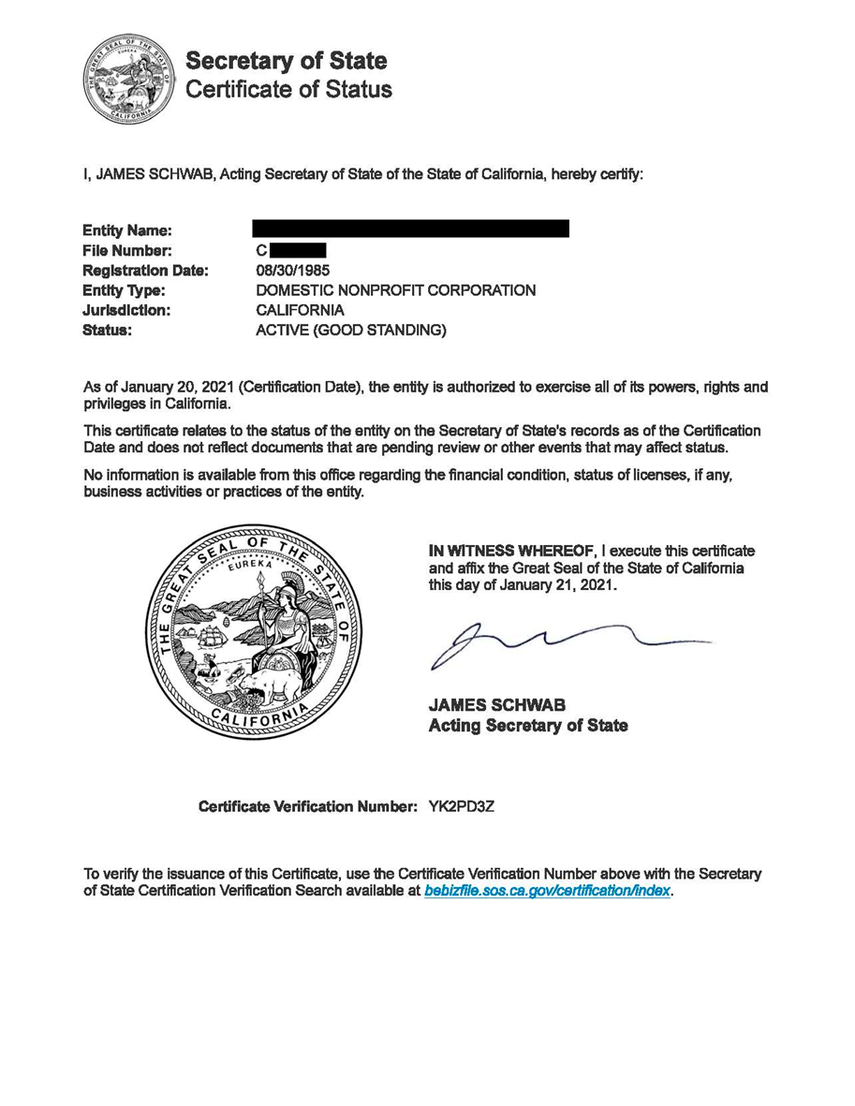

Figure 2: Sample Entity Status Letter from CA Franchise Tax Board

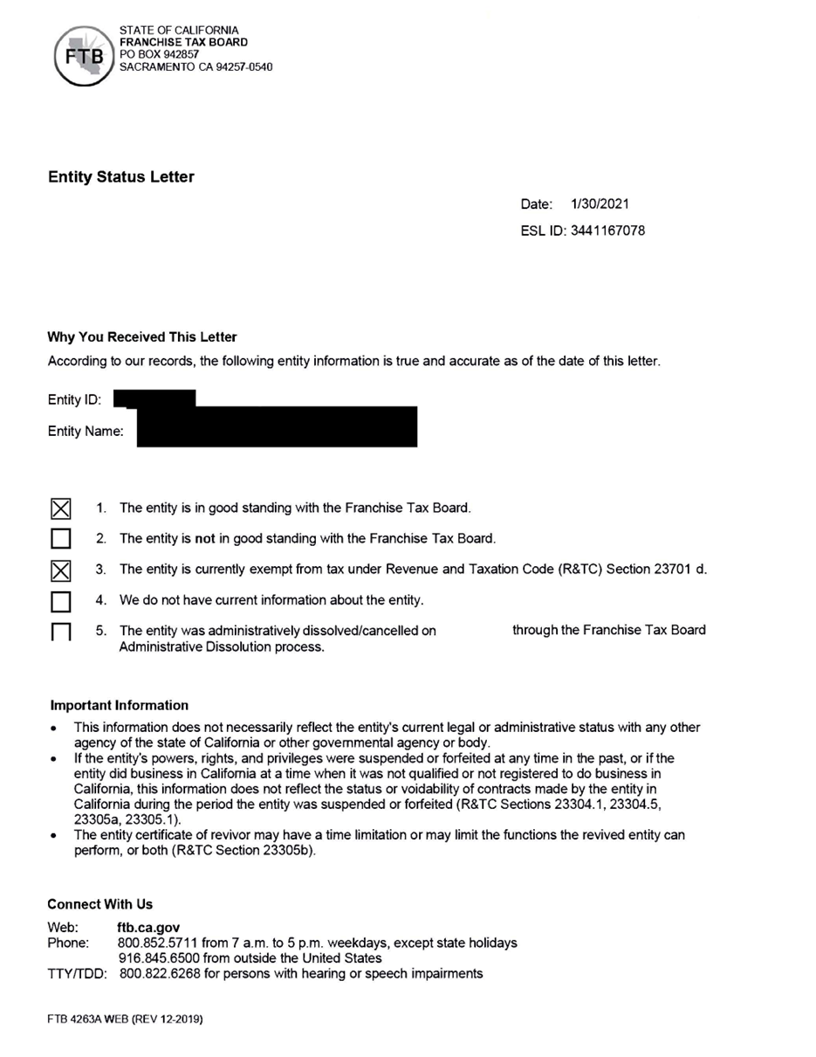

Figure 3: Sample Non-Profit Status Letter from the IRS
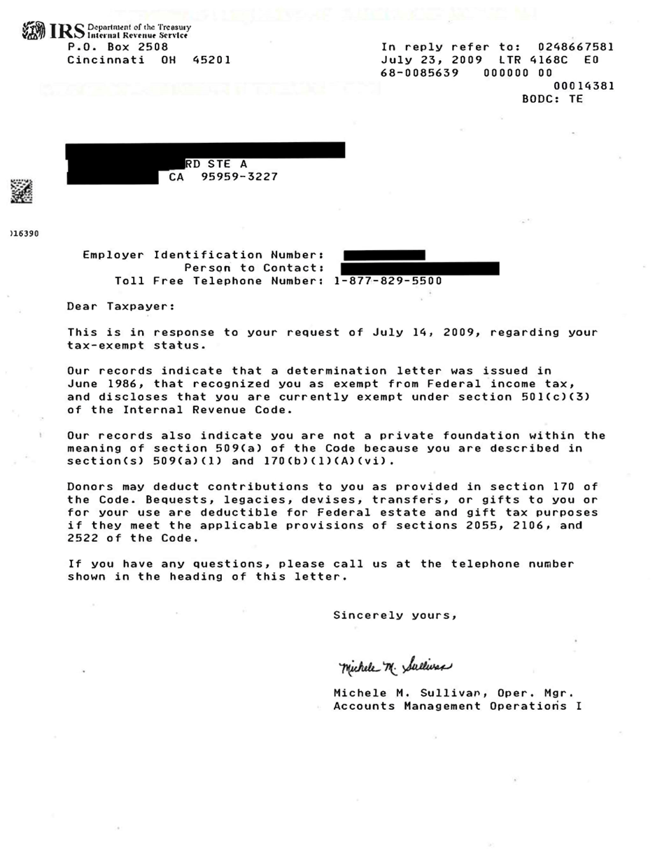

Figure 4: Sample of Proof of Insurance Coverage

