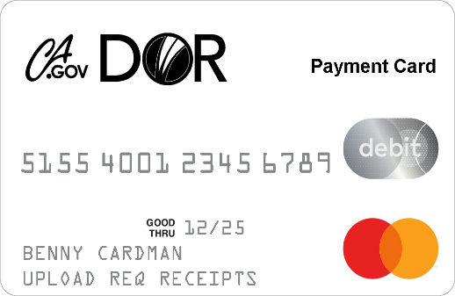



(Updated 2/27/23: Section VII, page 12;

3/1/2023: Section VIII, page 14; 4/25/2023: Section IX, page 17.)

**Participant portal instruction**

The logo of Department of Rehabilitation with Employment, Independence, & Equality.

Table of Contents

**I.** **CalDOR Payment Card Participant Portal Login**: 2

**II.** **Participant Portal Home Page** 4

**III.** **Accounts Tab** 5

**IV.** **Tools & Support** 9

**V.** **Message Center** 9

**VI. Upload the receipt** 10

**VII. Report your Card Lost or Stolen** 13

**VIII. Report Fraudulent Transactions** 15

**IX. Request a Replacement Card** 17

# **CalDOR Payment Card Participant Portal Login**:

From your computer web browser, click on [caldorpaymentcard.lh1ondemand.com](https://caldorpaymentcard.lh1ondemand.com/Login.aspx?ReturnUrl=%2f)

1. In the Login page, enter your **Username** and click **Next** in the **Existing Users** since you were provided a Username when you are enrolled to CalDOR Payment Card. Your username is your first initial, last name, and zip code (ex, jsmith92545) that was listed on your enrollment Agreement form. After initial login, you can choose to change your Username.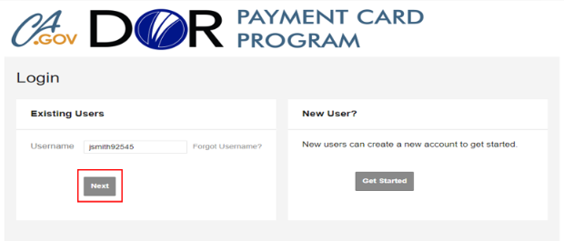
2. Enter your temporary password in the **Password** box and click **Login**. Your temporary auto-assigned password will be your first name, last name, and zip code that you listed on your Enrollment Agreement form, e.g., jonahsmith92545.

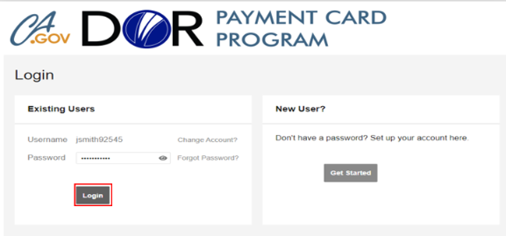

1. Select your **Security Questions** and enter your answer to each question. Then, click **Next**. Remember your answers as you will need to answer at least 1-2 questions to reset your password.

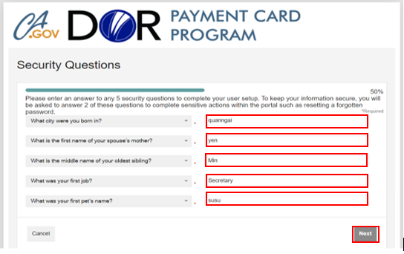

1. Once initial log-in is complete, you will need to change your password. In the **New Password** and **Confirm Password** fields, enter your personally selected password that meets the password requirements listed. Click **Submit**.

***The password hint:*** ***Have a minimum of 8 characters and a maximum of 10 characters. Not be one of your last 3 passwords. Contain upper and lowercase letters. Contain at least number***.

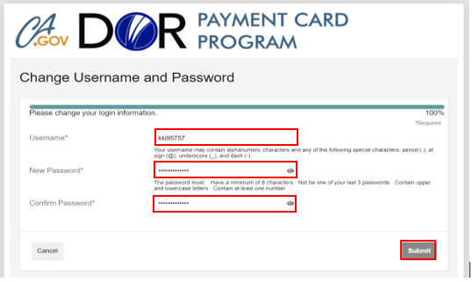

1. On the **CalDOR Payment Card Program Participant Portal** home page, a message will show the successful update of your Usename and Password.

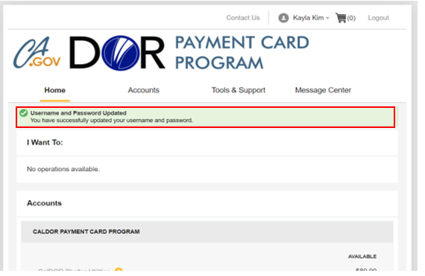

1. **Participant Portal Home Page**
2. From the Home Page, under the “I Want To” you will see the **Accounts** section, you can view your CalDOR Payment Card Service Plan Accounts and the total funds available to purchase and pay for the specific authorized IPE goods and services that have been loaded to your account.

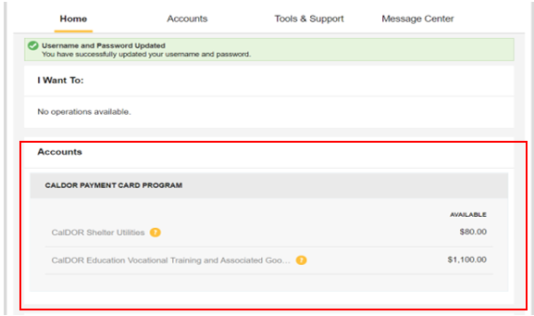

1. If you have questions outside of CalDOR Payment Card Services hours from 5am-5pm Pacific Time, After Hours Self-Help Guidance is available through the link.

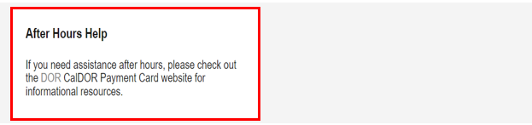

1. **Accounts Tab**

Click on the **Accounts** tab to view the **Accounts** and **Profile** options.

* Under **Accounts** section, **Account Summary**, and **Account Activity** are benefits to you.
* Under **Profile**, **Profile Summary** and **Login Information** are benefits to you.

1. **Accounts**

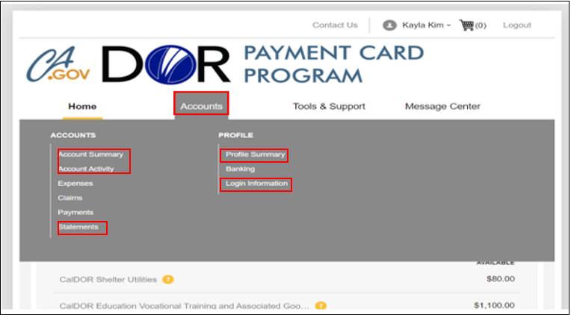

1. Click on **Accounts**/**Account Summary** to viewthe total amounts paid, pending, and available for each Service Plan.

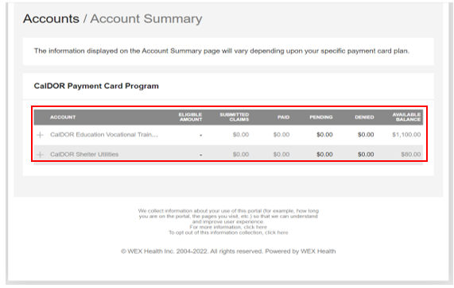

1. Click on **Account Activity** to view total Available Balance for the Service Plan. Under **Activity Details**, you can view a more detailed description of the specific goods and services authorized for purchase and the funds available to pay for the items approved by your DOR Counselor.

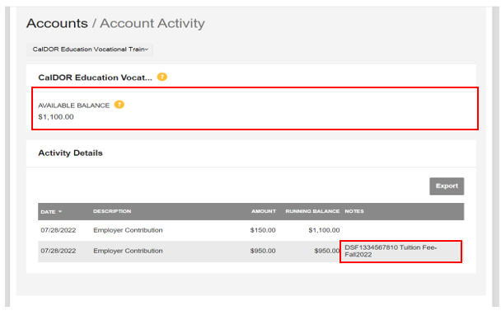

1. **Profile**
2. Click **Profile Summary** to view/update your profile information.

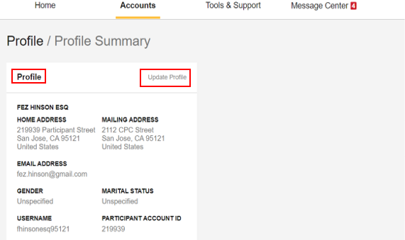

1. Click **Update Profile** to update your mobile cell number and email address, and then click **Submit.**

IMPORTANT: If you need help to reset your password, change your name, or change your physical address/mailing address, please contact your local DOR VR Service Delivery Team.

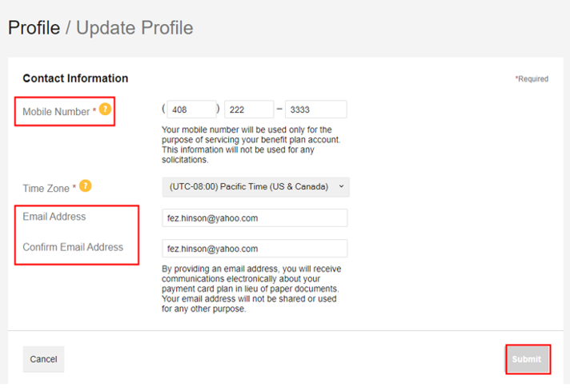

1. Click **Login Information** to change/update your Username or Security Questions. If you need to change your password, select Forgot Password to request a new one to be sent to your email. If you need direct assistance, contact CalDOR Payment Card Services at **1-833-654-3078** or your DOR VR Services Delivery team member.

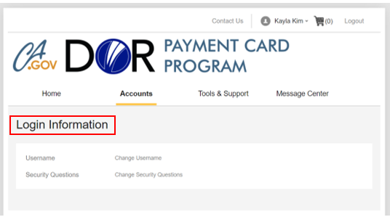

# **Tools & Support**

Under **Tools & Support**, you can find useful information about the CalDOR Payment Card and links to useful resources located on other websites. New content will be added as it becomes available.

* **Document & Forms**
* **Contact Us information**
* **How do I?**
* **Quick Links**

The Tools and support tab of the menu is selected, displaying tools and support, Document & Forms, Contact us information, How do I, Quick Links. 


# **Message Center**

The **Message Center** stores the notifications issued to you related to your account activities, including when:

* Funds are loaded onto your payment card for use to purchase the authorized goods and services at most merchants who offer the items for sale [subject to payment card acceptance]
* CPC updates are released

The message center tab is selected, showing current messages related to your account displayed. The current messages are highlighted with a red box. 


# **VI. Upload the receipt**

From the home page of your participant portal, you will see a notification at the top of the page regarding a receipt(s) needed for your transaction that has been made.

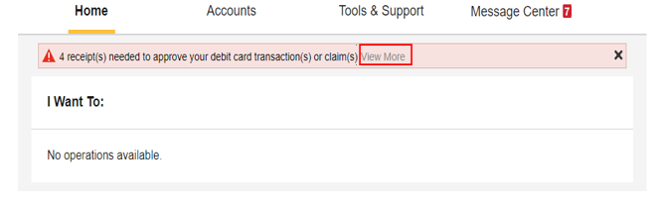

Either click on the View More link or scroll down on the same page to the Tasks section and click on the link with the message that informs you of the number of receipts needed to approve your debit card transaction(s) or claim(s) and upload your receipts here.

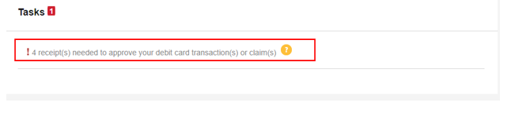

1. **Receipts Needed** window will open and then click **Upload** button to upload your receipt on that transaction.

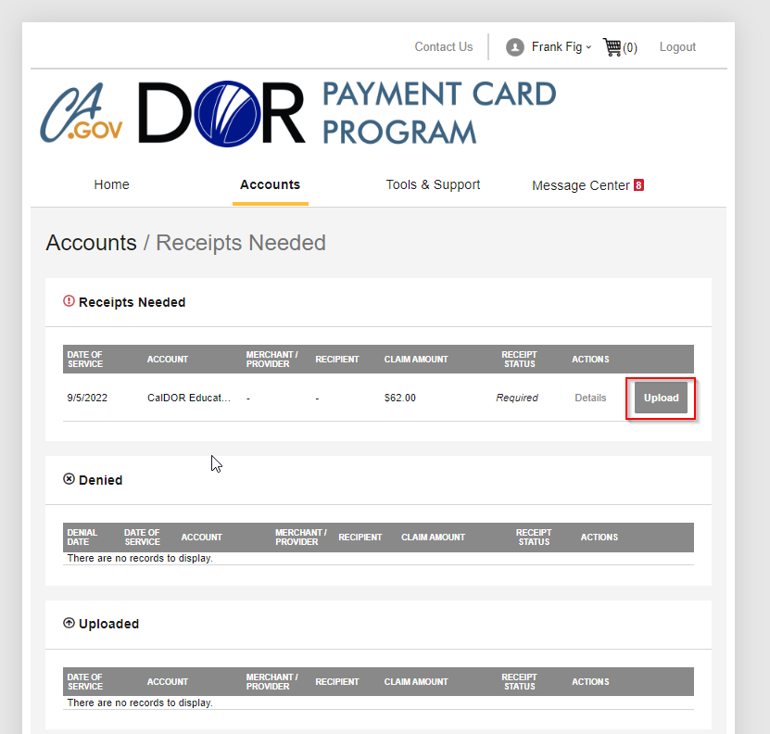

1. Click on **Browse for a file** to select the receipt from your computer and then click **Submit** button.

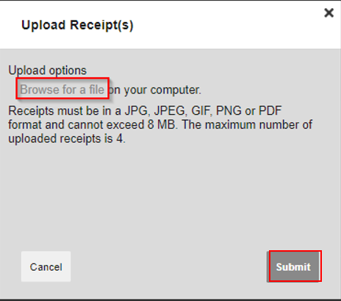

After submitting a receipt, you will see a message showing the receipt has been uploaded.

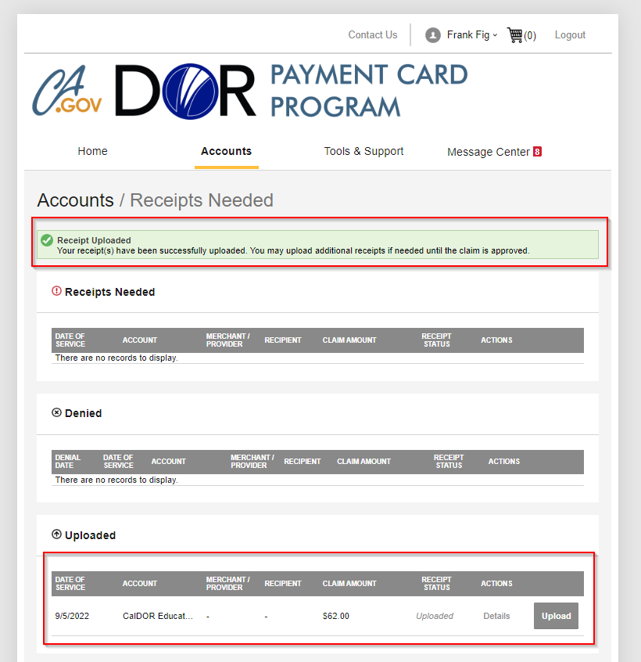

# **VII. Report your Card Lost or Stolen**

A. From the Home page of your account, hover over Accounts with your mouse. Click on Banking/Cards. 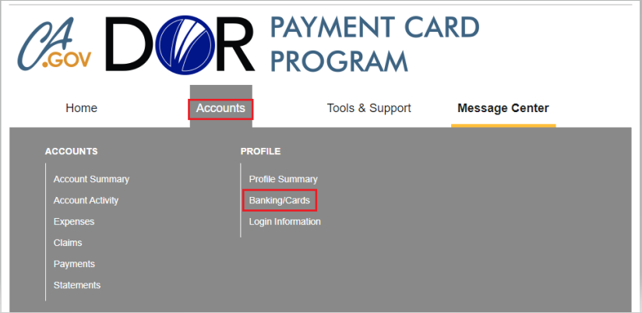

B. Click Report Lost/Stolen hyperlink in the Debit Cards section.

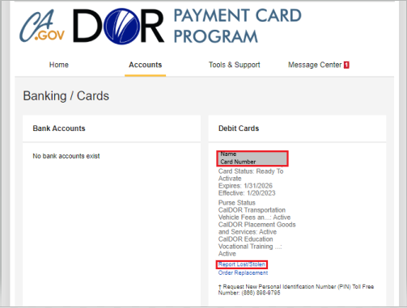

C. Confirm your name and mailing address on ‘Card / Report Card Lost/Stolen’ screen. Read the message and click Submit to finish reporting your card Lost or Stolen.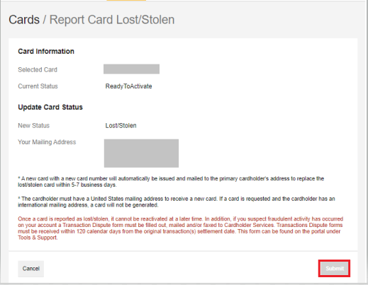

1. Review all recent charges on the card by going to Account Activity and report any fraudulent activity to DOR immediately.

# **VIII. Report Fraudulent Transactions**

A. From the Home page of your account, click on Tools and Support.

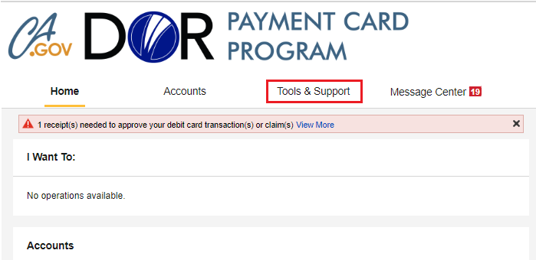

B. Under Forms, click on Transaction Dispute Form. Transaction Dispute form in PDF format will download and open in a new window or tab.

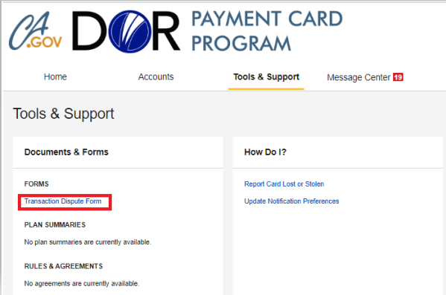

C. Print the form or use the tools on Adobe to fill out the required fields. Follow instructions on the second page to complete the form correctly. Reach out to your counselor if you need additional help with completing the form.

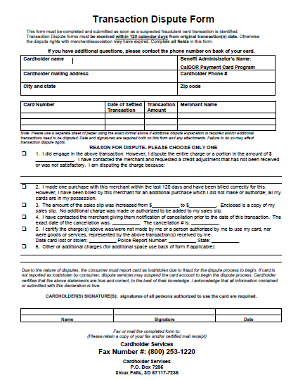

D. **Fax or mail** the completed form to Card Services. Fax number and address are on the bottom of the 1st page. Be sure to keep a copy of the form for your records.

# **IX. Request a Replacement Card**

Replacement card does not de-activate your current card. If your card was lost or stolen, please follow the steps in “Report your Card Lost or Stolen” section. You can request a replacement card 1 of 3 ways:

1. Call CalDOR Payment Card at 833-654-3078.
2. Contact your Local DOR District Rehabilitation Counselor / Support Team.
3. Request a replacement via the participant portal.

Below are the steps on how to request a replacement card using your participant portal account.

1. Log into your portal account.
2. Hover your mouse over Accounts tab, then select the Banking/Cards button.

Screen capture of Consumer Portal account Home screen with Accounts menu displayed. 
Accounts is outlined in red. 
Banking/Cards is outlined in red.

1. Click the Order Replacement hyperlink.

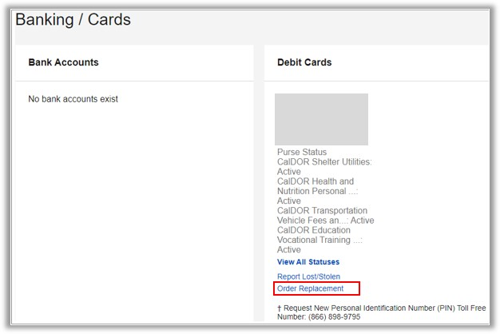

1. Confirm your name and mailing address on ‘Card / Order Replacement Card’ screen. Read the message and click Submit.
   1. If your name and/or address is incorrect, please request a replacement card by calling **833-654-3078**, your DOR Counselor, or DOR VR Service Delivery Team Primary Contact found on your CalDOR Welcome Letter.

Image of Cards/Order Replacement Card screen. 
Card information and Mailing address are redacted. 
Text informs consumer that the card will be issued within 5-7 business days and the mailing address must be a U.S. address or card will not be mailed.
Submit button is outlined in red.