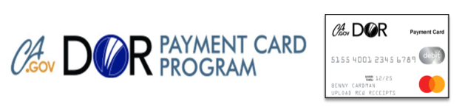
Welcome to CalDOR Payment Card!
You will be receiving your new personalized CalDOR Payment Card in the mail real soon! Be on the lookout for a basic white envelope with CalDOR Payment Card Program in the return address space to make sure you receive it.

Benefits of using this payment card include:
- Faster, convenient, and confidential way to purchase goods and services authorized by your DOR Counselor to help you with your employment goal
- Accepted by most Merchants, either online or at a Point of Sale* Register [*Excludes Square-type payment systems]
- Access to the CalDOR Payment Card Participant Portal to check balances, receive notifications of approved funds when available for authorized goods and/or services, and upload required itemized receipts
- 24/7 monitoring and fraud protection if your card is lost or stolen and you proactively notify CalDOR Payment Card Program Services

Please keep this Welcome letter for reference when you receive your card.

To activate your card, you will need to know your DOR Vocational Rehabilitation Program Participant Identification (PID) Number: #________________

For questions regarding your DOR vocational rehabilitation services:

DOR Counselor:
Phone number:
Email address:

DOR VR Service Delivery Team Primary Contact:
Phone number:
Email address:

For questions specifically regarding CalDOR Payment Card Program Services:
- www.dor.ca.gov - CalDOR Payment Card 24/7 Guidance & Resources
- CalDOR Payment Card Services Center @ 833-654-3078
  - Live Assistance 5:00 AM – 5:00 PM Pacific Time
- CalDOR Payment Card Participant Portal
https://caldorpaymentcard.lh1ondemand.com/Login.aspx

