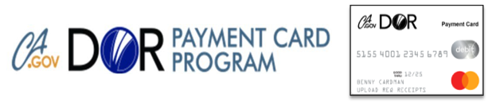

Frequently Asked Questions

How do I reset my Personal Identification Number (PIN)?
- Please call the toll-free number on the back of your card, at 833-654-3078.

What if I forget my Personal Identification Number (PIN)?
- When utilizing the CPC card to purchase authorized goods or services, you will be allowed 3 attempts to enter your PIN number before the card is locked and transactions are declined.
- For this reason, it is important when setting your PIN number to choose a number that you can easily remember.
  - If your card is locked, it will be locked for 24 hours before you can try using your card again.
  - If you would like to reset your PIN Number, please call (866) 898-9795.

How do I request a replacement card? (Lost/Stolen/Damage?)
- To request a replacement card or to report your card as lost or stolen, please contact the CPC Call Center at 833-654-3078 or login to your account online.

How will I know when an authorized fund is loaded to my card for authorized goods & services?
- When funds are issued or loaded to your CPC card, you will receive an email notification informing you funds are ready use. You can also check your balance on your online account.

How can I submit receipts?
- You can easily submit receipts by taking a picture of the entire receipt with your mobile phone and uploaded to your online account at CPC Pariticpant Portal or send in an email to your Counselor.

Can I withdraw cash using the CPC card?
- No, you are unable to withdraw cash from CPC card.

Can I make online purchases using the CPC card?
- Yes, you can use your card for both online and in-store purchases for the authorized goods and services.

How can I update phone number or email address?
- You can easily update your phone number and email address in your online account or contact the CPC Call Center at 833-654-3078.

How can I update my physical address, mailing address, or name change?
- If you need help to change your name, your physical address, or mailing address please contact your local DOR VR Service Delivery Team.

How to request a password change?
- If you need help to change/reset your password, please contact your local DOR VR Service Delivery Team.

