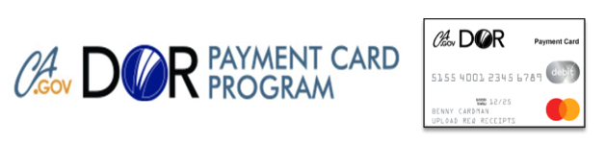

CalDOR Payment Card – Gas/Mileage Allowance Tip Sheet

Upon your DOR Counselor’s approval, authorized VR Transportation funds may be loaded to your CalDOR Payment Card (CPC) to purchase gas for your vehicle. For optimal success, keep in mind the following DOR CPC limitations:

- Select common gas station chains such as Arco, Shell, Chevron, 76, Circle K, 7-11, Mobil and other stations where their main focus is selling gas. This will help to ensure the gas charge will be accepted on your CPC and for card security.
  - Exclusions: The CPC will not work at gas stations that are non-chain locations or part of a grocery store chain, such as Safeway, Walmart/Sam’s Club, or Costco.

- You will need to pre-pay for the gas with a cashier inside the gas station. The card will be declined if you try to pay at the pump.
- Key Tip Reminder: When you inform the cashier of the amount to pay for the gas, be sure that the dollar amount requested is equal or below the amount authorized by your DOR Counselor. DOR is not able to provide any more funds for gas until the following month if needed and approved for your IPE services. Contact your DOR Counselor to discuss a change to your gas allowance if needed.

