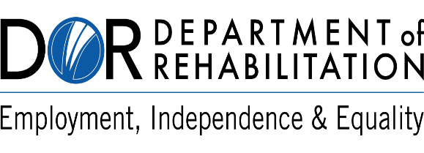

**Changes to Your Invoice Submission Process!**

**Attention DOR Vendors:**

We’re excited to announce a streamlined process for submitting your **invoices for consumer goods and services payments beginning August 1st 2025**. You can now submit your invoices quickly to our new statewide email address.

**New Invoice Submission Email:** [VR**.**INVOICE.SUBMISSIONS@DOR.CA.GOV](mailto:VR.INVOICE.SUBMISSIONS@DOR.CA.GOV)

**What This Means for You:**

* **Improved Efficiency**: Streamlining the submission process means faster invoice processing, fewer delays, and less duplication—helping you get paid more quickly and with less back-and-forth.
* **Submission** **of Service Reports** will need to be sent to the team that sent you the authorization for the consumer service.

**Convenient**: One statewide email simplifies submissions—saving you time and reducing confusion, no matter which district you provide services to.

**Ways You Can (or Options to) Submit:**

1. Utilize the [Vocational Rehabilitation Connections (VRC) Portal](https://www.dor.ca.gov/Home/VRCIntro)

**OR**

1. Send invoices directly to [VR**.**INVOICE.SUBMISSIONS@DOR.CA.GOV](mailto:VR.INVOICE.SUBMISSIONS@DOR.CA.GOV)

**Alternative Submission Option:**

If you prefer to mail your invoice, send it to:

**Department of Rehabilitation - Financial Services Unit**

721 Capitol Mall, 6th Floor

Sacramento, CA 95814

**Need Help with the VRC Portal? Instructions** are available on the [DOR Vocational Rehabilitation Connections Portal](https://www.dor.ca.gov/Home/VRCIntro) page to assist you in navigating DOR’s online system.

Questions? Contact our Field Accounting Team @ [FSR.Field.Accounting@dor.ca.gov](mailto:FSR.Field.Accounting@dor.ca.gov).

Thank you for helping us make the invoice submission process faster and easier for all—so we can pay you timely for the services you provide to DOR consumers!