Limited Examination and Appointment Program (LEAP)
State Internship Program (SIP)
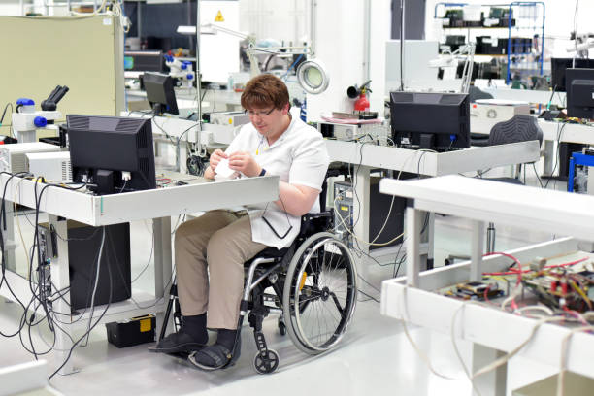

- The State Internship Program (SIP) is an interdepartmental effort between the California Department of Rehabilitation (DOR), Department of Developmental Services (DDS) and the California Department of Human Resources (CalHR) that offers an alternate pathway for persons with intellectual disabilities and developmental disabilities (ID/DD) to become Limited Examination Appointment Program (LEAP) certified.
- The SIP is authorized by legislation until January 1, 2023.

- Historically, persons with ID/DD have not been represented in California state civil service.
- In coordination with DOR and DDS, a SIP intern can become LEAP certified in a state eligible classification and apply for open state positions upon completion of 512-hours of an internship.
- SIP interns receive wages during their internship through the DDS and on-the-job-supports from a Community Rehabilitation Program funded by DOR.

- Coordination of SIP with an interested state agency is facilitated by DOR in collaboration with DDS and CalHR.

To learn more about the SIP and to schedule an introductory meeting, interested state agencies can contact DOR’s Workforce Development Section at 916-558-5423 or Workforce.Development@dor.ca.gov

