The Learner’s Dashboard

Your Dashboard
The following screenshot is a sample of what your dashboard may look like upon logging in.
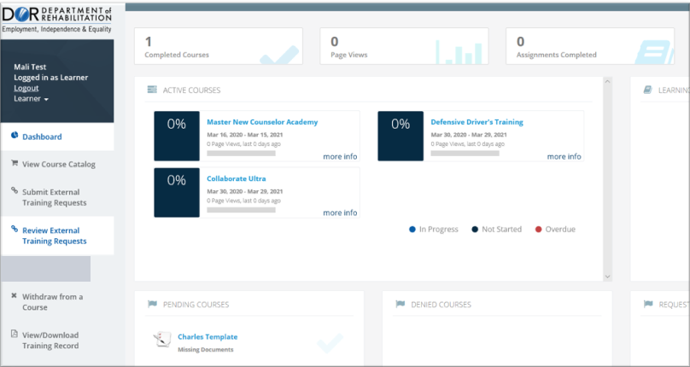

Page Views
Page Views is used to measure your engagement with the course material. It provides a quick snapshot of how many times you have accessed the course materials.
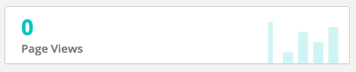

Assignments Completed
Assignments Completed keeps track of the sub-components of a course. Here you can quickly view the number of assignments completed for currently active courses.
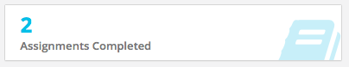

Overdue Courses
Overdue courses are courses in which your progress has not been as fast as expected. You can find this section on the top right-hand corner of your dashboard screen.
Best practices: You will want to make sure this number is low otherwise, you may find you are running out of time to complete your assigned coursework.
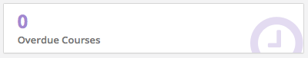

Active Courses
Active Courses shows courses in progress that you are considered an active enrollee in. For each course you are enrolled in, Active Courses provides the following:
- Your grade in the course so far, in percent
- Your status in the course, in a progress bar
- The start and end dates of your course, in MMM-DD-YYYY format
- The number of page views and the number of days since you last accessed the course
- The total time you have spent in each course, in minutes.
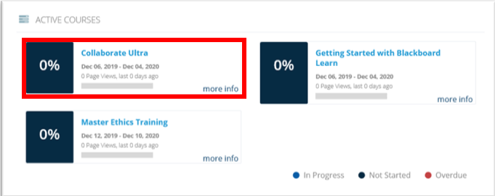
The Dashboard lets you see your progress, performance and engagement:
- Progress is shown through a Progress Bar that gives you a visual cue about how far you have advanced in each of the courses you are enrolled in.
- Performance is also visualized through your cumulative grade to-date in the course. Note that this not your final grade. You should read this result as "what my grade would be today if the course ended right now."
- Finally, engagement is shown by letting you know how many times you have accessed the course's content (your page views) and how long you've spent in the course.
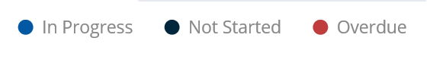
Color Guide

The color of the tiles in your Active Courses tab means the following:
- Blue around the grade for your course means the course is in progress and that you are making good progress toward its completion.
- Black around the grade for your course means the course has not been started yet.
- Red means this course is overdue. This means you are not making progress fast enough to complete the course on time.

Learning Paths
Learning paths allow managers and instructors to group related courses together and to create learning packages that help improve learner skills in a specific area.
The Learner's Dashboard allows you to see the status of each course in each learning path that you are enrolled in, as shown in the Learning Paths box below.
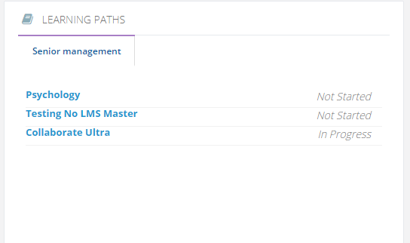
The Learning Paths box uses a tab system. Click on any learning path tab to learn more about your status in that specific set of courses. The name of the Learning Path will become green, and will list:
- All the courses that make up that path
- Your status in those courses (not started, in progress, completed or overdue)
With this tool, you can track your progress toward completing your assigned learning paths, including which courses require your attention to complete the specific learning path.

Pending Courses
Enrollments are not instantaneous. Reason an enrollment might start as Pending Courses:
- Department Approval needed
- Document Prerequisite needed – Some courses require a document to be submitted to your supervisor before you can complete the course.
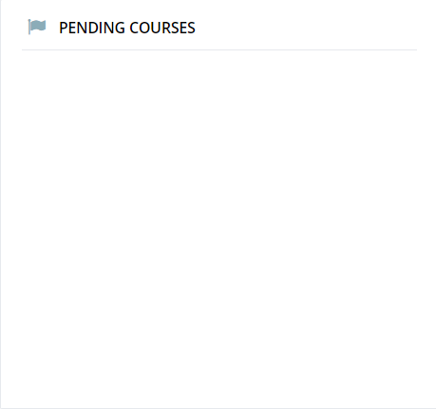

Denied Course
Denied Courses are courses denied by the Department.
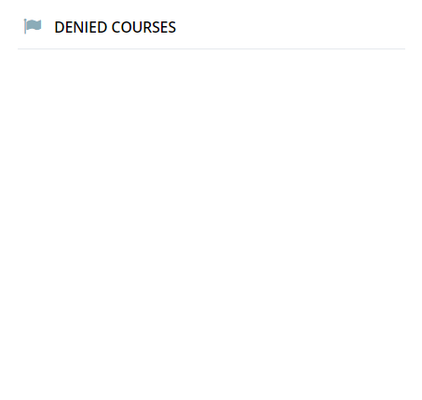

Requested More Information
If the Department requests more information as to why you are requesting to take a course, those requests will appear in the Requested More Information area.

Completed In-House Course
Completed In-House Course are courses you have already passed and obtained your final grade for. These courses are listed separately from your Active courses, so you can quickly scan through your accomplishments to find completion dates and grades. The course link provided will also allow you to click, view and download any training certificates, or uploaded documents that were previously uploaded upon completion of the course.
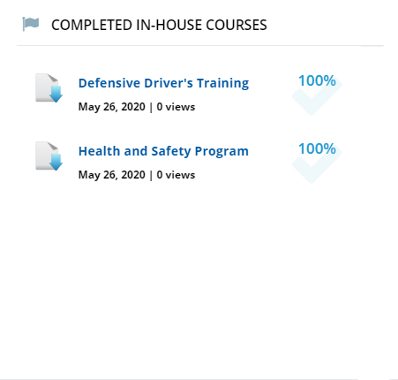

Completed External Courses used by DOR staff Only

Incompleted Courses
Incompleted courses are course that you have yet to complete. Active Courses and Failed course will appear in this area.
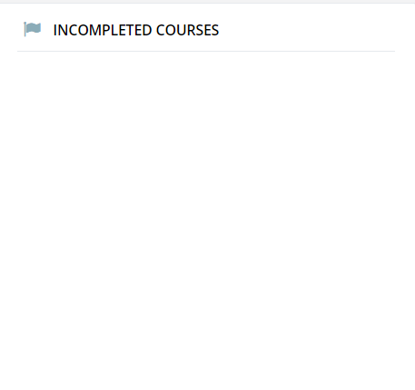
Enrollment Status
Enrollment Status shows a combined status of the courses you are currently enrolled in through a graphic that looks like a pie chart. Using the pie chart, you can quickly view courses that have been completed as well as those that have not been started.
To view your status, simply hover over the pie chart in different areas. Doing so will allow you to toggle back and forth between Not Started and Completed courses.

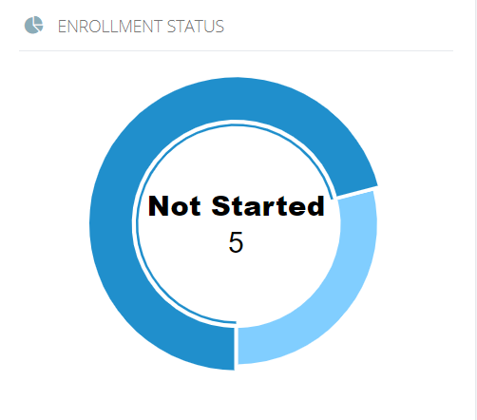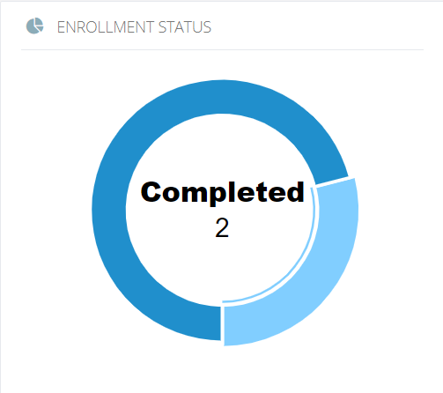

For more information, please visit the Blackboard Learning Management System (LMS) page, located on the DOR website.

