Withdrawing from a Course

- To Withdraw from a course, click on the “Withdraw from a Course” link on the on the left-hand side of the learner dashboard.
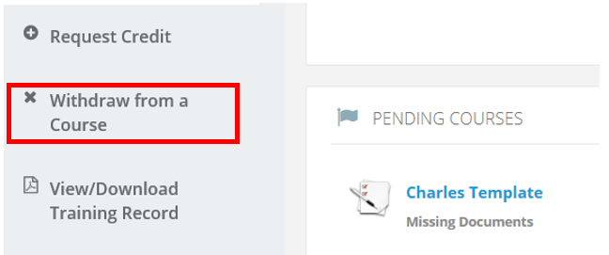
- Click on the “Withdraw from a Course” link on the upper left-hand side of your screen.
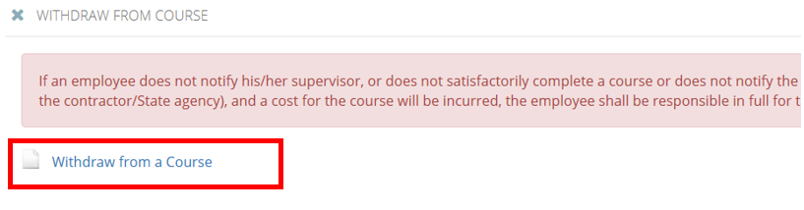
- Once selected, a pop-up window with a drop-down menu will appear, asking you to select the course you wish to drop and provide a reason for doing so.
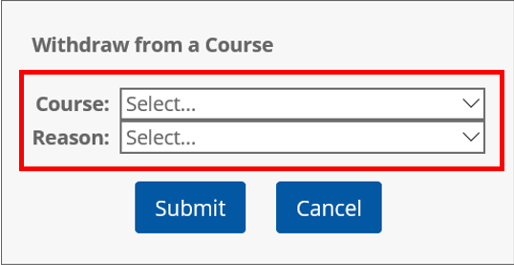

- After making your selection, click “Submit” to send the course withdrawal request to the course instructor and/or manager.
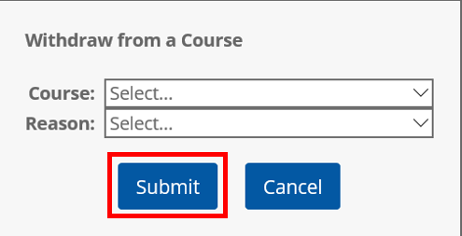

Checking the Status
- To check the status of the course you attempted to withdraw from, simply review the Status section to see whether the withdrawal has been instantly approved or if it requires a waiting or review period.
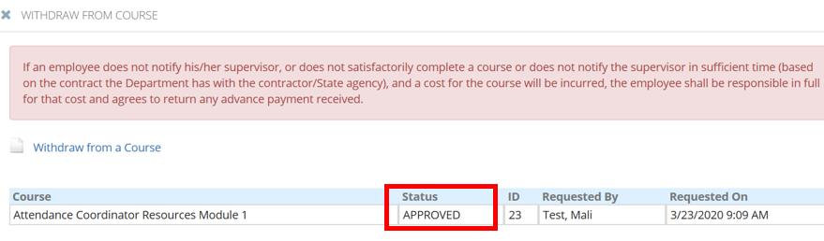
- To return to the main screen, click on Dashboard on the left-hand side of the page.
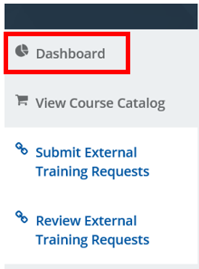

Removing a Course from your Cart
There are two ways to remove courses from your cart.
Option 1:
- To remove a course from your cart, click the Cart icon. A small preview of the courses in your cart will deploy.
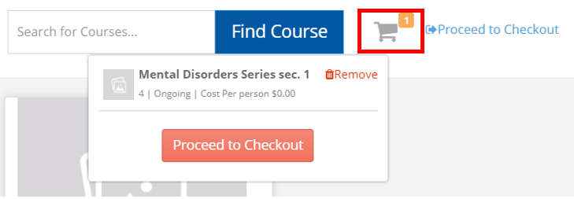
- On the right-hand side of each course, a Trash icon will be available. Click that icon to remove the course from your selection.
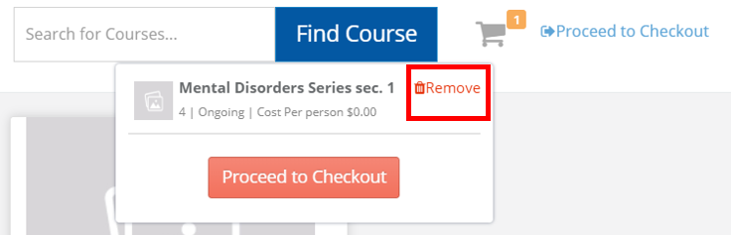
Option 2:
- If you selected Proceed to Checkout but would like to remove the course from your cart, Select the Remove icon located on the right-hand side of the course listing.
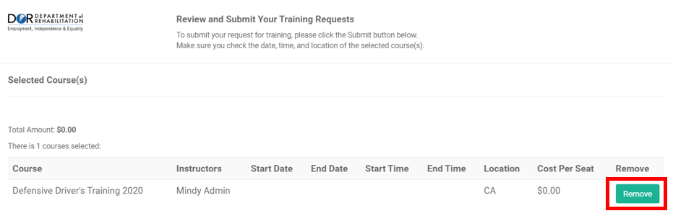

For more information, please visit the Blackboard Learning Management System (LMS) page, located on the DOR website.

