Training Records and Certificates

Accessing your Training Record
- Select the “View/Download Training Record” link on the left-hand side of the learner dashboard. This will generate a PDF with a course-by-course breakdown that includes:
- Your name
- Your ID in the system
- The date the training record was generated
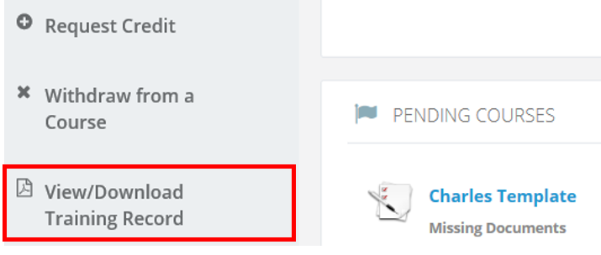
- To download your training record, select the “Click to Download Training Record” link located in the top right-hand corner of your screen.
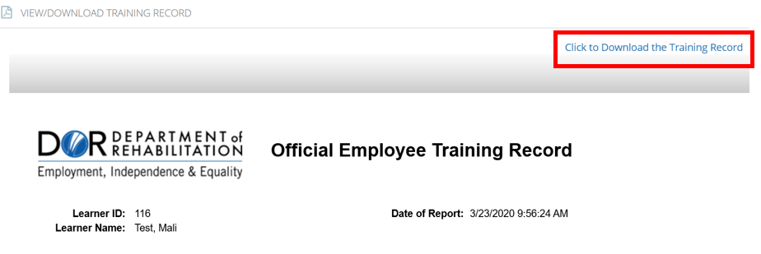
- You should receive a prompt to open or save the file to your computer. Follow the prompting and select your desired function.

Getting your Certificates
- From the learner dashboard, locate the section titled Completed In-House Courses.
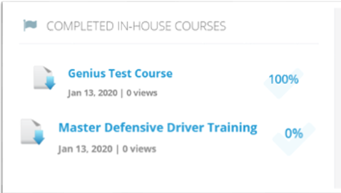
- To print a certificate, select the title of any of the courses you have already completed.
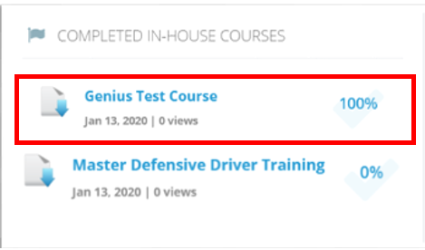
- A box will appear to the left of the course name with a link to the certificate. Select the “Certificate” link.
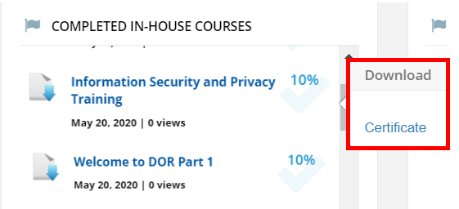
- This will download a copy of your certificate to your computer. Select the box at the bottom of your screen to open the certificate.
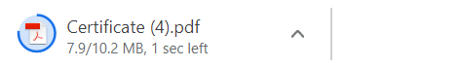
- Once the certificate opens you can either print or save to another location on your computer.

For more information, please visit the Blackboard Learning Management System (LMS) page, located on the DOR website.

