Submitting Proof of Completion
Some courses may require you to submit proof of completion to you supervisor in order to compete the course.
- From the Dashboard, select Submit Proof of Completion.
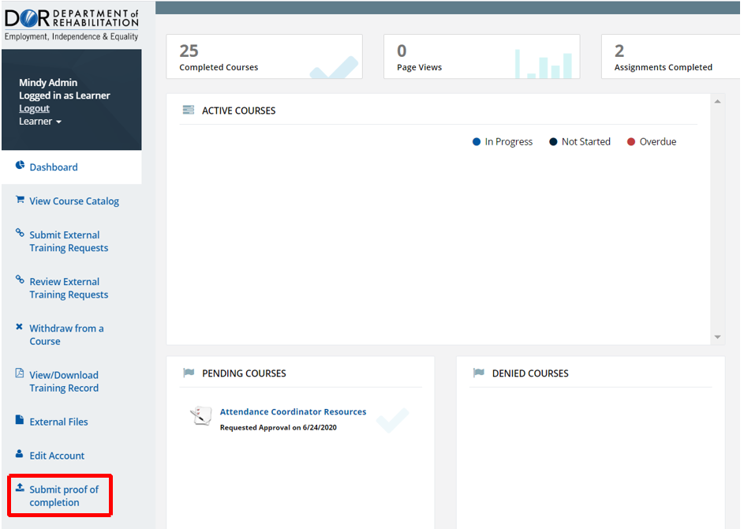
- Select your course from the dropdown menu in the center of the page,
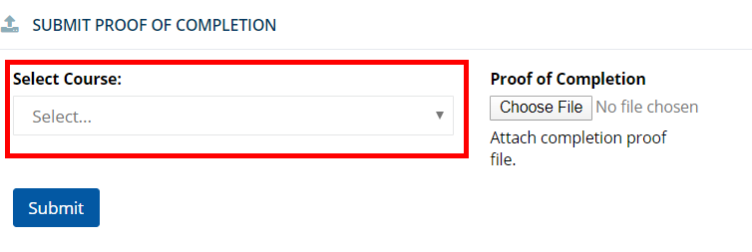

- Select “Choose File” to upload a document from the G drive or your H drive.
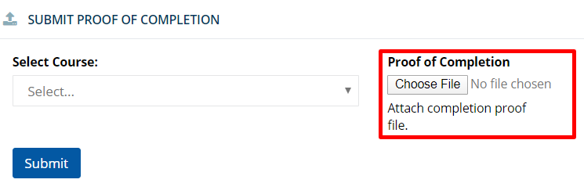
- Select “Submit”.
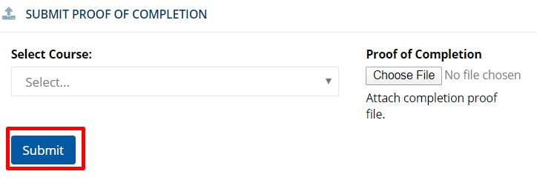
- Your document will show up on the list of submitted documents as “Pending”. Once your supervisor approves your submission, the status will change to “Approved”.
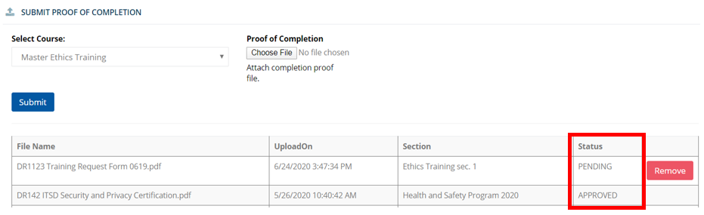
For more information, please visit the Blackboard Learning Management System (LMS) page, located on the DOR website.

