Logging into Blackboard

- There are two options for you to log in to Blackboard.
- DOR website home page – Look for the Blackboard LMS link under Quick Links
- Copy and paste the below link into your Chrome browser. https://dor.geniussis.com/PublicWelcome.aspx. Make sure to bookmark for easy access.

- Select the Partner Log-In button on the Blackboard log-in page
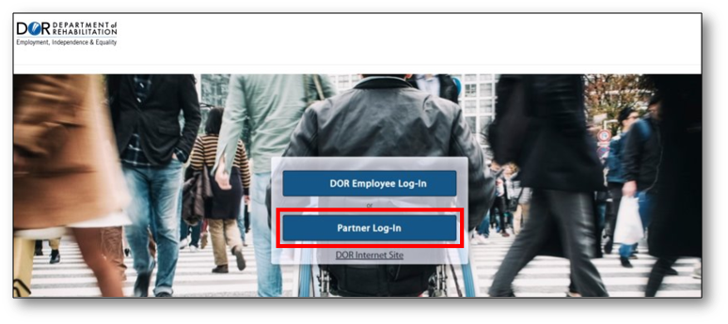
- The first time you log-in, you will need do create an account. To do that select the “Don’t Have an Account?” link under the password field.
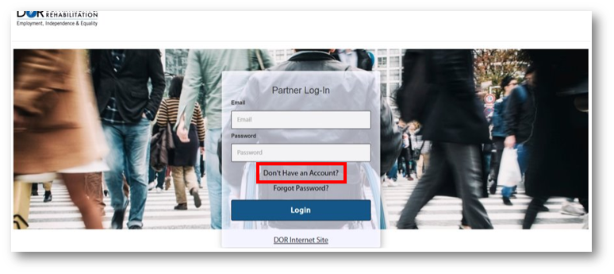
- On the registration page you will need to fill out your first name, last name, email, phone number, and create a password. Your password must contain 12 characters, 1 of those must be a special character, such as an exclamation point, and 1 upper case letter. From the drop down menu under How are you Affiliated with DOR?, select either consumer or customer. If you are a Consumer select Register to continue. A Consumer is someone receiving services from DOR everyone else is a Customer.
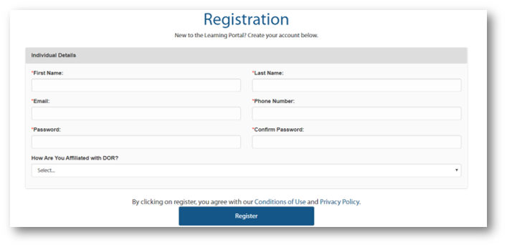
- If you are a Customer, you will need to select your affiliation, input your organization name, work phone number, and work address. Then select Register. Your request will be sent to DOR for approval.
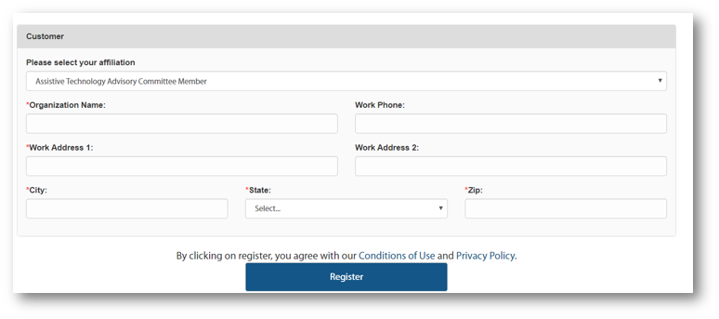
- Once you receive approval, select the Partner Log-In button, then enter your email address and the password you created when you registered.
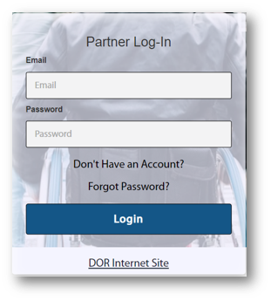

For more information, please visit the Blackboard Learning Management System (LMS) page, located on the DOR website.

