Learning about Courses

- From your dashboard, on the left side of your screen, select View Course Catalog.

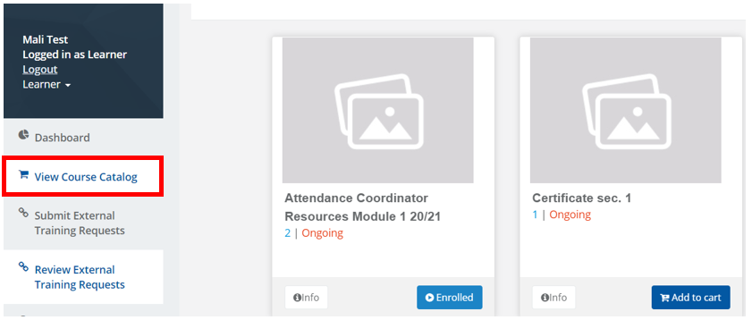

- In the Course Catalog, you will find an Info button on the bottom left corner of each course tile. Click on the Info button to expand an additional window providing course details.
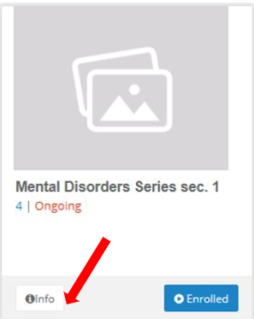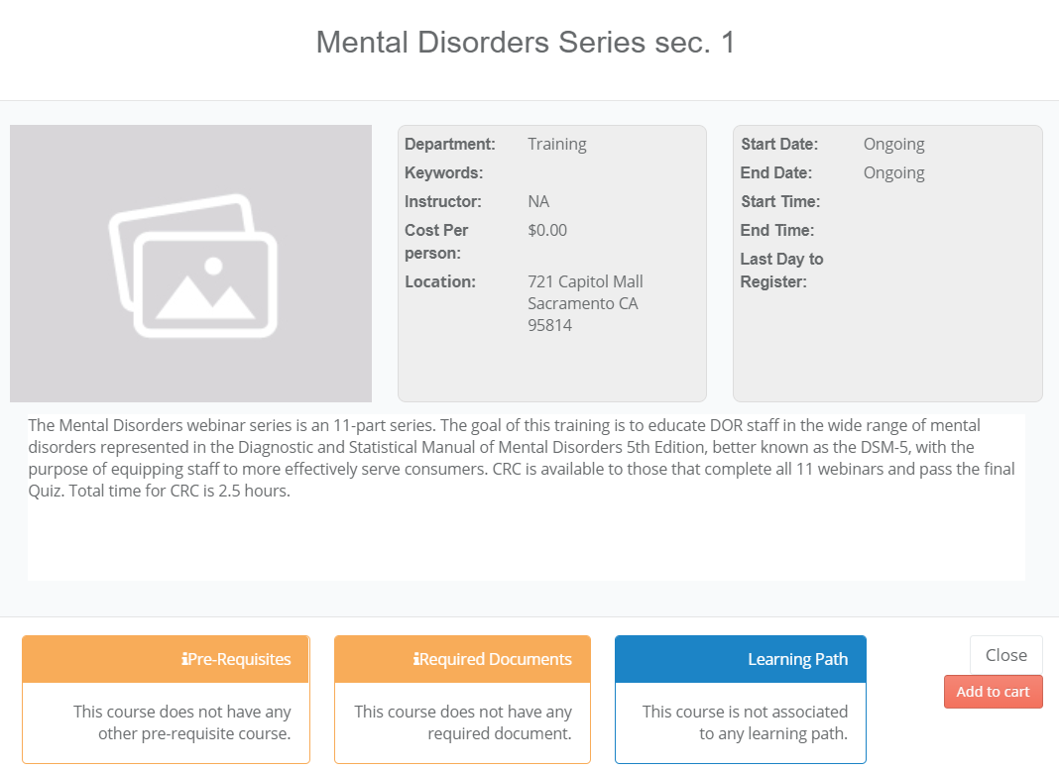
In the course information box, you’ll find:
- A detailed course description
- Instructor(s) name(s), location and date(s)
- Prerequisites, if applicable
- Required Documents, if applicable.
- The course’s learning path, if applicable

- To add the course to your shopping cart, select Add to Cart.

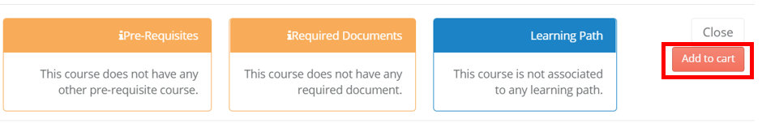

- To exit and return to the course catalog, simply select the Close button inside the course information box.
For more information, please visit the Blackboard Learning Management System (LMS) page, located on the DOR website.

