External Files

External Files
The External Files feature is used to submit an Adobe PDF document. External file submission may be required prior to being enrolled in a course. In this case, the course that requires the external file will display in your Pending Courses and indicate “Missing Documents”. You may submit the required documents by either using the External Files link, or by selecting the course.

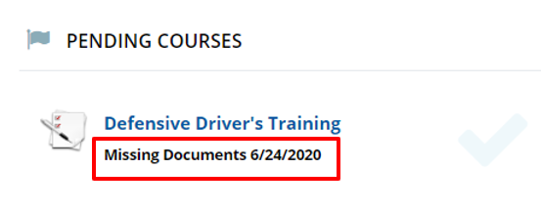

Prerequisite - Regardless of which method used to upload the file, please ensure you have the desired documents saved to a computer location you can access and is in a .pdf format prior to starting the process.

External Files Link

- External Files Link – To locate the External Files link, access the LMS Dashboard. The External Files link is in the left-hand side menu.

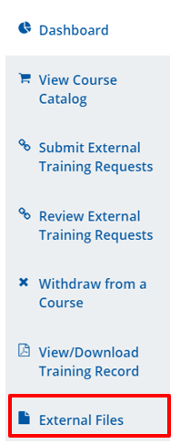
- Select – Select “Add new file” to access the area to upload the desired document.

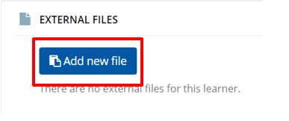

- Describe – In the description area, enter the name of the document you will be uploading. The drop-down menu is prepopulated with External Files that are required for courses. Select the document you will be uploading.
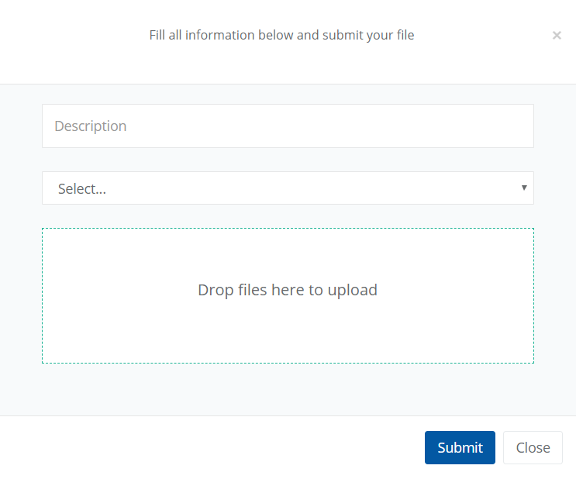

- Search – To search for a document, select the “Drop files here to Upload” area. Once selected a Windows File Search window will appear. Navigate to the correct file and select “Open”.

- Upload – The selected file will begin uploading. Ensure the file is successfully uploaded. If the document was successfully uploaded, the Submit button will aluminate.

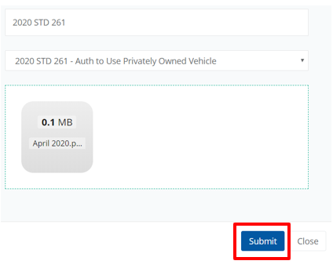

- Review – If completed correctly, External File information will be displayed on the External Files page and include a message “External File Successfully Updated!” The External File was forward to the Manager for review and approval.

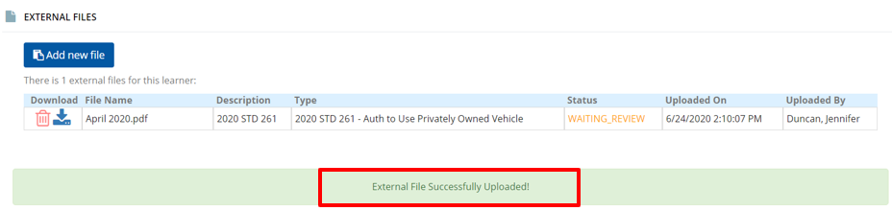

- Approved – Once approved by the Supervisor, the External Files page will display the status as Approved and the pending course will automatically move to Active Courses and you may begin your training.

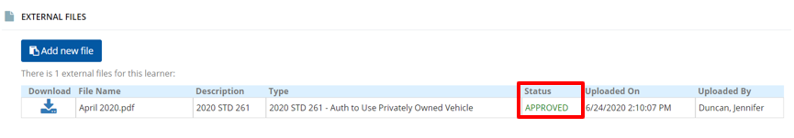

Submitting External Files using Pending Courses

- Course – Select the course you will be submitting the document for. In the example below, we will be submitting a document in order to enroll in Defensive Driver Training.

Upload File – A list of Required Documents will appear. Select the Upload File link to launch the upload window.

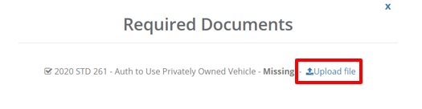

- Identify - The drop-down to identify the file being uploaded is pre-populated with the document type. Please ensure it matches the document type you will be uploading.

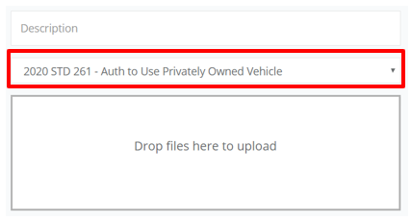

- Complete - To complete the file upload, complete Step 3-6 as indicated above.
For more information, please visit the Blackboard Learning Management System (LMS) page, located on the DOR website.

