Enrolling in Courses

Enrolling in a course is easy. As a learner, you will add courses to your shopping cart, checkout, and learn about the approval process for course enrollments.

Adding a Course to your Shopping Cart
- Select View Course Catalog.
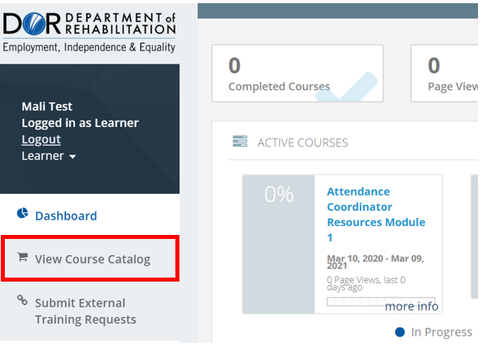
- Before adding a course to the cart please review the more information to determine what the requirements are to complete the course
- Select Add to Cart using the button inside the course tile.
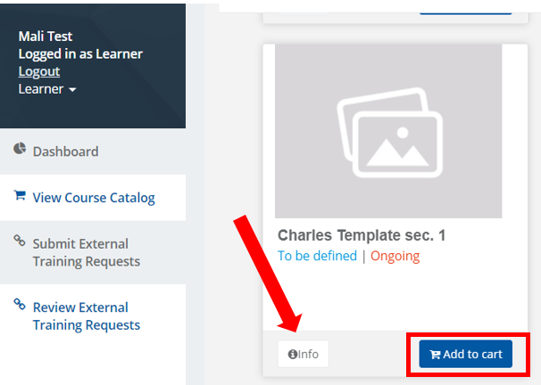

Checking Out
Your Shopping Cart will reflect the courses selected for enrollment by showing a number next to the cart.
- To view all items in your cart, simply click on the shopping cart icon.
- When satisfied with your selection(s), select Proceed to Checkout.
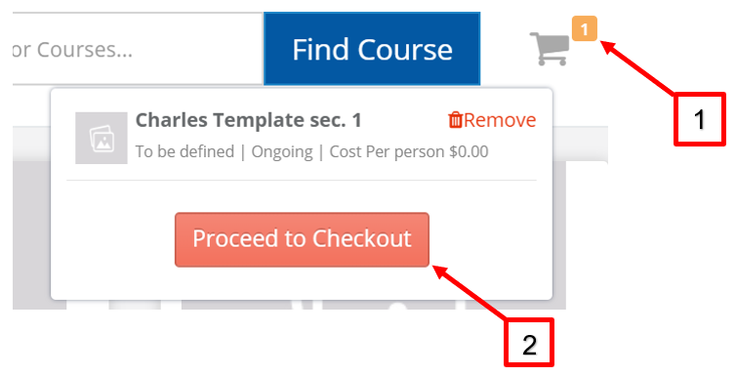
- Review for accuracy and select Submit.
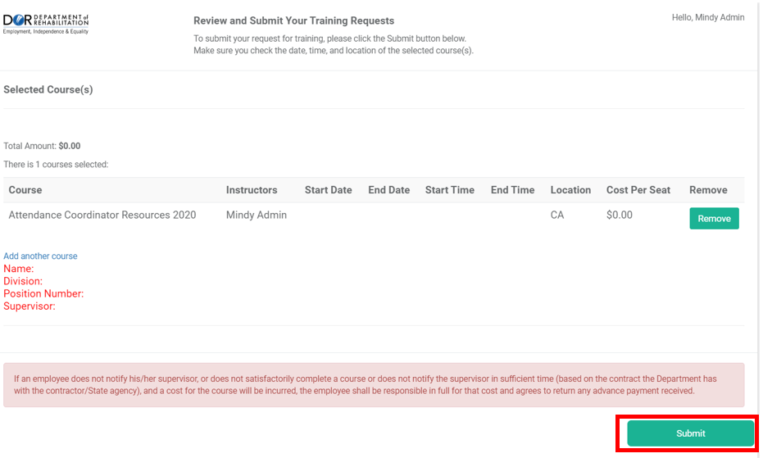
- Once you receive notification that your registration was received, select Go to Dashboard.
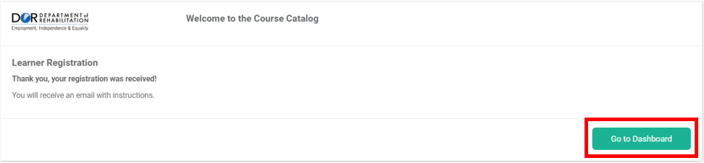
For more information, please visit the Blackboard Learning Management System (LMS) page, located on the DOR website.

