Editing your Account Information

Editing your Account Information
To edit your account, simply log into the Learning Management System (LMS). Then, on the left-hand side of the screen, towards the bottom of the list, select Edit Account.

You will have the option to edit your:
- Personal Information
- Education
- Password
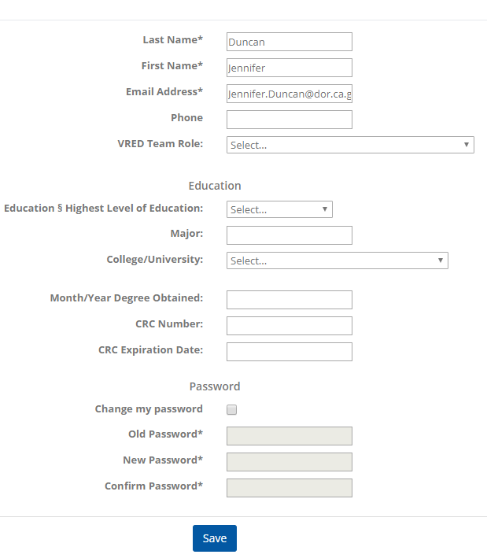

- Personal Information - Your last name, first name, and email address are automatically populated. You can update this information if needed.
- Education - You are not required to update your, VRED Team Role, education information, CRC information. These fields are for DOR staff only.
- Password - You can change your password if needed.

For more information, please visit the Blackboard Learning Management System (LMS) page, located on the DOR website.

