Browsing and Finding Courses

Searching for Courses
To browse and find courses, simply log into the Learning Management System (LMS). Then, on the left-hand side of the screen, directly below the Dashboard, select View Course Catalog.

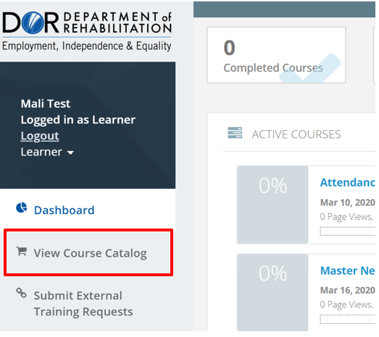

From there, you can search for courses 3 different ways.

- Scroll - By simply scrolling up and down, you can browse all available courses.
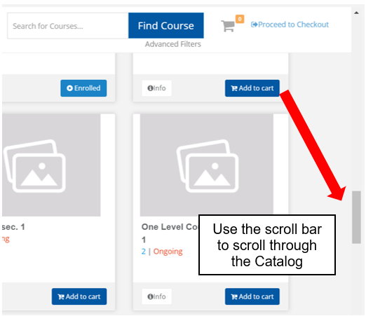
- Search – Use the Search Box to enter key terms to find a course on a specific topic. Click Find Course to see results.

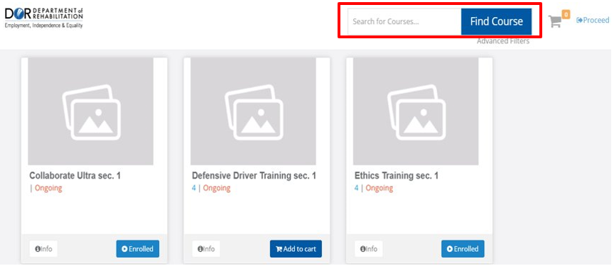

- Use Filters - To access the filters, click on the Advanced Filters link below the Search Box in the Course Catalog. ​

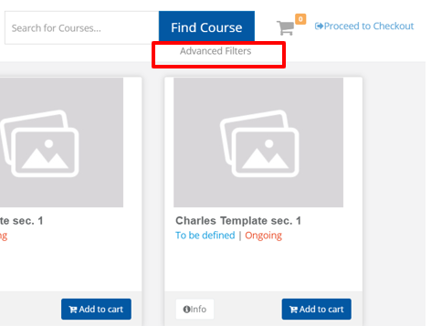

You will see a drop-down menu that allows you to search for courses using specific criteria, such as:
- All Categories
- All Dates
- All Delivery Methods, and
- All Locations

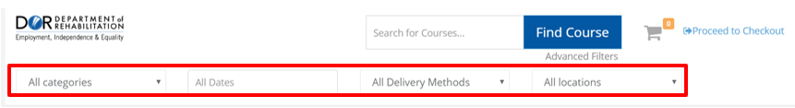

- Filtering by Category – To filter the Course Catalog by Categories, use the drop-down menu to select the category of your choice. Your options will include:
  - All Categories
  - Compliance
  - On-Site Course
  - Training, or
  - Virtual Training

If you are not sure what type of training the course is, the All Categories option provides the largest selection of courses to choose from.

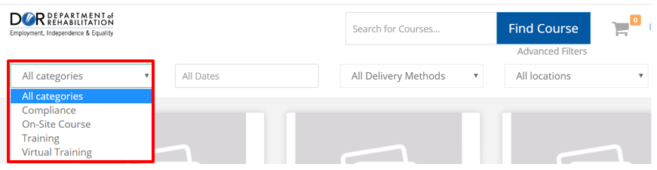

- Filtering by Date - To filter a course by Date, click on the text box All Dates and select the date range by day, month and year. Then select Apply to view courses within the specified date(s).

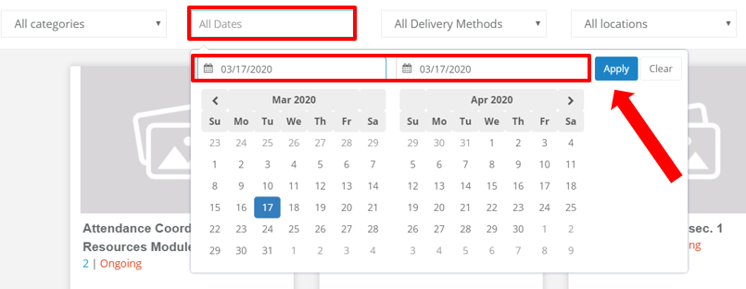

- Filtering by Delivery Method - To filter by Delivery Method, select All Delivery Methods. This will give you a drop-down menu with the following options:
  - Classroom / Instruction Led
  - Webinar
  - Computer Based Training
  - Web-Based Training
  - On-the-Job Training, and
  - Blended

Making a selection from the drop-down menu will automatically populate a selection of courses to choose from.

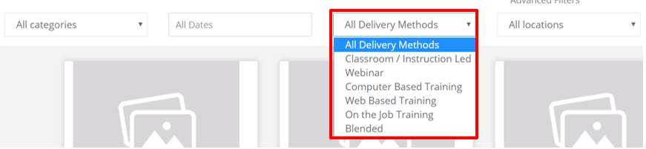

- Filtering by Location - To filter your Course Catalog by Location, click on the All Locations drop-down menu and select your desired location.

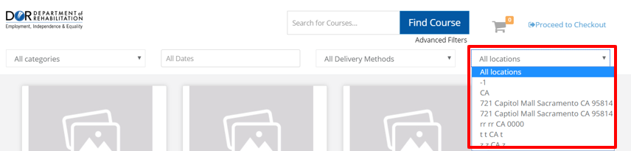

If your results have been limited by selecting specific filters, you can always revert back to using the All criteria under each filter in its original drop-down menu.

For more information, please visit the Blackboard Learning Management System (LMS) page, located on the DOR website.

