DOR Department of Rehabilitation Employment, Independence & Equality



*Welcome to the Department of Rehabilitation Payment Portal (DOR Payment Portal)!*

**GETTING STARTED – New User Guide for BEP Vendors**

**Click this link to access the** [DOR Payment Portal](https://gcc02.safelinks.protection.outlook.com/?url=https%3A%2F%2Fdpm.billeriq.com%2Febpp%2FCADOR%2F&data=05%7C02%7CSharon.Gong%40dor.ca.gov%7C7663193e0fdf41b8eea408dc3ee92c39%7C19ed70549d9743c792b16781b6b95b68%7C0%7C0%7C638454418385856917%7CUnknown%7CTWFpbGZsb3d8eyJWIjoiMC4wLjAwMDAiLCJQIjoiV2luMzIiLCJBTiI6Ik1haWwiLCJXVCI6Mn0%3D%7C0%7C%7C%7C&sdata=ikrc%2FKqyIwXE1lda8BROfDKTsfRrVOuytLIfnv1wsbI%3D&reserved=0)

##### Signing Up for Electronic “Bill” Payment:

1. **What do I need to sign up for the DOR Payment Portal?**

* An active bank account (checking or savings)
  + Note: Credit Card payments are NOT accepted at this time.
* A Personal or Business bank checking or savings account number
* A valid email address

1. **How do I make my first payment?**
2. Click **Pay Now** to open thescreen (image below), enter your **FIRST & LAST NAME** in the **Account Number** field (example: Jack Test)
3. Re-type your **FIRST and LAST NAME** in the **Confirm Account Number** field(example: Bob Smith)
   * Note: These fields are case sensitive
4. Click the box next to **I’m not a robot**,complete the re CAPTCHA authentication process and click **Verify**

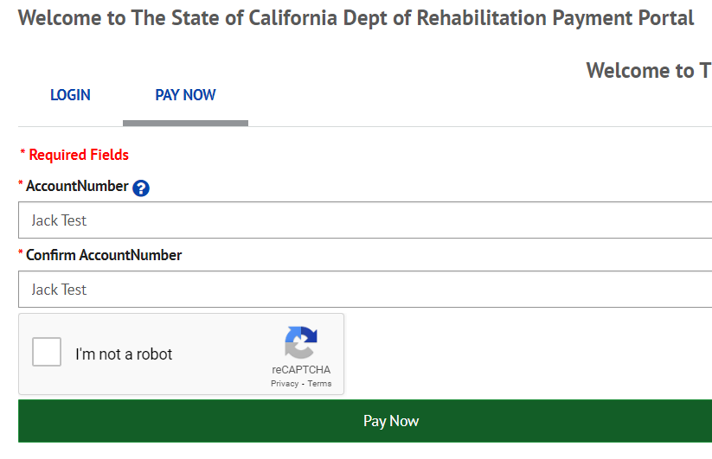

1. Click on the ***Pay Now*** button below the reCAPTCHA box
2. You’ll then be taken to the **Home** screen to enter your contact and payment information (image below):
3. Enter your MOR Business Name in the **Personal or Business Name** field.
4. Enter your phone number using only digits format (for example - 9169876543) in the **Phone** field. Select either Mobile or Telephone to indicate phone type.
5. Enter yourcontact email **address in the Email** field.

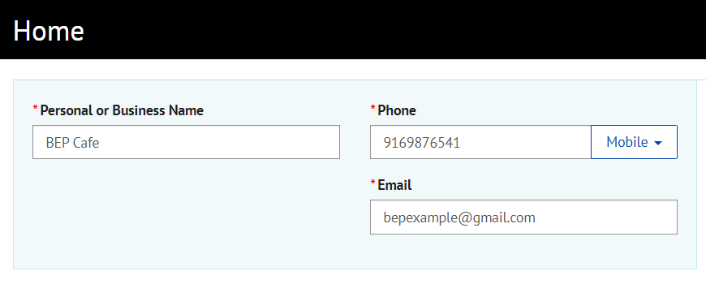

1. Enter the amount due from your BEP Vendor Monthly Operating Report in the **Payment Amount** field, example 675.00.
2. In the **Payment Purpose** box, click the arrow and select the **1-VS-MOR** option.

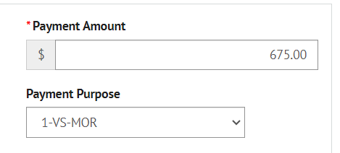

1. When submitting an electronic payment for the first time, you will need to add account information. Click on the **+Enter** hyperlink to open a new page ‘Enter a Payment Method’. See h) for details.
2. In the **Payment Method** field, click the arrow to select a pre-entered payment account. In the Pay Date field, enter the date you are submitting the payment either in the box, or using the calendar button next to it.

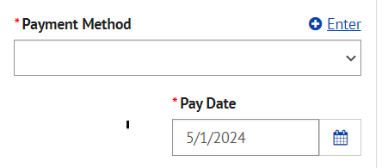

1. On the Enter a Payment Method page, click and enter the following fields:
   * **Account Type** – Personal or Business
   * **Banking Type** – Checking Account or Savings Account
   * **Name on the Account** – Name on bank account selected
   * **Routing Number** – Routing Number for the bank the funds are maintained
   * **Account #** – Personal or Business checking or savings bank account number
   * **Re-Enter Account #** – Re-enter Personal or Business checking or savings bank account number to confirm accurate number
     + Includes picture of sample check with Routing Number and Account Number. Make sure to use your bank checking or savings account number, not your ATM or Debit card number.
   * Click the **Agree and Enter Account** checkbox, and click Enter Account button to save this payment method.

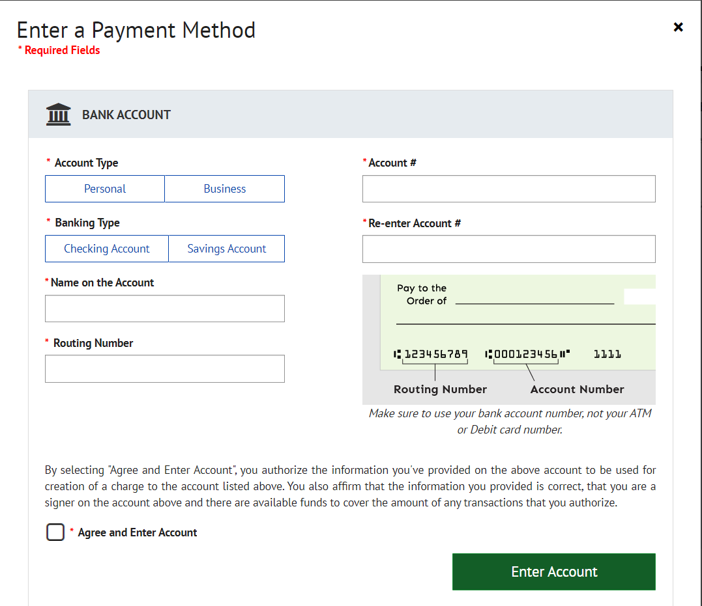

1. For the **Invoice or AR Number Required** field**,** insert your MOR Location number-MonthYear(example: MOR123-Apr24)**.**
2. Select **Continue with Payment button** to finalize submitting your payment. Follow confirmation steps
   * This last step is critical so that DOR’s proper tracking payment of each location’s monthly operating reports.

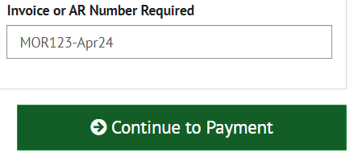

1. **How do I setup my own (first time user) account for future payment(s)?**

The option to enroll will occur once they initiate their first payment. Upon completion of the payment, they will get a pop-up receipt that says “Confirmation,” at the bottom of which will be a link to enroll. Example (Image below appears after your first payment is made):

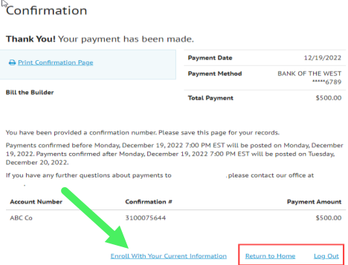

Select “Enroll With Your Current Information” and complete the prompts. Remember to make a note of your Account Number!

* **What can I pay with the DOR Payment Portal service?**

You can pay any invoice or Accounts Receivable with the DOR Payment Portal. You cannot make payments to any other California State Agency other than DOR and all payments must be in U.S. dollars.

* **Is there a fee for using the DOR Payment Portal?**

There is no charge payments made from a checking or savings bank account.

* **What is the maximum payment amount?**

The maximum amount for a CADORPP payment is $75,000. Payments that exceed the maximum amount will need to be split apart and made separately.

* **How many payments can I make in a single month?**

You may schedule as many payments as you would like in a month.

* **Can I edit pending scheduled payments?**

Yes, you can edit any pending payments that do not show a status of "Processing." Your payments will typically enter the processing status two to four business days prior to the payment due date. To guarantee that payments are edited in time, we recommend making your changes no later than 2 pm Pacific Time and at least four business days prior to the payment due date.

In some cases, you may be able to edit pending payments after this time; however, it cannot be guaranteed as payment-processing times vary depending on the payee. To edit a pending payment, click the "Change" link for the payment in the "Pending Payments" area of the Payment Center.

* **Can I cancel pending payment?**

Yes, you can cancel any pending payments that do not show a status of "Processing." Your payments will typically enter the processing status two to four business days prior to the payment due date. To guarantee that payments are canceled in time, we recommend signing in to cancel your payment by 2 pm Pacific Time at least four business days prior to the payment due date.

In some cases, you may be able to cancel payments after this time, but it cannot be guaranteed as payment-processing times vary depending on the payee. To cancel a pending payment, click on the "Cancel" link for the payment in the "Pending Payments" area of the Payment Center.

* **Can I print a history of my payments or transactions?**

Yes, go to Payments & Transfers > Bill Pay and select the "Activity" tab. Select the desired date range and narrow your results by adding a filter. When you have the payment history you want, select the "Print" link at the top of the page. You can also download your history by clicking the "Download Payment List" button at the bottom of the page.

* **How are my payments processed?**

Payments are sent electronically to DOR’s bank account; funds debited from your Payment Account on the Payment Date.

* **Will I receive a confirmation number when I submit a payment?**

Yes, you will receive a confirmation number to the email identified on the account, when you successfully submit a payment