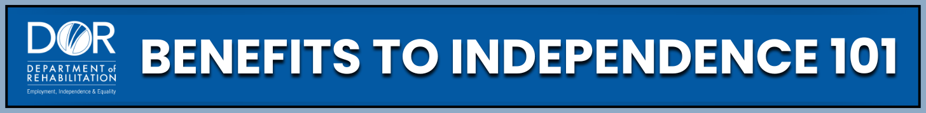
Check out this course

What you can expect to learn:
Information on
Social Security Disability Insurance (SSDI)
Supplemental Security Income (SSI)
Medi-Cal
Medicare
Work Incentives
Rules, thresholds, income limits, programs, and more
 For more details, visit the Department of Rehabilitation (DOR)
website at www.dor.ca.gov/home/benefits101

